VISTA MURRIETA HIGH SCHOOL

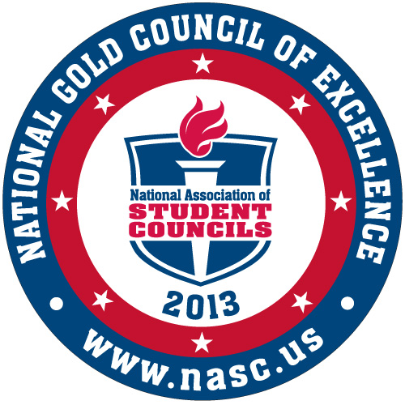


Outstanding Activities
Program 2005-2012


2014-15 STUDENT/PARENT HANDBOOK
BACK - TO - BACK
CIF CHAMPIONS
SCHOOL OF CHARACTER
2006 & 2007

28251 Clinton Keith Road • Murrieta, CA 92563 • Phone: (951) 894-5750 • Fax: (951) 304-1832
Website: www.vmhs.net

Vista Murrieta High School does not discriminate on the basis of race, creed, color, national origin, gender or disability
6-year Accreditation by the Schools Commission of the Western Association of Schools and Colleges

Murrieta Valley unified school district
Board of Education: Robin Crist - Kenneth Dickson - Paul F. Diffley III - Barbara Muir - Kris Thomasian
Superintendent: Pat Kelley

TABLE OF CONTENTS
GENERAL INFORMATION |  |  | STUDENT ACTIVITIES
Map of Campus........................................................ |  | 2 | Activities, Clubs & Dances............................................ 19-20
Bell Schedules & A/B/C Day Calendar..................... |  | 3 | Academic Organizations............................................... 21  Dance Contract…………………………………………… 22
Principal’s Message................................................. |  | 4 | Student Leadership....................................................... 23
Alma Mater............................................................... |  | 4
Mission Statement.................................................... |  | 5 | PHYSICAL EDUCATION & ATHLETICS
Administration & Support Staff................................. |  | 6
Frequently Asked Questions.................................... |  | 7 | Physical Education Information..................................... 24
Parking Program...................................................... |  | 8 | Athletic Program & Eligibility......................................... 24
Health Office Information......................................... |  | 9
Library Information................................................... |  | 9 | GRADUATION REQUIREMENTS
CODE OF CONDUCT |  |  | MVUSD/VMHS Graduation Requirements..................... 25
 |  |  | CAHSEE & Senior Exit Interview.................................... 26
School-Wide Rules................................................... |  | 10 | Community Service Hours.............................................. 26
Dress Code.............................................................. |  | 11 | Alternative Credits........................................................... 26
Behavior & Discipline Matrix.................................... |  | 12
Definition of Bullying…………………………………  Sexual Harassment................................................. | 14  15
Senior Contract Information..................................... |  | 15 | POST-HIGH SCHOOL PLANNING
Attendance Policies.................................................. |  | 16
 |  |  | Guidance Events, Career Center & College Planning…. 28
SCHOLASTIC INFORMATION
 |  |  | STUDENT PLANNER
Schedule Change Policy & Grades.......................... |  | 17
A-G College Entrance Requirements………………. |  | 18
Homework & Finals Policies..................................... |  | 19 | 2013/14 Student Planning Calendar............................... 29 | 29
MAP OF CAMPUS

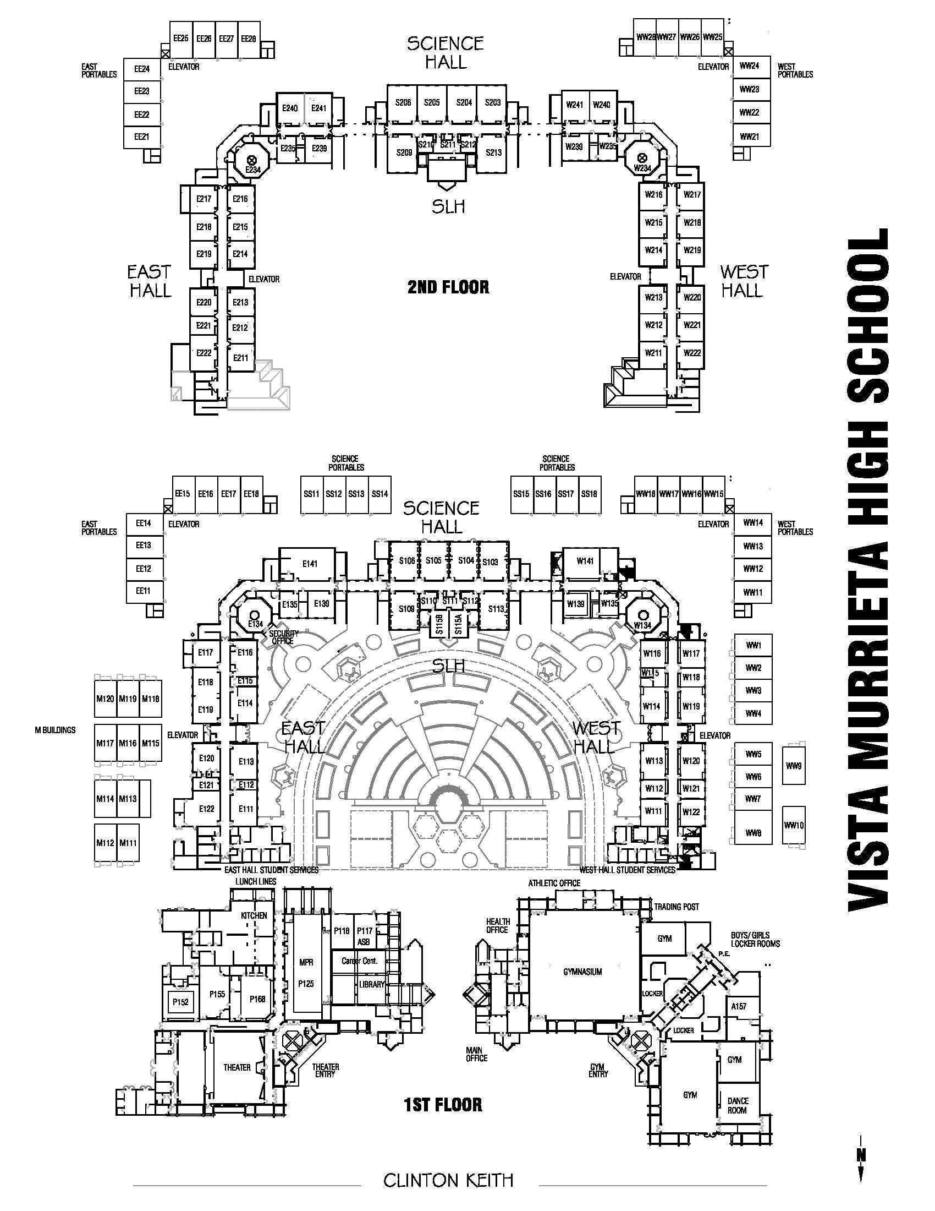
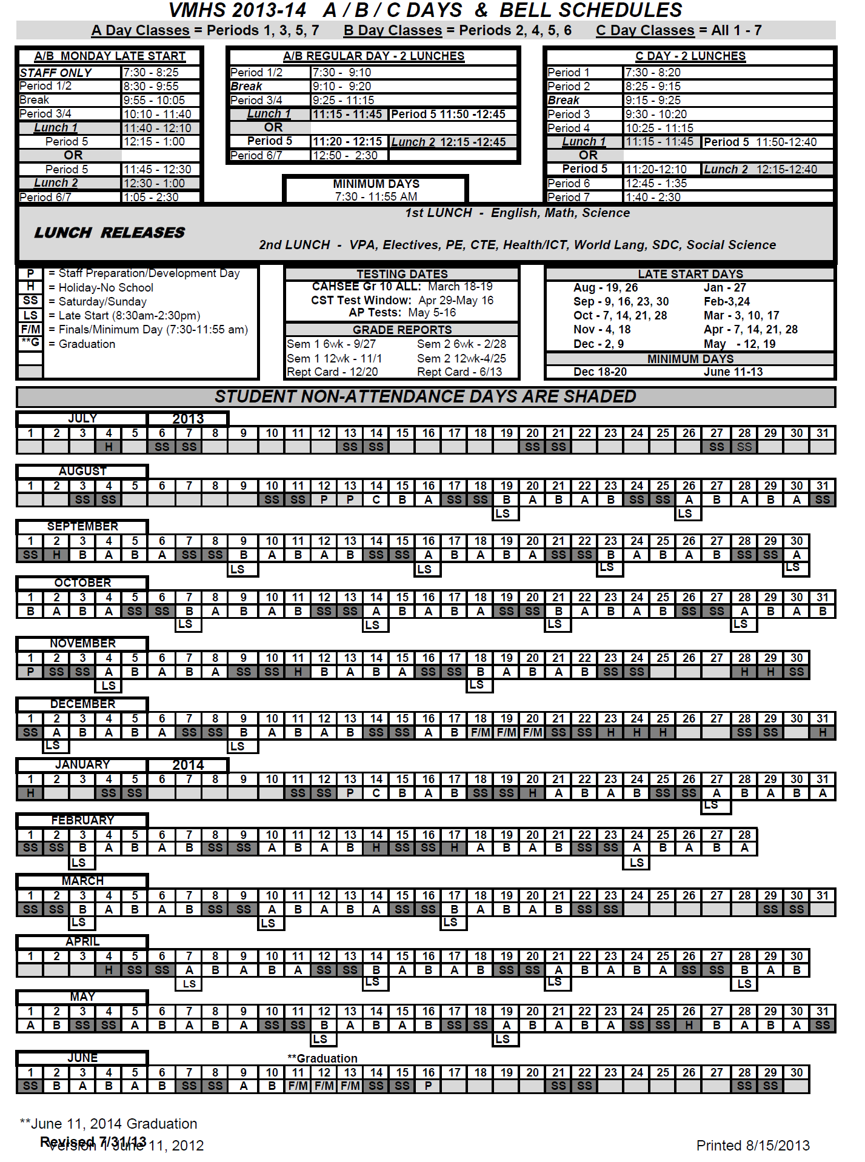
PRINCIPAL’S MESSAGE



Dear Bronco Students and Parents;

Welcome to Vista Murrieta High School, Home of the Broncos. Vista Murrieta High School is a very special school that opened its doors in August of 2003. Since its inception, we have worked to build a school that is worthy of this community, and we appreciate and value the communal support we receive. Vista Murrieta’s staff is committed to helping your student achieve their fullest potential. We proudly offer something for everyone, and I personally invite every student to jump into Vista Murrieta High School with both feet. Students, your willingness to become involved and actively participate in our campus culture will not only enhance your high school years, it is vital to the high school experience. Furthermore, students who are actively engaged in campus life are on average more successful academically in school, whether it is in our award winning athletics, activities, or arts programs. Throughout our history, our students and staff have amassed a number of awards and accolades, and I want you to be included as we welcome and celebrate another great year.

Every year and every day, we test ourselves to live up to the standards of CLASS—Character, Leadership, Attitude, Scholarship, and Service. As you start the school year, I hope you will set goals to stretch your capacity as you prepare for your future. Regardless of what last year held for you, I want to encourage you to come to school with a mindset of growth—a belief that you can learn and do what you set your mind to; this positive attitude is essential for your personal growth. Regardless of your passion or pursuits, your willingness to champion self- improvement starts with being competitive in the classroom and not accepting anything less than your personal best.

Senior Class of 2015, I challenge you to step up and lead our campus by modeling CLASS. I also encourage you to challenge yourself; take rigorous courses, establish great study habits, make your mark as a leader in whatever you are most passionate about, and most importantly, immerse yourself in all Vista Murrieta has to offer.

On behalf of the entire Bronco staff, I welcome new and returning students and parents to Vista Murrieta High School. I am confident that you will find our staff to be highly dedicated partners in educating your students, preparing them for success in college and their careers, and providing an exceptional high school experience. Have a great year and remember to do everything with CLASS, the Bronco Way!

Sincerely,

Mick Wager, Principal

Vista Murrieta Alma Mater

Vista Murrieta Broncos true,
We pledge our hearts and minds to you.
Pursuing victory with class,
Our pride in you will forever last.
As we raise our colors blue and gold,
We’ll help our history to unfold.
As we gaze across our valley wide,
We’ll blaze through life with Bronco pride.

MISSION STATEMENT

The mission of the Vista Murrieta High School community is to inspire every student to think, learn, achieve,
care and live through C.L.A.S.S. - Character, Leadership, Attitude, Scholarship and Service.

C.L.A.S.S.

What does it mean to be a Vista Murrieta High School Bronco?
It starts with the way that we do business every day; in every classroom, at every school activity ~
And, in the way we interact with each other - doing everything with C.L.A.S.S.
Character
C = Character by…
- Showing respect and compassion
- Acting with personal and academic integrity
- Following school behavioral expectations
- Pursuing success with honor
S = Scholarship by…
Utilizing effective work habits
Pursuing a high level of achievement
Taking personal responsibility for academic performance
Engaging in higher-level thinking skills
Using technology to enhance their learning
Leadership
L = Leadership by…
- Modeling positive behavior within the school community
- Contributing to a culture of positive risk-taking
- Engaging in collaborative learning experiences
- Participating in extracurricular opportunities
Attitude

A = Attitude by…
- Displaying motivation for academic excellence
- Accepting rigorous challenges
- Contributing to a positive school culture
- Welcoming feedback
- Embracing the culture of life-long learning

Scholarship
S = Scholarship by…
- Demonstrating effective work habits
- Taking ownership of individual learning experiences
- Aspiring to perform at personal best
- Using communication, information and technology to enhance learning
- Implementing and completing a four-year academic and career development plan

Service

S = Service by…
- Contributing to the well-being of global society
- Exercising positive citizenship
- Participating in a variety of community service opportunities
- Contributing to a clean, safe and orderly school environment

ADMINISTRATION & SUPPORT STAFF

Administrative Staff

Mick Wager, Principal..........................................................................Janell Cox, Site Secretary x6798
Mark Pettengill, Deputy Principal......................…...............................Karen Pickrahn, Secretary x6777
Matt Bean, Assistant Principal.................…………….......................Shonda Hollowell, Secretary x6778
Tracy Threet, Assistant Principal.............................................................Cathy Morse, Secretary x6689
Steve Rausa, Dean of Students.........…………………………….….....Ruth Resendez, Secretary x6678
Ray Moore, CMAA, Athletic Director........................................................Jan Principe, Secretary x6782
Hien Nguyen, Activities/ASB Director...................................................Maria Charron, Secretary x6792

Counseling Staff

Demetrius Caldwell..................................................................................................Alpha A - Cn x6789
Marty Quisenberry.................................................................................................Alpha Co - Gq x6785
Aurora Padilla..........................................................................................................Alpha Gr - Lh x6776
Diana Ruiz.................................................................................................................Alpha Li - O x6772
Eric Peterson............................................................................................................Alpha P - Sg x6779
Claudia Gomez.........................................................................................................Alpha Sh - Z x6685

Support Staff

Guidance Technician A - K..................................................................................Cindi Davenport x6684
Guidance Technician L - Z......................................................................................Renee Weber x6774
Guidance Technician, College Career Center........................................................................TBD x6589
Secretary Front Office…………………………………………………………...……Paulina Paulson x6690
Secretary Guidance Office……………………………………………………………..Sheri Calderon x6676
School Resource Officer/SRO...........................Murrieta Police Department Officer, John Martin x6753
Activities, ASB Secretary & Student Store.............................................................Maria Charron x6791
Athletics Secretary.....................................................................................................Jan Principe x6781
Bookkeeper……………...........................................................................................Alicia Biagioni x6784
Assistant Bookkeeper…………………………………………………….......................Linda Allmon x6795
School Psychologist.............................................................................................William Bennett x6574
Attendance Clerk –Grades 9/10.....……...................................................................Diane Castle x6677
Attendance Clerk – Grades 11/12..............................................................Maria Salgado-Adams x6773
Attendance Clerk (Front Office Window-Check-In/Out)…............……………….....Debbie Rausa x6783
School Nurse...............................................................................................Lucie McCarthy, R.N. x6796
Health Technician...................................................................................................Marisa Stuppy x6793
Library Technician II..................................................................................................Laurie Smith x6760
Receptionist.....................................................................................................Patsy Long x“0” or x6797
Theater Technician...................................................................................................Michael Ruiz x6536
Locker Room Attendant - Boys’........................................................................Gerald Rodriguez x 6709
Locker Room Attendant - Girls’.................................................................................Darci Conley x6714
Technology Support................................................................................................Mark Entezari x6767
Campus Security: Elizabeth Baker, Bob Charron, Melinda Howard, Cindy Jacobson,
David Jennings, Dan Torres, Chad MacDonald.............................................................................x6583
Kitchen.........................................................................................................Chris Pasciuto, Lead x6581
Head Custodian.....................................................................................................Dennis Harkey x6740


FREQUENTLY ASKED QUESTIONS

MESSAGES & Deliveries
Please make travel, lunch, clothing and other arrangements with your student before he/she arrives at school as these items are no longer accepted at the front office. While we join with you in the celebration of special occasions, bouquets of flowers, balloons or other gifts should be delivered elsewhere and will not be accepted at the front office. Calling into or delivering messages and non-emergency items to classrooms is disruptive to the learning environment and students should be responsible for remembering their own work, lunches, clothing, sports equipment or other necessities; therefore we no longer deliver any items to classrooms. Students should be encouraged to accept the consequences if they neglect these responsibilities. We appreciate your assistance in helping us to reserve this function for true emergencies.

CLOSED CAMPUS
VMHS is a closed campus. During the break/lunch periods, students are to remain in the Quad area. All other areas are considered out-of-bounds and unauthorized. Students are not permitted off campus at any time unless a parent/guardian provides a written request. Attendance personnel will verify all requests. Loitering before or after school is not permitted and students who disregard this rule will be assigned Saturday School.

SCHOOL VISITATIONS
Parents, guardians, and community members are welcome to visit the school. If your desire is to meet with an administrator, please call ahead for an appointment, as most drop-in requests are difficult to accommodate. Classroom visitations require a 24-hour advance notice to ensure that someone will be available to accompany you. All visitors must first check-in at the Campus Security Station to receive a parking pass, then show a current photo ID at the Reception Desk before a guest pass is issued. We highly guard students learning time; therefore, it is important not to disturb teachers and students during instruction. In order to maintain a safe and orderly learning environment, students’ friends or visitors without specific school business are not allowed on campus at any time during school hours.

Parent/Teacher Communication
Often, parents want to contact a teacher and are able do so via telephone or email. Every teacher has a telephone with voicemail, as well as an email address. All of this contact information can be found on the VMHS website at www.vmhs.net under Staff Directory. You should expect messages to staff to be returned within a 48-hour time-period, which is a professionally accepted standard. We appreciate your patience in this regard, as teacher contracted work hours are from 7:30am to 2:30pm daily and most have limited time to return calls during these hours.

CommunicationS
In this age of information, VMHS administration has found it beneficial, timely and cost effective to use technology to communicate with parents on a regular basis. Email and phone systems are used to communicate regular and emergency information to students and parents. The Pony Express is the VMHS email newsletter which is utilized in place of a traditional paper newsletter and includes distribution to parents, students, staff and community members. This is a great way to find out about current and upcoming school activities, testing, important events, sports, community service opportunities and breaking news. Newsletter will be emailed weekly to home email. The Bronco website is a great place to find out information about school programs and departments, testing, report card and progress report dates, PTSA and Site Council, newsletters, the student calendar and bell schedules, maps, student leadership, sports, clubs, event pictures, contact information for all staff and much more, just go to www.vmhs.net. While the vast majority of families have internet access, other forms of communications which are utilized include: the daily newscast of BNN (Bronco Network News) to students in all classrooms at the start of 3rd/4th periods, a school-to-home automated telephone system for attendance and notification on important and emergency issues, as well as the automated marquee sign-boards on the front of the school gym and Quad. You may always call the Reception Desk at 894-5750 x '0' to have questions answered or directed.

Security
There are staff protocol and systems in place to assure a safe environment for all students and staff. VMHS is a closed campus and students may not leave campus during school hours without appropriate authorization. All visitors are required to provide picture ID, sign in at the Reception Desk and receive a guest pass. Specially trained Campus Security Staff and administrators supervise all areas of campus and meet regularly with the local police department. A Murrieta Police Department officer (SRO-School Resource Officer) is also assigned to campus during school hours. Students and vehicles parked on school property are subject to search based upon reasonable suspicion and safety issues. Administration reserves the right to determine the basis for reasonable cause for search. VMHS has an extensive video-surveillance system, along with a 24-hour security patrol, as deterrents to crime. The district provides regular InterQuest canine visitations to search for illegal substances. All students, staff and community members are encouraged to utilize the We-Tip hotline (7 days/week, 24 hours/day) to report suspicious campus activity or crime information at 1-800-78-CRIME.

PURCHASES
Purchases may be made with a bookkeeper during school hours or via the Trading Post On-Line, which allows students/parents to easily purchase items, pay for student activities all securely through the internet. Throughout the year all types of transactions may be necessary including purchase of P.E. clothes, yearbooks, AP tests, dance, play and concert tickets and much more. Just visit www.vmhs.net, click on the Trading Post Online, create a secure account by clicking on the Set-Up button, complete the required fields and chose a username/password. You must have the student 9-digit permanent ID number.

STUDENT PARKING/DISMISSAL RULES
Students must obtain a parking permit (from the Bookkeeper) before they can park a car in the student lot. At that time, they will receive parking regulations that require a parent signature. Students who do not follow parking regulations will be ticketed and assessed a fine or ultimately denied parking privileges. Students may park on campus in the student lot on the west side of campus (near athletic fields) or in any space that is not designated ‘staff, reserved or visitor’. Students may not loiter in parking lots at any time (before, during or after school) - those who do, will be assigned Saturday School. Students with four tardies per semester will have their parking pass revoked with no refund. MVUSD is not liable for any loss, damage or theft in parking lots.

LATE START/EARLY RELEASE
Some senior and junior students may have a late start or early release schedule. Late start students should not enter campus before break and early release students should be off campus before the start of last period. Student photo I.D. cards are required to leave campus early - failure to carry will result in time in OCI. If you have difficulty securing regular transportation, a full schedule will be provided as loitering is not permitted.

VMHS PARKING PROGRAM

Vista Murrieta High School has a parking program to ensure safety and to prevent unauthorized vehicles from parking on campus. All vehicles parked in VMHS parking lots must have a permit ($20 from Bookkeeper). In the event you arrive on campus without a permit, a temporary one-day permit may be obtained by contacting the campus security officer in the guardhouse at the main entrance of VMHS. Students may only park in the student lot (west side of campus by athletic fields) or in any space that is not marked ‘staff, visitor or reserved’. Students who have four unexcused tardies per semester will have their parking permit revoked with no refund given.

It is recommended that all students be dropped off in proper student loading zones. The drop off loop in front of school provides a safe place for parents to drop off and pick up VMHS students. Please enter either the loop from the eastern-most driveway entrance on Clinton Keith (in front of gym) and proceed through the parking lot as far forward as possible, towards the Performing Arts Center, so traffic doesn’t backup onto Clinton Keith Road (then exit onto Whitewood), or enter the southern-most Whitewood entrance and proceed through campus (exiting onto Clinton Keith at the signal).

❖ 0100 – PARKING PERMITS MUST BE VISIBLY DISPLAYED: Every vehicle parked on the VMHS campus during school hours must have a site issued parking permit visibly displayed. (All permits can be obtained in the main school office.) A violation occurs when a vehicle is parked in one of the school lots without a temporary or permanent parking permit properly displayed in accordance with violation 0200. Fine: $25.00

❖ 0200 – PARKING PERMIT NOT PROPERLY DISPLAYED:
•Every vehicle parked in any parking lot on the Vista Murrieta High School campus must possess a parking permit in accordance with violation 0100.
•The parking permit must be hung from the rearview mirror or placed in the lower left hand corner of the dashboard with all numbers facing through the windshield. Fine: $25.00
•Temporary permits must be placed in the lower left hand corner of the dashboard with the date facing through the windshield. Fine: $25.00

❖ 0300 – NOT PROPERLY PARKED IN PARKING STALL: Each vehicle that parks in any VMHS parking area must have the front of the vehicle leading into the marked stall. Each stall will be clearly marked enabling the driver to know where the vehicle is to be parked. When the vehicle has come to rest, the front of the vehicle will be facing into the stall. A violation will result on vehicles not properly parked in the stalls. Fine: $25.00

❖ 0400 – PARKED IN RESERVED STALL WITHOUT THE PROPER PERMIT: Each vehicle parked in a marked “reserved” stall must display a permit which is designated to park in that assigned “reserved” stall. No students shall park in stalls designated for staff. A violation will result if a vehicle is parked in a reserved stall without displaying the proper permit. Fine: $35.00

❖ 0500 - VMHS parking is as follows:
•One student parking lot is located off of Clinton Keith Rd., through the main school parking entrance (adjacent to the track); the other is in the south lot between the tennis courts and softball field with entrance/exit from Whitewood as well.
•Visitor parking is located off of Clinton Keith Rd., through the main school parking entrance (in front of the Gymnasium & Administration Building).
•Two administrative/staff parking lots: one located off Clinton Keith Rd., through the main school parking entrance (in front of the Administration Building), and one off of Whitewood (east of the school complex). These lots are exclusively designated “reserved” parking only. Stickers will be issued to all staff to allow vehicles to park in these numbered ‘reserved’ parking spaces.
•All students wishing to park on campus need to purchase a parking permit from the Bookkeeper and have it correctly displayed. It is a violation for students to park in areas other than designated “student parking” and could result in receiving a ticket and a $35.00 fine.

❖ 0600 – PARKED IN VIOLATION OF THE RED CURB: No vehicle shall park along the red curb. All vehicles must be parked in a designated painted stall. A violation will result in vehicles parked along a curb, which is painted red. Fine $35.00.

❖ 0700 – PARKING IN A POSTED FIRE LANE: Vehicles shall not park in an area that is designated by the Murrieta Fire Department, Murrieta Police Department or Vista Murrieta High School. The curbs will be painted red with the Murrieta City Municipal Code or Riverside County Code stenciled in white. A violation will result in vehicles that are not parked in a designated stall and are parked along the red fire lane. This excludes emergency vehicles in accordance with the California Vehicle Code. Fine $80.00.

❖ 0800 – PARKED IN A “NO PARKING” AREA: No vehicle will be parked in an area that is designated as no parking. The ‘no parking’ area will either be clearly stenciled as ‘no parking’ or properly marked stalls will be visible indicating cars may park in this area. This will exclude buses and emergency vehicles. A violation will result when a car is not properly parked in a visibly marked stall. Areas where there is no properly marked stall indicating parking is allowed will be considered a ‘no parking’ area. Fine $35.00.

❖ 0900 – VEHICLE PARKED IN MORE THAN ONE STALL: No vehicle shall park taking up more than one marked stall. Each vehicle must be properly parked per section 0300. Failure to do so by parking in a manner that doesn’t allow another vehicle to park in a properly marked adjacent stall will result in a violation. A violation will occur if a vehicle is parked across or over one or more lines taking up more than one stall. Fine $35.00.

❖ CALIFORNIA VEHICLE CODE - C.V.C.
Section 22507.8(a) – PARKING IN A SPACE DESIGNATED FOR DISABLED
Refer to the State of California – Vehicle Code. Fine $325.00.
Section 22500.1 – PARKED BLOCKING WHEEL CHAIR ACCESS
Refer to the State of California – Vehicle Code. Fine $325.00.
Section 22507.8(b) – OBSTRUCT/BLOCK SPACE DESIGNATED FOR DISABLED
Refer to the State of California – Vehicle Code. Fine $325.00.

❖ Payment of citations/appeal process
In the event a citation is given for a violation in which you feel you do not deserve, the appropriate information is provided at the bottom of the citation with an 800 number and instructions. For information call 1-800-989-2058. Payment for citations must be mailed to:
Parking Citation Service Center, C/O Vista Murrieta High School, P.O. Box 2730, Huntington Beach, CA 92647- 2730

HEALTH OFFICE INFORMATION
We are primarily a health office, not a health clinic, which means that we treat injuries that occur at school, and only illnesses that generally require a student being sent home (vomiting, fevers, etc.). A Health Technician is staffed in the Health Office during school hours to care for students. Health Technicians are unlicensed personnel who have CPR and First Aid Training. The Credentialed School Nurse (Registered Nurse with a bachelor’s degree and post graduate credential in school nursing), covers multiple school facilities, but may be contacted at VMHS any time if needed - Lucie McCarthy, R.N., 894-5750 x6796.

EMERGENCY CARDS Please keep this information current. It is the only way to locate parents in case of an emergency or if a student is ill. Students are not dismissed from school due to illness unless a parent, guardian or designated person is notified. Call 894-5750 x6793 to update emergency contact names or home, work or cell phone numbers. We need to have at least two local phone numbers that we can call in an emergency. If registering online, please make sure to complete the medication information section with any health concerns or medications for your student that we or emergency personnel should know. This is information that should be updated annually either with an updated Emergency Card or with online registration.
IMMUNIZATIONS A student enrolling in a Riverside County School must show proof of three (3) polio & three (3) DPT immunizations (one must have been given after the 2nd birthday) and one (1) MMR (received after 1st birthday), three (3) doses of Hepatitis B (at any age), one (1) does of varicella (chicken pox) or documentation of disease, and a Tdap (Whooping Cough/Pertussis) vaccine (given after the 7th birthday). If your student needs any immunizations to comply, you may contact the Immunization Hotline: 1-888-246-1215.

MEDICATION California Education Code 49423 states: Any student taking medication during school hours must fill out a special form in the health office and must be signed by the doctor and parent. Please contact the Health Office if your student needs to take medication at school. Medication must be brought by the parent/guardian to school in the original prescription container. Medications CANNOT be brought to school and kept in purses or pockets. This also pertains to any over-the-counter medications (Tylenol, Advil, etc.) State Law does allow students with asthma to carry inhalers and students with severe allergies to carry epi-pens as long as the student’s parents and doctor give permission, which must be on file in the Health Office. Forms are available in our Health Office, or visit the Parents/Health Services page on the district website. Also, if your student takes medication at home for a health problem, it is recommended that a three-day supply be kept at school in the event of an emergency or disaster.

HEALTH PROBLEMS If a student has any health problems we need to be aware of, such as arthritis, scoliosis, hearing loss, heart problems, diabetes, allergies etc., please notify the School Nurse, so we can work together in making necessary adjustments to ensure student’s success at VMHS.

ACCIDENT INSURANCE As a reminder, injuries frequently occur with students and your medical insurance may not cover all the costs. A low cost accident insurance policy is available for parents to purchase to help offset those costs. Please review your medical coverage and consider accident insurance if your family has a need. This information is available at the beginning of the school year in the school’s main office.

LIBRARY INFORMATION
GENERAL INFORMATION The library is open from 7:00am-3:30pm Tuesday through Friday and 8:00am-3:30pm on Late Start Mondays for all students, as well as during breaks and lunches and during scheduled class time for those students with passes. Our school library is more than just books - it’s a learning hub with a full range of print and electronic media that support student achievement. These resources include books, magazines, audio books, computers, databases and more. A current VMHS student ID is required to check out text/library books. Books are checked out for a 4-week period and may be renewed, either in person or online an additional four weeks. Notices are sent to students with overdue books who are not permitted to check out any further materials until the overdue item is returned. When using a computer, students must display their student ID card with their Internet Permission clearly marked. In addition to fiction and non-fiction titles, access to online periodical databases and E-Books is available from classrooms as well as from any computer with internet access. These databases/electronic books contain full-text articles from current editions of newspapers/magazines and multi-volume reference books. Website links are on the VMHS Library Web Page. Ten computers are available for student use, with programs such as PowerPoint, Word, Access, and Excel, in addition to the card catalog, EBSCO periodical database and E-Books. A computer lab with thirty computers is available for class use. Textbooks are also checked out through the library. Students keep a copy of their texts at home, use a class set during class, and copies of textbooks are available for use in the library when students need to do homework. All books must be returned or paid for at the end of the school year. See the Textbook Policy for more information on textbooks. Additional information can be found at the school website.

MVUSD TEXTBOOK POLICY FOR GRADES 6-12 Textbooks become the student’s responsibility from the moment that the student checks the book out until the moment he/she checks it back in to the library. Giving a textbook to a teacher or friend does not constitute turning in a textbook. Textbooks must be returned in personally to the library before the end of the school year. Students must write their name in front of the textbook on the stamp titled “This Book Belongs To.” Leaving textbooks in classrooms or outside is not recommended. If the book is stolen or damaged, the student is still responsible for the loss or damage. It is the students’ responsibility to protect textbooks from rain, moisture, and from damage by siblings or pets. Students will be fined if their textbook is returned with torn pages, underlining, or writing in or on the book. If a textbook is lost or damaged beyond use, full replacement cost (the current price of the text) will be charged. For a damaged and repairable text, up to 25% of the textbook replacement cost will be charged. Students have two weeks to look over the textbooks they are initially issued and if there is damage in a text, to notify the library staff. If students do not return their textbooks at the end of the school year, they will be billed for the replacement price of the textbooks, per Board Policy 6161.2 and Ed Code 48904.3, and their grades, transcripts, or diploma will be withheld.

ADDITIONAL INFORMATION TWO-HOME FAMILIES: No additional text sets will be issued before September 1st for families with two homes. Parents wishing 2nd set must contact administration with details of extenuating circumstances for approval, but only if extra books are available. If school need arises, student must return 2nd set. The student is responsible for both sets.
WILLIAMS DECISION: Per the Williams Decision, all students are entitled to textbooks in basic core subjects for homework. Any student who doesn’t return textbooks, thereby denying other students access to these materials for homework, will not be issued a 2nd set, unless the 1st set is returned or paid for. Textbooks are available in the library before/after school and during lunch. There will also be textbooks available in class for in-class assignments. Arrangements can be made for other restitution, if the student is unable to pay for lost or damaged textbooks.

SCHOOL-WIDE RULES & REGULATIONS

The goal of VMHS is to provide a safe and comfortable learning environment. VMHS rules are based on a few simple considerations: appropriateness, courtesy and safety. Students should occasionally review the rules listed below, as they will be held responsible for knowing and following them at school and school events.

Progressive discipline consequences will be assigned to students who repeatedly fail to follow these established rules which could ultimately lead to suspension from school. On-campus Intervention, or OCI, is used for students who are sent out of class for behavior reasons, non-suits in PE, tardy sweep students during the first period of the day, students with multiple tardies, those who missed a Saturday school or who violate dress code and are awaiting correction. Students are expected to follow the rules in OCI and any class work they miss may be sent to the OCI classroom. OCI is the first step of progressive discipline that can lead to suspension, with Saturday School being utilized for repeat offenders. Students may be put in OCI in lieu of suspension as an opportunity to address an infraction at the administrators’ recommendation. Students in OCI or Saturday School can expect written assignments, as well as campus trash pickup duties and other campus community service activities. Removal from OCI will result in an automatic suspension.

1. Students are to exhibit acceptable standards of behavior at all times on campus and during school activities. After-school detention may be assigned to students who do not follow classroom or school rules. All students have three days to serve After-school detention. Failure to serve After-school detention results in a Saturday School.

2. To ensure student safety, VMHS is a closed campus. Students are not permitted to leave campus at any time. This includes break and lunch periods. Parents must check students out of school.

3. Students MUST have their student identification card during school hours for security reasons. Failure to carry an ID card will result in assignment to OCI. Early Release students must have their release time printed on their student ID card, or they will not be permitted to leave campus. Students must carry ID when attending school-related activities including games and dances.

4. Students MUST have a hall pass if out of class during assigned class time. Students out of class without a pass will be sent to OCI.

5. Student parking is permitted only in the student parking lots with a current parking permit. If parked in any other location, the offense will result in a citation. Reckless driving is not permitted. Any student driving recklessly on campus may be cited and/or have parking privileges revoked. No refunds will be made if student parking privileges are revoked. Parking lots are out of bounds during class time, break and lunches and between periods, and loitering on school property before or after school is not permitted. Students who receive four tardies in a semester will have their parking pass revoked with no refund. At VMHS, driving is a privilege, not a right!

6. The electronic device policy, based on recent legislation (listed below), allows students to have cell phones on campus for emergency situations. Therefore, cell phones are allowed on campus and it is acceptable for students to use them during lunch or break. While in class however, cell phones must remain turned off and put away. Students will not be given permission to leave class to return or answer a cell phone call. Students may not have cell phones out during class for checking time, calculating, picture taking, text messaging, incoming/outgoing calls, or for any other reason. Absolutely no cameras or recording devices are allowed to be used on campus without prior permission. Sexting (indecent pictures or language sent via cell phone), or electronic bullying or threats will not be tolerated.

The school strongly discourages bringing other electronic devices to school that have no educational purpose. This includes any audio or video devices such as; iPods, games, etc. If you choose to bring a cell phone or any other electronic device, you do so at your own risk. The school does not have staffing to investigate or be responsible for loss or theft of any electronic devices. Loss or theft of any item should be reported to the Murrieta Police Department. Confiscated items may be picked up at the Security Office after school on Tuesday or Thursday with a valid student ID.

California Education Code Section 51512 provides for...disciplinary action to be taken if a student uses, without expressed permission from a teacher, any electronic recording or listening device:

“The Legislature finds that the use by any person, including a pupil, of any electronic listening or recording device in any classroom of the elementary and secondary schools without the prior consent of the teacher and the principal of the school given to promote an educational purpose disrupts and impairs the teaching process and discipline in the elementary and secondary schools, and such use is prohibited. Any person other than a pupil, who willfully violates this section, shall be guilty of a misdemeanor. Any pupil violating this section shall be subject to appropriate disciplinary action.

7. Food and drinks are not permitted in the classroom, offices or hallways at any time. Bottled water is permitted if capped and stored out of sight.

8. Skateboards, roller blades, scooters and bicycles are not to be ridden on campus at any time (day or night). These items may be locked in the bicycle rack near East Hall during school hours. If confiscated, these items may be picked up at the Security Office on Tuesday or Thursday with a valid student ID.

9. Publications, posters and announcements may only be distributed with prior administrative approval and only in designated posting areas.

10. No sharpie pens or any other type of permanent marker may be carried by students on campus at any time.

11. Due to safety concerns, no students are allowed in hallways before school, during break, lunches or after school. Saturday school will be assigned to students who disregard this rule. As exceptions arise, such as inclement weather, students will be directed by school personnel as to hallway usage. As always, keep VMHS beautiful and pick up your trash!

12. Lost and found and confiscated items will be stored in the Security Office. Items not claimed within 30 days will be donated to charity.

VMHS Dress Code

All students are expected to know VMHS Dress Code expectations. Parents we need your support with this, so we ask that you review the Dress Code with your student prior to shopping for school attire so that school-appropriate clothing is chosen. School clothing should be safe and should not cause undue attention or be offensive to others. The focus of school is education and students should be properly and modestly dressed. Students who violate the Dress Code will meet with a school administrator and face the consequences listed in the Discipline Matrix.

NOTE: Students who are not appropriately dressed will be brought to the On-Campus Intervention (OCI) classroom until someone can bring the student appropriate clothing. Our focus is on learning, and we don’t want students to miss instructional time, yet we need to make sure our students are dressed for academic success.

INAPPROPRIATE ATTIRE
- Clothing that exposes undergarments (sagging or low cut pants, low cut tops that expose bra straps or tops that expose bra straps). Sheer garments must be accompanied with items that comply with the dress code.
- See through or sheer garments worn over clothing that does not comply with the dress code.
- Garments that, when standing, sitting or walking, show stomach or back (whole or partially)
- Any sports jersey (except VMHS teams)
- Garments with large rips or tears that do not comply with the dress code.
- Non-suits in P.E.
- Bare feet not permitted at any time
- Pajamas or slippers (except during Spirit Week)
- Garments with pictures, wording and/or symbols depicting the following:

- Tobacco, Alcohol, Drugs or associated paraphernalia
- Sexually explicit content or numbers
- Lewdness or Obscenity (including nudity or nude silhouettes)
- Offensive Content (including foul language)
- Hate or Defiance
- Violence or Weapons (brass knuckles, grenades, guns/knives)
- Iron Cross or Nazi/neo-Nazi symbols
- Gang affiliation or living or belonging to a particular town or part of a town
- Garments that are intimidating or offensive
- Any garment that may endanger a student
- Hair nets, do-rags or bandana
- Hanging belts
- Belt buckles with inappropriate symbols or initials
- Chains or spiked apparel or accessories
- Safety pins as jewelry or accessories
- Colored shoe laces that represent a group
- Hats: ONLY ‘VMHS’ hats or solid navy, white, grey or gold hats are approved to be worn on campus
and must be removed when entering a classroom or office. No other hats may be worn OR carried on campus from 7:30am to 5pm.

Female Specific Items NOT Allowed
- Tube tops
- Low cut tops that expose cleavage
- Tops that expose most, to all of back (including single strap and halter tops)
- Skirts/shorts/skorts MUST BE NO SHORTER THAN 4” FROM TOP OF KNEE even while walking
- Tights, leggings, yoga pants must be worn with an outer garment that is no less than 4” from top of knee

Male Specific Items NOT Allowed
- Bandanas
- Sagging pants
- Non-school approved hats

ADMINISTRATION RESERVES THE RIGHT TO DETERMINE
‘APPROPRIATE DRESS CODE’
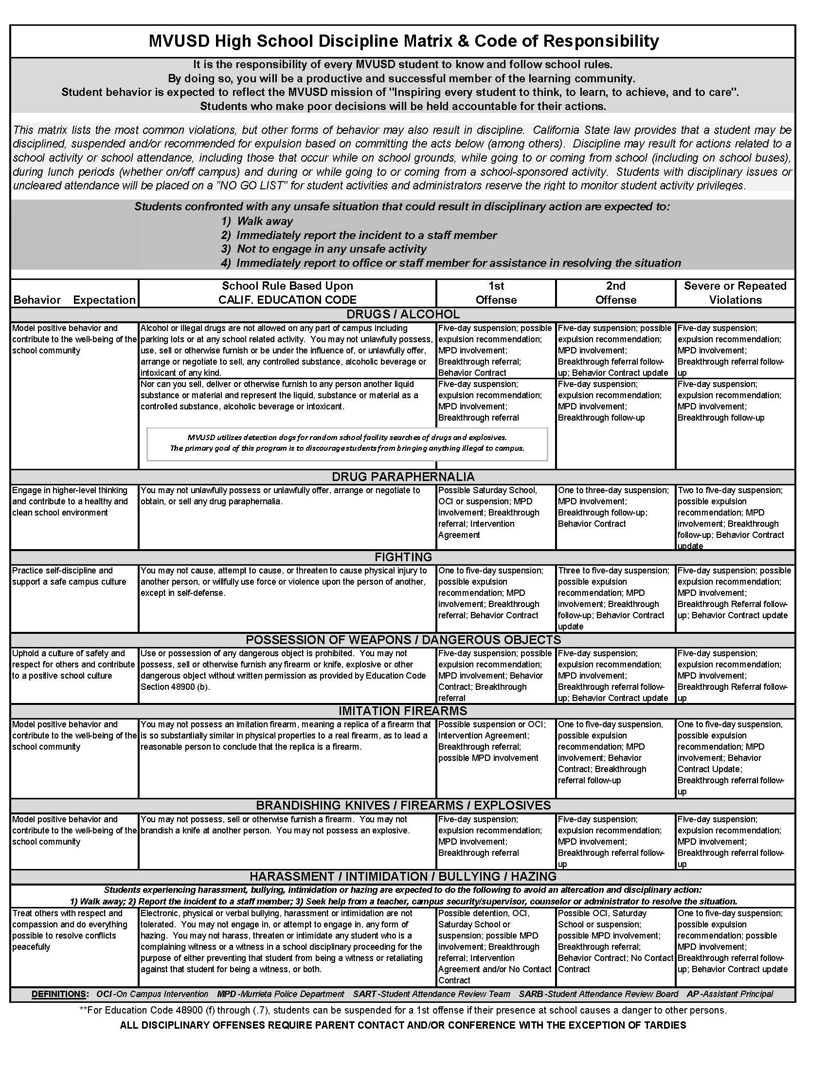
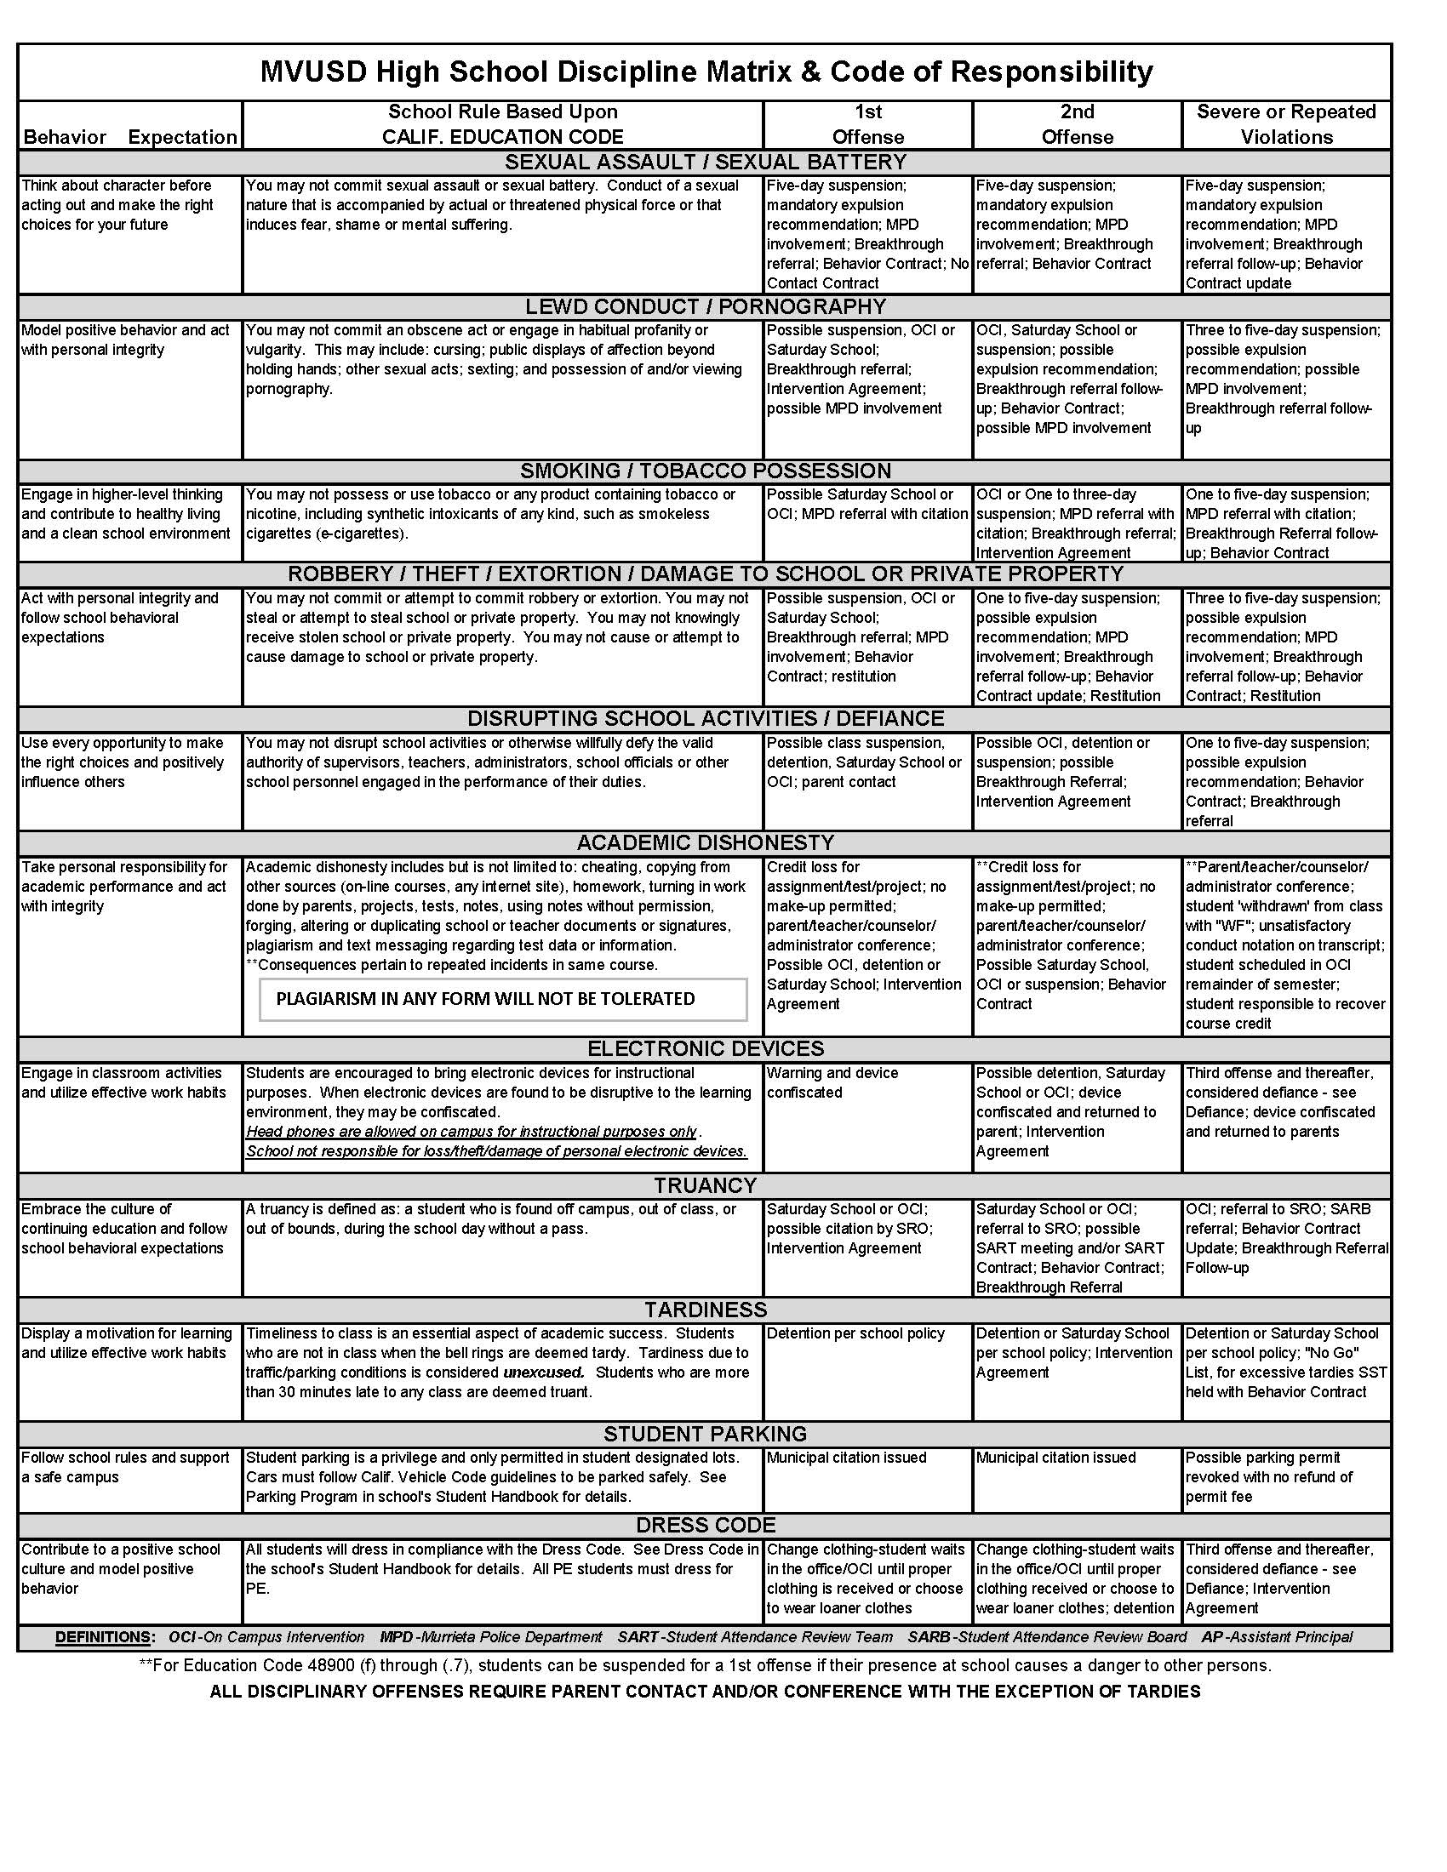
Definition of Bullying

- Bullying is exposing a person to abusive actions repeatedly over time and becomes a concern when hurtful or aggressive behavior toward an individual or group appears to be unprovoked, intentional, and (usually) repeated.

- Bullying is a form of violence which involves a real or perceived imbalance of power, with the more powerful child or group attacking those who are less powerful. Bullying may be physical (hitting, kicking, spitting, pushing), verbal (taunting, malicious teasing, name calling, threatening), or emotional (spreading rumors, manipulating social relationships, extorting, or intimidating).

- Bullying can include any severe or pervasive physical or verbal act or conduct, including: communications made in writing or by means of an electronic act, directed toward one or more students that has or can reasonably be predicted to have the effect of placing a reasonable student in fear of harm to himself/herself or his/her property; cause the student to experience a substantially detrimental effect on his/her physical or mental health; or cause the student to experience substantial interferences with his/her academic performance or ability to participate in or benefit from the services, activities, or privileges provided by a school.

- Bullying also includes one or more acts by a pupil or group of pupils directed against another pupil that constitutes sexual harassment, hate violence, or severe or pervasive intentional harassment, threats, or intimidation that is disruptive, causes disorder, and invades the rights of others by creating an intimidating or hostile educational environment, and includes acts that are committed personally or by means of an electronic act, as defined, that has any of the effects described above on a reasonable student.

- Electronic act means the transmission of a communication, including, but not limited to, a message, text, sound, image, or post on a social network Internet web site, by means of an electronic device, including, but not limited to, a telephone, wireless telephone, or other wireless communication device, computer, or pager. A post on a social network Internet web site shall include, but is not limited to, the posting or creation of a burn page or the creation of a credible impersonation or false profile for the purpose of causing a reasonable student any of the effects of bullying described above.

- Reasonable student means a student, including, but not limited to, a student who has been identified as a student with a disability, who exercises average care, skill, and judgment in conduct for a person of his/her age, or for a person of his/her age with his/her disability.

SEXUAL HARASSMENT

WHAT IS SEXUAL HARASSMENT?
- Any unwelcome sexual advances, requests for sexual favors or other verbal or physical conduct of a sexual nature.
- Uninvited behavior that makes being in the school offensive, negative, unfriendly and/or intimidating and leads to a hostile environment that makes learning difficult.
- “This for That/Something for Something Else” is another form of harassment. Examples: The manager at the fast food place in which you work says that you will be fired if you do not engage in certain behaviors with him/her; someone blocking the door and refusing to let you through unless you agree to certain behaviors.

FLIRTING VS. SEXUAL HARASSMENT

SEXUAL HARASSMENT
OFTEN GOES UNREPORTED.

REPORTING IS THE ONLY WAY
TO GET HELP.

Welcome behavior Un-welcome behavior
Positive feeling Negative feeling
Respectful Disrespectful
Fun Not fun
Flattering Unpleasant
Enjoyable Illegal

WHAT CAN BE DONE? TAKE ACTION!

BE ASSERTIVE: Tell the harasser to stop the behavior. Tell him or her aloud or in writing what behaviors you find offensive.

CALL FOR HELP: Ask for the help of someone you trust — your friends, parents or a person in authority. Tell them of your problem. Enlist friends as witnesses.

TAKE NOTES: Keep a detailed, written record of what was said and done to share with the person who investigates your complaint.

INFORM AUTHORITIES: Report offensive behaviors to a teacher, counselor or principal. Give details and provide witnesses. This action may stop the behavior.

FILE A REPORT/COMPLAINT: File a complaint against the person who is harassing you.

NEVER GIVE IN: If you are not satisfied with the results of your complaint, continue to take action and get help.

Sexual Harassment is based on impact to the victim, not the intentions of the perpetrator. If a student has been proven to have caused sexual harassment, he/she will be suspended and possibly recommended for expulsion.

SENIOR CONTRACT

I agree to abide by the items listed in this Senior Contract for the duration of my senior year, specifically as it relates to any and all senior activities, including commencement.

- Return or make payment for all library books, textbooks, equipment and athletic uniforms/equipment by Friday, May 29, 2015.

- Clear all outstanding discipline (detention and Saturday Schools), attendance issues, and financial debts in order to participate in ANY senior activities, including Winter Formal, Senior Prom and graduation ceremony.

- Abide by all school policies, rules and regulations as stated in VMHS student handbook at ALL SENIOR ACTIVITIES on and off campus and any other school sponsored activities, including Winter Formal and Prom. I realize that failure to comply with all school rules and policies will prevent my participation in graduation commencement and senior activities.

- Fulfill all graduation requirements including 230 credits in the required areas, pass the CAHSEE Math and Language Arts exams, complete and document 40 hours of community service by February 27, 2015, and complete the Senior Exit Interview requirements (Exit Interview Essay must be completed by 1st semester of Senior year, 6th-week progress report). Credit Recovery courses must be completed by the 12-week Progress Report date in order to be eligible for participation in senior activities. Satisfactory progress in all courses must be maintained to participate in senior activities. “F” grades on progress reports and semester grade reports as well as not completing credit recovery classes by the 12-week progress report will result in being placed on the NO-GO list for all school sponsored activities, including senior activities. I understand that under no exception will I be allowed to participate in the graduation ceremony or receive a diploma until all graduation requirements listed above, and outlined by the district, are met.

- Attend school on a regular basis. Truancies will affect my grade and place me at risk of not graduating. Truancies will result in being placed on the NO-GO list for all school sponsored activities, including senior activities and the graduation ceremony.

- Attend graduation practices. If I do not attend graduation practices, I know I will not be allowed to participate in the Class of 2015 Graduation Commencement in June 11, 2015.

- Understand that Senior pranks will not be tolerated, and if I participate in a Senior prank, I jeopardize the privilege of participating in Senior activities, including the graduation ceremony.

Each senior student must turn in a Senior Contract, signed by student and parent

to the Security Office by Friday, August 29, 2014
ATTENDANCE POLICIES

Call the Attendance Line: 894-5750
(24 hours – 7 days a week)
Press #1 for Attendance; Press #1 again to report an absence.

Expected Behavior Good attendance is a priority at VMHS and a key to academic success. Students are expected to be on time and prepared for each class. We need parent assistance in ensuring that this occurs, in following check-in/out procedures properly and reporting any absences in a timely manner.

Re-admittance Procedures and Calling in Absences Parents should call the attendance line (894-5750) on the day their student is absent. If a parent has not called, students should return to school after an absence with a signed note from a parent or guardian that includes the reason and date(s) of the absence. Students are considered truant if the parent has not called the Attendance Line or sent a note to school with the student at the time of readmission. It is important that all absences are cleared in a timely manner as California Education Code states that teachers do not have to give makeup work for unexcused absences. Parents: Please contact your student’s grade level Assistant Principal if your student will miss five or more days due to serious illness, hospitalization or injury.

To report an absence, please call the attendance line at 894-5750. Press 1 for attendance; wait for the prompt then press 1 to report an absence. This is a 24-hour number with full voicemail capacity. Please contact us on or before the day of your student’s absence and leave the following information: a) the student’s name (spell the last name), b) date of absence, c) reason for absence, d) your name and relationship to student, and e) a contact phone number.

Calling in an Off-Campus Pass for Student Drivers To assure your student’s safety and to eliminate forged notes, please call 894-5750, press 1 for attendance and wait for the prompt, then press the number based on the grade level to speak to an attendance clerk. Please call at least 1 hour PRIOR to the time the student is required to leave. You may also call the Attendance Line the previous day to leave the departure information. If you send a note with your student, you will be contacted by the attendance office to verify the note. If we are not able to contact you, the student will not be allowed to leave campus. Students are not allowed to leave with other student drivers during school hours.

Picking Up a Student Early Please come to the attendance window in the front office and present picture identification to the clerk and sign an Off-Campus Pass. Students will not be released to any individual not listed on the Emergency Card (filled out annually during registration), or you must make prior arrangements with the attendance office. Students will not be called out of class prior to the parent’s arrival. Please understand, if you wish to pick up your student after 2:00 pm, it may take longer due to staffing and dismissal procedures. If you need to take your student from a PE class, please call at least 1 hour prior to the time the student is required to leave; otherwise students will be called out of class when parent or guardian arrives. Please note that retrieving a student who is in PE without prior notice may take an extended amount of time.

Truancy Consequences Truancy is defined as; a “student to is found off campus or out of bounds during class time without a valid excuse or any student who is out of class later than ten minutes without a hall pass or readmit”. The consequences for truancy include, but are not limited to: Saturday School, On Campus Intervention (OCI), parent meetings, suspension, a referral to the School Resource Officer (SRO) for consult and/or citation and referral to the School Attendance Review Board (SARB). Visit the district website at www.murrieta.k12.ca.us under Parents, Child Welfare & Attendance – SARB for more information. Unverified Absences - The Murrieta Valley Unified School District Board of Education wishes to emphasize the importance of school attendance. Therefore, per Board Policy 5121, students in grades nine through twelve with excessive unverified absences (20 absences per semester) shall receive a failing grade and shall not receive credit for the class(es).

Tardiness and Tardy Consequences Timeliness to class is an essential aspect of academic success. Students who are not in class when the bell rings, are deemed tardy. Please provide a written excuse for each tardy, or phone the attendance office prior to arrival with the reason for the late arrival (illness, doctor appointment, or personal).
***Please note that traffic is not an excuse for tardiness. Students who are tardy to the first period of the day will be placed in a Tardy Sweep/OCI and/or receive after school detention from the OCI instructor (students in OCI during a Tardy Sweep may be called out by parent and sent to class). Students who are tardy to a period other than the first period of the day will be assigned After School Detention by campus security. Failure to attend detentions may result in Saturday School. Failure to attend Saturday School will result in a rescheduled Saturday School or sent to OCI for the day and/or home suspension. Administration monitors attendance in OCI and students with multiple visits in one week will receive a Saturday School as well. Continued concerns with tardiness will result in a parent meeting, OCI, Saturday School and possible suspension. Students with four or more tardies will be required to serve a Saturday School or be placed in a full-day of OCI to clear them from the attendance record. Failure to do so may result in the student being placed on the No-Go List for activities. Multiple written notes clearing unexcused tardies or absences may result in Saturday School.

Personal Business/Family Trips Students who miss school for pre-planned family trips or other personal business need to notify the office prior to the start of the absence. They must also notify each teacher in writing five school days in advance if they want to request work for the period of time they will be absent. These absences are unexcused according to state guidelines. It is the student’s responsibility to turn in makeup work on the day the student returns to school. Please note that makeup work completed during personal business/family trips may not coincide with class work and academic progress may be adversely impacted. We strongly recommend personal business/family trips be scheduled during breaks. Final exams will not be given early due to vacations or family trips. Students must prearrange pre-planned trips and make arrangements with the teacher to take the exam when the students return from the trip. In order to not compromise common examinations, early finals will only be given in extreme situations. See Final Policies for more information.

SCHOLASTIC INFORMATION

NEW REVISED SCHEDULE CHANGE POLICY To support academic success, our goal is to have all students in appropriate classes as quickly as possible. Schedule changes will only be considered for the following criteria:
- An incomplete schedule
- Course already completed
- Scheduled into a duplicate class
- Prerequisite not met (includes level changes based upon prior academic performance)
- Movement of Early Release or Late Start period
- Missing graduation requirement
- Course level placement issue

Fall semester requests for schedule changes will not be accepted after the 5th day of the semester and must be submitted to the appropriate counselor on the CLASS CHANGE REQUEST FORM no later than August 19th. Form must have a parent/guardian signature.

Midyear requests for schedule changes will not be accepted after the 5th day of the semester and must be submitted to the appropriate counselor on the CLASS CHANGE REQUEST FORM no later than January 19th. Form must have a parent/guardian signature.

Fall 2015 Schedule adjustments: Schedule adjustments for the next school year must be completed the week of May 11th through May 15th 2015. Class Change Request Forms will not be accepted outside of these dates and must be submitted to the appropriate counselor on the CLASS CHANGE REQUEST FORM with parent/guardian signature.

Important Change in A-G Course Work Schedule Drops or Level Changes:
All students are expected to complete the A-G College and Career Readiness Path at VMHS. If you are experiencing challenges in your coursework and are considering a schedule change, be advised the following steps must be taken to level change or drop an A-G Course:
- Meet with your counselor to:
  - Address accurate placement
  - Review Academic Indicators for Success
  - Review Gradebook Summary in particular class
  - Get Counselor Recommendation for next steps
- Parent Teacher Conference
- Mandatory Intervention: Attend Broncotorials
- Assistant Principal Approval for Course Change

WITHDRAWAL FROM CLASS A student who drops a course during the first six weeks of the semester may do so without any entry on his/her permanent record. The student must continue to be enrolled in required courses for graduation and the required number of instructional minutes per day. A student who drops a course after the first six weeks of the semester shall receive a W/F grade on his/her permanent record, unless otherwise decided by the principal or designee because of extenuating circumstances.

REQUEST FOR TEACHER CHANGE At VMHS, we believe it is in the best interest of the student to work through any difficulties that may arise in the teacher-student relationship. We realize that the rigor of high school coursework places additional demands upon our students and that they may become frustrated or despondent regarding their classroom performance. When these situations present themselves, students and parents must schedule a meeting with the teacher of the class in question and counselor (if needed). If the problem has not been satisfactorily addressed after meeting with the teacher, please contact the appropriate Counselor or Assistant Principal.

GRADING SYSTEM Most courses at VMHS are taught on a semester basis and are worth five credits per class per semester. Grades are computed on a four point scale where:
A = 4 pts. B = 3 pts. C = 2 pts. D = 1 pt. F= 0 pts.

The Advanced Placement classes taken during the Junior or Senior year use a five point grading scale where:
A = 5 pts. B = 4 pts. C = 3 pts. D = 1 pt. F = 0 pts.

Dual Enrollment: Please refer to the Dual Enrollment handbook available on the VMHS website at www.vmhs.net

Six-week, twelve-week and semester grades are available on student and parent ABI approximately one week after grades are submitted. Refer to ABC Bell Schedule in handbook for grading periods. Students without computer access can request a printed grade report in East Hall Guidance Office. Weekly and daily progress report forms are available for students in East and West Hall Guidance Office.

HOMEWORK & FINALS POLICIES

HOMEWORK Homework philosophy is relevant and directly related to course objectives. The purpose of homework is one of the five examples listed below:

Introductory Homework Introduce a new concept of information to be used later in class
Learning Homework An assignment that adds to a student’s knowledge base that can be done independently
Reinforcing Homework An assignment that strengthens a student’s knowledge base
Assessment Homework An assignment to be graded that then helps guide instruction
Performance Homework An assignment designed to allow the student an opportunity to demonstrate
understanding and learning

Although the Murrieta Valley Unified School District recognizes that quality is more important than quantity, the following guideline is suggested in our Board Policy: Grades 9-12 may have 75 – 120 minutes of homework up to four days per week. It should be noted that in grades 7 – 12, the homework time may vary according to type and number of subjects a student is taking. AP and Dual Enrollment courses may also require homework/reading beyond the four days per week. Many times AP exams are given in the time period immediately following spring break, which would require students to study and prepare during spring break.

Make-up Homework Policy: When a student is absent from school, it is his/her responsibility to contact teachers upon returning to school regarding make-up work. (The teacher may also be contacted via email or telephone. The student may also refer to the assignment sheet prior to returning to school to get homework assignments.) The time allotted for making up missed work will vary depending on the circumstances surrounding the absence, the actual time out of school, and the teacher’s classroom policy. Each student will make arrangements with his/her teachers for turning in this work. If a student is absent for three (3) days or more, the parent should call and request the work. Teachers will be given a 24 hour notice to provide make up work.

The make-up policy for missing assignments when a student is not absent is at the discretion of the individual teacher. Please read individual teacher guidelines for their specific homework policy. Some teachers, although not all, accept late work which may be turned in during the unit/chapter of study or within a specific time period with a penalty such as a reduced grade based upon the lateness of the assignment. Assignments may be corrected/resubmitted at the discretion of the teacher. Students are encouraged to correct/resubmit assignments when the opportunity arises.

FINALS POLICIES Each semester ends with a final exam or culminating activity in each subject area. These exams are usually scheduled for the last 3-4 days of the semester. Final exam grades do not become semester grades, but are usually an important component of that semester grade. Make up exams are permitted for excused absences only. Final exams are to be taken on the day scheduled (see the current school calendar for scheduled dates). On the rare occasion that a final needs to be taken early, it must have the approval of Vista Murrieta High School Administration, i.e., the student is moving to another state and it is not feasible to take the final at the appointed time or due to acute medical conditions. The expectation is that all students take their final exams on the dates scheduled by district/school administration.

ACTIVITIES & CLUBS

Welcome Broncos! A successful school culture and climate is defined by spirit, enthusiasm and participation. This is what makes Vista Murrieta a special place! We were twice chosen Max Preps Most Spirited High School in the Nation for a reason! Our goal is to reach out to each and every student. There are numerous opportunities to be part of Vista Murrieta High School; think clubs, teams and organizations! VMHS leadership programs include but are not limited to, ASB/Senate, Band, Dance, Link Crew, PLUS, Renaissance and JROTC. We want you to be an active member of this campus. Our elected officers and student senators are a group of leaders whose goal is to provide quality service with genuine hospitality. Our student led school events strive to show we care passionately about the welfare of each student academically and socially. The activities office is located behind the gym on the Quad and you are always welcome to stop by our offices to find out about upcoming events, get class ring order packets, purchase tickets for events or find out information about clubs or organizations. We also have the “Trading Post”, our student store, where we offer Bronco spirit items such as sweatshirts, t-shirts, hats, school supplies, snack items and more. The tradition continues!

BRONCO PRIDE

Mr. Nguyen - Activities Director

ASB CARDS ASB Cards are the main source of income for our campus activities, recognition programs and athletic events. The ASB Card is an identification card and provides a variety of discounts for Vista Murrieta High School students:
1. Free admission to all home athletic events (CIF Playoffs and tournaments are excluded).
2. A discount at social events, dances and cultural events.
3. A discount on your yearbook and/or video yearbook when purchased at registration and discounts at businesses in the community.

The ASB Card is priced at $36. Activities supported by ASB Cards are: social events, academic recognition programs, athletic recognition programs, cultural programs, assemblies, publications such as the yearbook and newspaper and academic clubs and organizations. An ASB Card saves money on tickets and purchase of many items such as dances, yearbooks and recognition letters for jackets and you get FREE admission to football and basketball home games. There is an $11 replacement charge for lost or damaged I.D. or ASB/I.D. Cards. Students who wish to hold a school office or who are on Homecoming, Winter or Prom Courts need to have a current ASB Card.

GENERAL POLICY FOR SCHOOL-SPONSORED EVENTS
1. Administrators and faculty members have full authority to admit, refuse admission to, or dismiss any student /guest from any event.
2. All VMHS students bringing a guest to VMHS events are responsible for their guest’s conduct.
3. Participants at events are to be courteous, friendly, and polite. School regulations apply to students and visitors at all times during the event.
4. All events will be scheduled at the discretion of the Principal, Activities Director, and Student Government.
5. At all events, all students will be asked to present a Student ID card at the ticket office and at the entrance door.
6. Guests at formal school dances will be required to obtain a guest pass before the dance and present a photo ID and the guest pass at the entrance door. Guest passes are due at the Activities Office forty-eight hours before the scheduled event. No guest passes will be issued at the time of a dance. Vista Murrieta High School students should bring their I.D. card when attending school dances and activities.
7. Students are not to loiter on or near campus after school events. At events at other sites, the same rule applies.
8. Students or guests who do not display appropriate behavior at a school event will be required to leave. Parents will be contacted and required to pick up their student immediately. Until such time as they arrive, the student or guest will remain with the administrator in charge.
9. Any student placed on home or in-school suspension by an administrator may not attend or participate in school events for the duration of the suspension.
10.Any student removed from an event due to poor behavior will not receive a refund if a ticket purchase was required for entry.
11.Students are responsible for keeping their academic and behavioral records in good order. If any of the conditions exist listed below, a student will be put on the No-Go List for 6 weeks and will be unable to attend school dances, assemblies and school events:

- Outstanding fines/fees due (clubs, library, athletics, parking) • Overdue library or text books
- Attendance issues (cuts, tardies, truancies, unverified absences) • No-show to Saturday school/s
- Discipline issues, no-show to Saturday School/s • No-show to detention/s
- Inappropriate dancing, No-Go List for next dance • GPA below 2.0
- Suspensions
- SENIORS ONLY: Less than 40 Community Service Hours turned in by 2/28/13 (must be cleared by counselor)
- SENIORS ONLY: Any class grade that is a D or F (must be cleared by counselor)
- SENIORS ONLY: Any Senior Contract violation

PERFORMANCE GROUPS
•Marching Band •Jazz Band •Wind Ensemble •Drum line •Color Guard •Drama •Dance Team
•Concert Choir •Advanced Chorale •Chamber Choir •Synchronize Vocal Jazz •Cheerleading

CLUBS/ORGANIZATIONS Vista Murrieta High School offers a large variety of clubs on campus – over 63! A Club Rush (an information day) is held during the first semester of each year in the Quad where you can meet members and sign up if you are interested. New clubs may be formed at any time if they meet school and District guidelines. Contact the Activities Director or a member of the ASB cabinet if you wish to start a new club. Clubs must have an employee advisor as the sponsor and meet during lunches or before/after school. Meeting dates and activities are included in daily newscasts and newsletters. For details about currently active clubs, view details on the VMHS website at www.vmhs.net.

ACADEMIC ELIGIBILITY All students involved in co-curricular activities must pass minimum of 4 classes and earn a 2.0 (C-average) minimum GPA. A student who falls below the 2.0 GPA will become ineligible for participation and put on the No-Go List until the next grading period. You must be cleared from the No-Go List to attend dances. When the student achieves a 2.0 or above again, they will become eligible. Grades leaving 8th grade determine initial eligibility. Eligibility is determined every 6 weeks.

BRONCO DANCES Several school dances are held during the school year, some dances follow athletic events, while others are for an entire evening such as the Winter Formal, a semi formal dance open to all VMHS students. Students must have I.D. cards to attend any school dance. Students must attend school on the day they attend a dance. The cost of dances varies with the length of the dance, and in most cases, ASB cardholders enjoy a savings. When your date for the semiformal/formal dance is not a student of Vista Murrieta High School, you must obtain a guest pass from the Activities Director and a signed approval form from an administrator.

REMINDER: All Vista Murrieta High School students are responsible for the actions and behavior of their guests. All guests must be a high school student or under the age of 21. A student who leaves the dance may not return. VMHS ADMINISTRATION has the right to refuse any guest pass.

The Bronco Dance Policy positively impacts student behavior and addresses safety issues at school and district-wide dances by clearly describing dance rules/regulations and the consequences for rule violation. This policy ensures consistency across MVUSD high school sites for the handling of consequences for inappropriate dance behavior and will eliminate/reduce disruption of dance activities as a result of the actions of some students.

Student dancing occurs which may be deemed appropriate by some for an adult night club, but which is not appropriate for a high school dance. To prevent inappropriate dancing and ensure student safety, students will be expected to understand the dance rules required of all students and to sign the Dance Policy portion of the Acceptable Use contract during registration each year. Please review and familiarize yourself with the following dance policy.

BRONCO DANCE POLICY & BEHAVIOR RULES

Must be Standing Up
- No laying on the floor
- No dancing/standing/moving on all four legs/arms
- Both feet must be on the ground; break dancing is excluded from this rule

No Groping or Inappropriate Touching
- No touching someone below the waist
- Touching the waist is ok

No Bending Over
- No bending in a 90˚ angle, no hands on the floor, no head below the waist

No Hurting Others (dancing that could potentially hurt others)
- No jumping on other people
- No mosh pits

Student Informational Assemblies/Activities will occur at the beginning of each school year to ensure that all students understand the dance rules and consequences and the process required to participate in school-sponsored dances.

ASB Cards may be used for discounts for purchase of advance dance tickets.

Violation of Dance Rules will result in student removal from the dance and notification of the parent. Repeat violations, which are considered defiance, at subsequent dances (3rd time violators) will result in the loss of privilege to attend school-sponsored dances for the remainder of the current school year.

Regular Reviews of Dance Rules/Regulations by administration will occur through meetings during the school year with input from students, staff, and/or the community.

ACADEMIC ORGANIZATIONS

CALIFORNIA SCHOLARSHIP FEDERATION The California Scholarship Federation or CSF is a prestigious academic organization that is exclusive to the state of California. Its purpose is to foster high standards of scholarship, leadership, service and citizenship. The basic requirements for student members are to maintain a 3.5 academic GPA and at least satisfactory citizenship grade. Students apply on a semester by semester basis, completing the required update of the membership form which evaluates coursework and grades to determine eligibility. The peer tutoring program, community-based service projects, and fundraising events become the focus of each semester’s program. The organization meets every other week on Friday mornings.

Beginning with the second semester of the 9th grade, a student with a 3.5 academic GPA or higher may apply for membership in CSF. Once an application has been approved, the student is expected to attend regular meetings and participate in scheduled service/fundraising projects. Active members who maintain membership for four of five potential semesters are considered “life members” and are provided with a special cord for graduation, an embossed gold seal on diplomas and eligibility for regional scholarships provided specifically for CSF members. Each year the VMHS chapter of CSF provides a scholarship for eligible CSF seniors who exemplify the best in the four areas of scholarship, leadership, service and citizenship.

NATIONAL HONOR SOCIETY The National Honor Society is the nations’ premier organization established to recognize outstanding students. More than just an honor roll, NHS serves to honor those who have demonstrated excellence in the areas of scholarship, leadership, service and character. Membership in NHS also challenges students to further develop skills through active involvement in school activities and community service.

Tenth and eleventh grade students with an academic GPA of 4.0 or higher will be invited once a year, in the fall, to pick up and complete an NHS application for membership consideration. Surveys are then read and evaluated by an NHS Faculty Council to determine if the student meets the rigorous criteria in the areas of scholarship, leadership, service and character. Once a member, students are required to maintain a minimum academic GPA of 4.0, to attend all meetings of the organization, to provide evidence of individual community service and whole group community service, to engage in fundraising, and to pay annual membership fees. Each year the VMHS Chapter of NHS provides a scholarship for one or more members who exemplify the best in the four areas of scholarship, leadership, service, and character. Graduating NHS members will also receive special cords for graduation in recognition of their dedication as an NHS member, and a seal on their diploma reflecting NHS membership.

TUTORING

LATE START TUTORING Free tutoring is available before school on late start Mondays in the library from 7:30-8:30am. Tutoring is available in all core subjects by VMHS National Honor Society and California Scholarship Federation students.

BRONCOTORIALS All students with grades D or F in an academic core class will be expected to attend Broncotorials Saturdays from 8am until 12pm. They will have the opportunity to meet with teachers and academic tutors. These will be offered seven times throughout the course of the school year.

STUDENT LEADERSHIP 2014-15

ASB President...........................................................................................................................................................John Bennett
ASB Vice President.........................................................................................................................................................Jet Lewis
Secretary of Senate……………………………………………………………………………………………………….Kendall Whitney
ASB Secretary..................................................................................................................................................Michaela Reynolds
ASB Treasurer.........................................................................................................................................................Ava Lammers
Commissioner of Clubs/Fundraising.........................................................................................Jessica Ramirez & Jeweliet Fuller
Commissioner of Publicity........................................................................................................Fares Abdullah & Madison Nunley
Commissioner of Cultural Awareness.......................................................................................Ben Vanderhyden & Trung Duong
Commissioners of Activities........................................................................................Elise Benner, Alex Cha & Hunter Twamley
Commissioner of Academics.................................................................................................................Mikelle Morris & Minji Kim
Commissioner of Fine Arts.................................................................................................................Alex Noble & Kaela Serrano
Commissioners of Program Services.........................................................................................................................Casey Jones
Commissioner of Men’s Athletics..................................................................................................................................Ravi Alston
Commissioner of Women’s Athletics..................................................................................................................................Alli Kim
School Board Representative...................................................................................................................................Michael White
City Council Representative........................................................................................................................................Ariana Pena
Commissioner of Staff Relations...........................................................................Nasrean Nael, Brittany Reed & Tiera Shedeed
Commissioners of Recognition......................................................................................................Kade Klarich & Kilee Reynolds
IRS………………………………………………………………………………………………………Kaitlynd Majeske & Jacob Pickell
Historians........................................................................................................................Cristina Castro & Kianna Oscala Bouttry
Commissioner of Community Service ………………………………………………………….Delaina Castillo & Cheylin Salcido Commissioners of Pep.................................................................................Aydan Bowers, Christian Francisco & Megan Dimler
Commissioner of Environmental Concerns.....................................................................Keale Kaolulo Sauer & Sofia Steckdaub Commissioners of Dances..........................................................................................Katie Chapman, Zoe Cocker & Wanny Mei
Commissioners of Unity.......................................................................................Taylor Daniel, Morgan Furlong & Erin McCrann
Commissioner of Care...............................................................................................................Sierra Contreras & Wendy Arroyo
Commissioner of Web Programming.......................................................................................................................Dewald Maree
Parliamentarian.....................................................................................................................................................Cameryn Idema

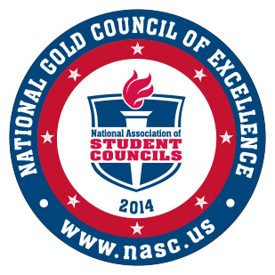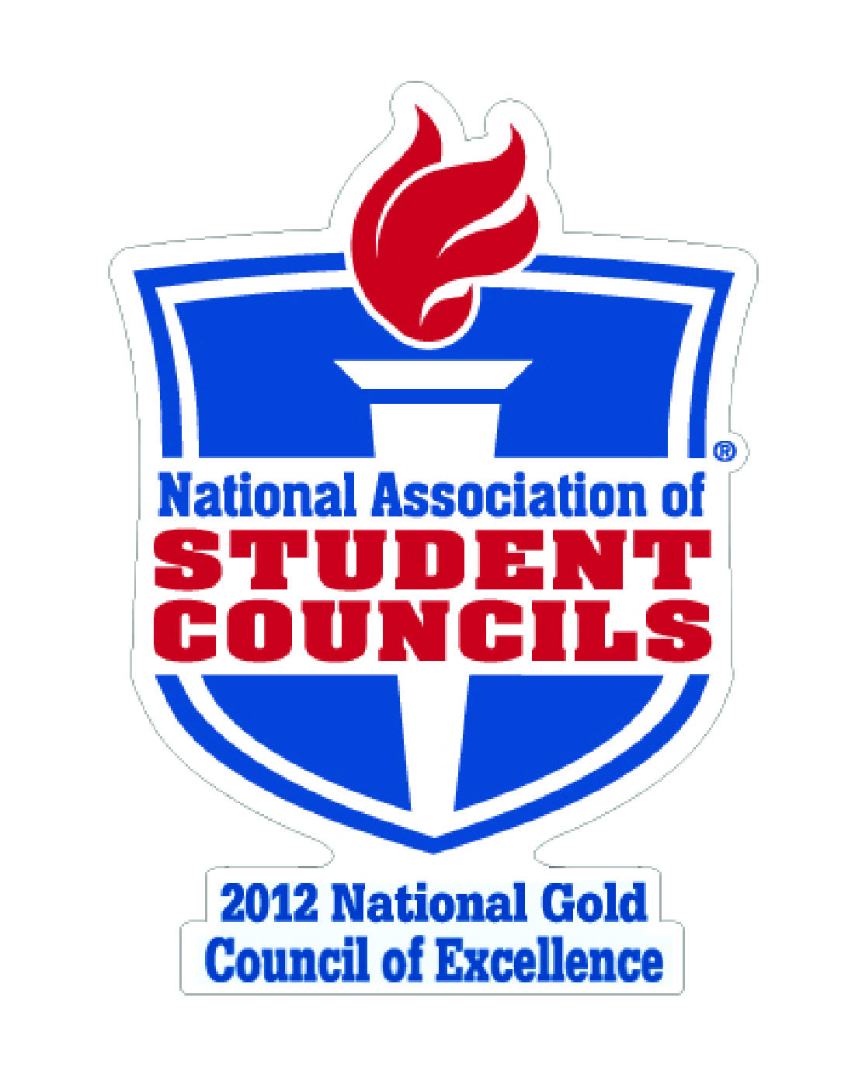
OUTSTANDING ACTIVITIES PROGRAM AWARDS 2005-2014

CLASS OF 2015 ~ SENIOR CLASS OFFICERS

Advisors: Mrs. Melinda Howard
President.....................................................................................................................................................................Amie Garcia
Vice President............................................................................................................................................................Jared Rivera
Secretary/Treasurer................................................................................................................................................Jake Schaeffer

CLASS OF 2016 ~ JUNIOR CLASS OFFICERS

Advisors: Mrs. Janell Cox & Mrs. Rebecca Lane
President........................................................................................................................................................................Inna Yang
Vice President.....................................................................................................................................................Samuel Mountain
Secretary/Treasurer...................................................................................................................................................Sofia Serafin

CLASS OF 2017 ~ SOPHOMORE CLASS OFFICERS

Advisors: Mrs. Ashley Davis & Mr. Michael Papciak
President.................................................................................................................................................................D’Andre Smith
Vice President...........................................................................................................................................................Victoria Paller
Secretary/Treasurer ................................................................................................................................................ Justin Vickers

CLASS OF 2018 ~ FRESHMAN CLASS OFFICERS

Advisors: Mrs. Leticia Ochoa & Ms. Kaylyn Yup
Freshman Elections September 11 & 12 – Officer TBA

P.E. / ATHLETICS
P.E. CLOTHING Success for a physical education student begins with attendance and preparation for class. All students are expected to “dress out” each class meeting in appropriate clothing. Clothing utilized must be different than that worn to a classroom for hygienic and movement purposes. A student’s choice in a PE uniform must take into account the environmental conditions as well as lesson for the day. PE specific clothing or “uniforms” consisting of a grey VMHS T-shirt ($15) and navy gym shorts ($15) can be purchased from the school bookkeeper (see box below) and then obtained from the physical education staff. Appropriate student footwear includes shoes and socks and must be closed toed, non-marring, laced, rubber soled athletic type shoes. UGG boots or work type boots are not athletic shoes. Dress or casual pants, jeans, jackets and flannels are not allowed. Nonsuited students will be sent to the security office for appropriate discipline and possible Saturday school assignment. Students may wear VMHS sweats (bought through the bookkeeper) on inclement weather days. All other sweats must be of a single color; navy, black, gray or white, and may not be cutoffs or have any lettering or design other than VMHS logos/designs. Navy blue sweatpants ($18) and hooded matching sweatshirts ($30) are available for purchase through the bookkeeper. Waterproof backpacks can be purchased for $17 or save $8 when you buy a PE package for $45 (Includes PE shorts, shirt, lock and backpack). Appropriate aquatic attire will be expected for any class utilizing the pool, as well as dance classes (individual teachers will cover these specific requirements). The PE staff will not accept half-shirts, torn or altered shirts or inappropriate sized tops. Students name should be permanently written on all clothing to help prevent theft/loss. Borrowing or sharing uniforms is prohibited. Head wear or hoods are allowed when worn appropriately for sun protection or from extreme cold/wet weather. A limited supply of clean loaner clothes is available on a single period basis for students with a picture ID. Please see your coach for assistance with loaners or any economic concerns regarding PE clothing. All school dress code expectations are applicable in PE also.
P.E. attire may be purchased from bookkeepers at break/lunches (no personal checks accepted)
or from the VMHS website www.vmhs.net at the Trading Post On-Line
LOCKS/LOCKERS P.E. students may choose to be assigned a small locker when a lock is purchased from bookkeeper ($6) to store P.E. clothing and personal items during the semester. Each student is responsible for transferring and securing their own belongings. Sharing of locks/lockers is not allowed and students should not give their combination to others for any reason. Larger street lockers are available for a single period only for storage of backpacks and street clothes. These lockers must be cleared out at the end of the period for utilization by the next period classes. Items that won’t fit in the street lockers such as band instruments can be placed in the coaches’ office for the period with permission. Unfortunately, theft is a reality and students must purchase a lock in order to utilize the VMHS locker room and lockers. The PE staff has the ability to quickly retrieve items from lockers in case of injury or for security reasons with master keys cut for these locks. Assigned lockers are the property of VMHS and are on loan to students. Each student assumes the responsibility for the care and security of his/her assigned locker. Only VMHS locks, purchased through VMHS can be used if a student chooses to utilize the locker rooms. The PE staff reserves the right to remove by key or cutting device unauthorized locks not being used in compliance with school policies. The school accepts no liability for lost and or stolen clothing or belongings. Students are responsible daily for locking their belongings. Taking home clothing to wash will be encouraged! The locker room is a privilege not a right.
ATHLETIC PROGRAM ELIGIBILITY REQUIREMENTS
To participate in competitive athletics at Vista Murrieta High School a student must:
1. Have earned a minimum 2.0 or “C” grade point average on a 4.0 scale. (See Board Policy 6145 A&B) Students first entering high school from the eighth grade and not meeting initial eligibility requirements due to a grade point average below 2.0 will be allowed one probationary period to remain eligible to participate in interscholastic athletics. The probationary period shall not exceed the Fall progress report period or be allowed for any other time other than the period from the start of the school year to the first 30-day progress report.
2. Complete the following paperwork (forms are available on school website on Athletics page under forms):
a. Physical completed by a doctor
b. Consent/Release form
c. Insurance policy/group/ID number (all athletes are required to possess insurance)
SPORTS PHYSICALS
A physical examination is required by CIF for each student prior to the beginning of the school year. Any student planning to participate in a sport (including spirit groups) must have a sports physical. The athletic department will notify students/parents in the spring regarding athletic physical clinics for the coming year being held at Vista Murrieta.

PARENT NIGHT SPORT MEETING DATES
All sports will have a pre-season Parent Meeting that will be publicized in advance.

SOUTHWESTERN LEAGUE TEAMS AND TRAVEL DIRECTIONS:
Chaparral Pumas: 27215 Nicholas Rd, Temecula. 15 south, exit Winchester Rd, east to Nicholas Rd, left to school.
Great Oak Wolfpack: 32555 Deer Hollow, Temecula. 15 south, exit Hwy 79, south toward Indio, turn right on Pechanga Parkway, left on Deer Hollow.
Murrieta Mesa Rams: 24801 Monroe Ave, Murrieta. Exit 15 Cal Oaks, go east to Monroe, and turn right to school.
Murrieta Valley Nighthawks: 24105 Washington Ave, Murrieta. West on Clinton Keith Rd, left on Palomar (turns into Washington), right on Nighthawk Way to school entrance.
Temecula Valley Bears: 31555 Rancho Vista Rd, Temecula. 15 south to Rancho California Rd, left on Rancho California, right on Ynez, left on Rancho Vista.
FALL
August-November
Football
Girls’ Volleyball
Co-ed Cross Country
Girls’ Golf
Girls’ Tennis
Boys’ Water Polo
WINTER
November-February
Boys’ Basketball
Girls’ Basketball
Girls’ Water Polo
Boys’ Soccer
Girls’ Soccer
Wrestling
SPRING
February-March
Softball
Baseball
Co-ed Track&Field
Boys’ Tennis
Boys’ Golf
Co-ed Swimming

GRADUATION REQUIREMENTS

MVUSD/VMHS GRADUATION REQUIREMENTS

To earn a high school diploma from Vista Murrieta High School, a student must complete 230 credits including: 3 years (30 credits) of math, 4 years (40 credits) of English, 3 years (30 credits) of science and 50 elective credits. Additionally, a student must successfully complete: 40 hours of community service from a non-profit organization, pass both the English and math sections of the CAHSEE and complete the Senior Exit Interview.

- Successfully complete a minimum of 230 semester credits within the specific requirements indicated below:

- ENGLISH 4 years 40 SEMESTER CREDITS

- MATHEMATICS 3 years 30 SEMESTER CREDITS
Full year of Algebra I – Required

- SCIENCE 3 years
Physical Science - Required 10 SEMESTER CREDITS
Life Science - Required 10 SEMESTER CREDITS
Additional Science Course 10 SEMESTER CREDITS

d. SOCIAL SCIENCE 3 years
Modern World History 10 SEMESTER CREDITS
U.S. History 10 SEMESTER CREDITS
U.S. Government/Economics 10 SEMESTER CREDITS

e. VISUAL & PERFORMING ARTS 1 year 10 SEMESTER CREDITS

f. WORLD LANGUAGE 1 year 10 SEMESTER CREDITS

g. PHYSICAL EDUCATION
PE 9 is mandatory 2 years 20 SEMESTER CREDITS

h. HEALTH 1 sem 5 SEMESTER CREDITS

i. CAREERS & INTRODUCTION
TO COMPUTERS 1 sem 5 SEMESTER CREDITS

j. GENERAL ELECTIVES 50 SEMESTER CREDITS

3. Successfully complete 40 hours of community service (volunteer work) in any combination of approved community service projects/programs for any non-profit organization/s.

4. Successfully complete competency in writing, mathematics and reading according to the California High School Exit Exam and be able to pass both the CAHSEE English and math tests.

5. Successfully complete the Senior Exit Interview, which includes:

- A reflective written essay (completed Spring of Junior year)
- A problem-based senior project
- An oral presentation before a panel

CALIFORNIA HIGH SCHOOL EXIT EXAM (CAHSEE)

All students must pass the California High School Exit Exam (CAHSEE). The primary purpose of the CAHSEE, which is mandated by state law, is to ensure that students who graduate from high school can demonstrate grade-level competency in the state’s academic content standards for reading, writing and mathematics. Students must satisfy the CAHSEE requirement, as well as meet all other state and local requirements, to earn a high school diploma.
The CAHSEE is divided into two parts: (1) English-language arts, which includes reading and writing and (2) mathematics. All questions on the exam are aligned to California content standards adopted by the State Board of Education. Content standards describe what students should know and be able to do at each grade level from kindergarten through grade twelve. Students must earn a score of 380 or higher on each part of the CAHSEE (English-language arts and mathematics) to be proficient. Students do not need to pass both parts of the exam during the same administration in order to satisfy the CAHSEE requirement.

For further information about the CAHSEE contact a counselor. CAHSEE information is also available on the California Department of Education’s web site at http://www.cde.ca.gov/ta/tg/hs.

SENIOR EXIT INTERVIEW

The Senior Exit Interview is a graduation requirement established by the Murrieta Valley Unified School District which began with the graduating Class of 2013. Students obtaining a diploma shall successfully complete a presentation on personal career/life goals. This presentation emphasizes the student’s potential contribution for an ever-changing world after graduation, which will help reveal how the student will be a vital asset to the chosen area of interest. The presentation will exhibit the student’s creative ability, critical thinking and communication skills, while demonstrating a clear understanding of the essential activities needed to achieve the career/ life goals. The Senior Exit Interview process includes: a written reflective essay; a problem based senior project - a presentation that reveals their passion and goals; and a culminating oral presentation that reflects the student’s high school experiences, academic growth, passion, community service learning, level of preparation for success in the 21st century, and the student’s plans for the future. Students who do not receive a successful evaluation will be given the opportunity to revise and present again, prior to graduation. If the student does not meet the Exit Interview requirement, he/she will not graduate.

COMMUNITY SERVICE GRADUATION REQUIREMENT

A component of the high school graduation requirements adopted by the Murrieta Valley Unified School District is that every graduate complete forty (40) hours of community service. Community service must be for nonprofit organizations (501(c)3 tax status) – no babysitting or lawn mowing allowed. Below is a partial listing of options students may consider to satisfy this requirement. Current local opportunities are listed in regular email newsletters, as well as in the College & Career Center and announced on the daily news video BNN. If you have questions regarding community service hours, please contact your counselor or visit the College & Career Center. Log sheets are available in East/West Hall Student Support offices and at the Reception Desk and must be signed for all hours completed. Log sheet can also be downloaded from school website from College Career Center page under forms.

Alternatives to Domestic Violence
American Red Cross
Assistance League of Temecula
A.R.K. Animal Rescue Kompany
Boys and Girls Club
California Army National Guard
Child Development Center, Avaxat ES
City of Temecula
Community Food Pantry/Thrift Store
Habitat for Humanity
Local Elementary Schools
Monte Vista Elementary School
Murrieta Chamber of Commerce
Murrieta Little League

Murrieta Chamber of Commerce
Murrieta Little League
Murrieta Public Library
Murrieta Valley Unified School District
MVUSD Family Services
Saint Thomas Thrift Shop
Santa Margarita Ecological Reserve
Senior Center of Murrieta (Mary Phillips)
Susan G. Komen for the Cure
Temecula Valley Womens’ Club
Tovashal Elementary School
Valley Restart Homeless Shelter

ALTERNATIVE CREDITS
Students may earn alternative credits toward graduation via non-Dual Enrollment college credits while still attending high school (Ed. Code 48800). The following three criteria must be met to earn these credits:

1. The course subject is included in the high school course of study or is approved by the high school Counselor.
2. The student must be in good academic standing at the high school with a minimum 3.0 GPA for academic courses, and a minimum 2.0 GPA for trade/vocational courses.
3. The student applies in writing for the credit. The student must complete the community college/school/parent agreement and turn it in to their Counselor, which also requires the Principal’s approval/signature.
4. District board policy limits the amount of alternative credits a student may earn.

POST-HIGH SCHOOL PLANNING
The VMHS counseling team offers a comprehensive guidance program addressing academic and career planning components. In conjunction our College and Career Center and Guidance Technician, we have developed a purposeful agenda throughout the school year for each grade level. Systematically, students meet with their counselors at least twice each year developing their academic plan with a view towards post-secondary ambitions and possible pathways. Our website includes a Counseling Section which addresses each year’s tasks and resources to assist them in planning during and after high school. This guidance process includes each student taking the ICT (Career/college) course their freshman year. We seek to amplify their pathway vision by providing a variety of presentations, fairs, workshops, post -secondary planning, and counselor facilitated labs. Students are given tools which offer select web links and resources encouraging our students to investigate: College majors, AA/AS degree programs, Career Certificate programs, college and community college searches, Vocational School, Art Institutes, Apprenticeships, and the Military.

Aligned with the national career development organizations and the nation’s top university models, we assist and encourage our students to learn about themselves and their developing strengths and values through career assessments, and expand their ability to explore the world of work by investigating career pathways in depth, matching education to career, and formulating career plans. There are many methods available to investigate occupations, their trends and related industries with the latest versions of software, and a multitude of resourceful websites. Our calendar of activities for each grade level includes those listed below.

Keep up-to-date on parent and student events which will provide you with essential information regarding post-high school planning and important dates by: checking the website at www.vmhs.net, listening to the morning announcements on BNN, checking the Quad Marquee and reviewing the school email newsletter.

Seniors
Senior/Junior Night (September)
NCAA (September)
College Placement Exams-SAT, ACT (Fall)
Transcript & Senior Timeline Reviews (Early Fall semester)
Matching Career and College Major Workshops (Fall)
UC, CSU, Independent California Colleges & Out of State Colleges Workshops & Labs (Fall)
SAT & ACT Test Preparation
College Application Workshop (CSU - October & UC - November)
Financial Aid Night (December)
FAFSA Line by Line lab (January, February)
ASVAB assessment and interpretation workshop (Spring)
Cal Grant Applications-Inclusive with FAFSA online application (School submits GPA)
Registering for and taking the AP Testing (Spring)
Career Education Fair (Spring)
Scholarship Applications (Fall & Spring)
Scholarship Night (Spring)
MSJC Application Workshops (May)
Senior Exit Surveys (June)

Freshmen
Academic Seminar Parent Meeting (August 25, 2014)
Parent Orientation Night (October)
Grade Level Expectations, Four Year Planning & Transcript Review (Fall)
Career Development & College Majors presentations during ICT course (Fall & Spring)
Course Selection for sophomore year (February)

Juniors
Junior/Senior Night (September)
NCAA Night (September)
Grade Level Expectations, & Transcript Review (early Fall)
PSAT, ACT, & SAT (Fall & Spring)
UC, CSU, Independent California Colleges, & Out of State Colleges Workshops & Labs (Fall)
Course Selection for senior year (February)
ASVAB assessment and interpretation workshop (Spring)
Dual Enrollment Registration (Spring)
Career Education Fair (Spring)
Career & Post-Secondary Education Planning & College Major Lab (May)
Registering for and taking the AP Testing (Spring)

Sophomores
Grade Level Expectations, Four Year Planning & Transcript Review (Fall)
Career Planning, Pathways and program of study
PSAT (Fall)
Course Selection for junior year (February)
Career Education Fair (Spring)
Registering for and taking the AP Testing (Spring)

