Color variation over time in rock pocket mouse populations.
Adapted from HHMI – Biointeractive.org
Introduction:
A typical rock pocket mouse is about 170 millimeters long from nose to rump, shorter than an average pencil. And at just 15 grams, this tiny mouse weighs about as much as a handful of paper clips. Rock pocket mice, however, have had an enormous impact on science. What’s so special about them?
You can find populations of rock pocket mice all over the Sonoran Desert in the southwestern United States. There are two common varieties—a light-colored variety and a dark-colored variety. There are also two major colors of substrate, or surface materials, that make up the desert floor. Most of the landscape consists of light-colored sand and rock, but patches of dark volcanic rocks that formed from cooling lava flows are found, separated by several kilometers of light-colored substrate.
Procedure:

The illustrations on the back represent snapshots of rock pocket mouse populations. Each quadrant illustration shows the color variation at two different locations, A and B, at a particular moment in time. (Note: The images are out of order.)
1. Count the number of light-colored and dark-colored mice present at each location at each moment in time. Record your counts in a chart that resembles the one to the right.
2. Rank the illustrations what you think is the correct order from oldest to most recent.
3. Explain how you decided which illustration represents the most recent rock pocket mouse population and why you positioned the others in the sequence as you did.
Time | Location A Light | Location A Dark | Location B Light | Location B Dark
1
2
3
4

Oldest ______ ________ _________ _______ Most Recent

4. Watch the video: Think about the following as you watch the film:
• Why are some mice light colored and some mice dark colored?
• Does fur color provide any selective advantage or disadvantage?
• What role does the rock pocket mouse play in the desert food web?
• What can explain the differences among the illustrations?

5. Using what you learned by watching the film, check the order in which you arranged the illustrations. Change the order as necessary. Once you are satisfied that you are correct, fill out the new data table, recording the counts in order of occurrence.
Time | Location A Light | Location A Dark | Location B Light | Location B Dark
Oldest – First
Second

Third

Most Recent - Fourth

6. Use colored pencils to prepare a bar graph based on the data that shows the distribution of the mice at locations A and B through time. Be sure to provide an appropriate title for the graph, and titles and labels for the x- and y-axes. You may record all of your data for each time period (A and B) on one bar graph or split A and B and make two graphs.
QUESTIONS
1. Explain why a rock pocket mouse’s color influences its overall fitness. Remember that “fitness” is defined by an organism’s ability to survive and produce offspring.
2. Explain the presence of dark-colored mice at location A. Why didn’t this phenotype become more common in the population?
3. Write a scientific summary that describes changes in the rock pocket mouse populations at location B. Your summary should include
• a description of how the population has changed over time,
• an explanation of what caused the changes, and
• a prediction that describes what the population will look like 100 years in the future. Base your prediction on trends in the data you have organized. You can assume that environmental conditions do not change over the 100 years.
4. Use the data and what you have learned about evolution to explain how mutation is a random process, but natural selection is not random.

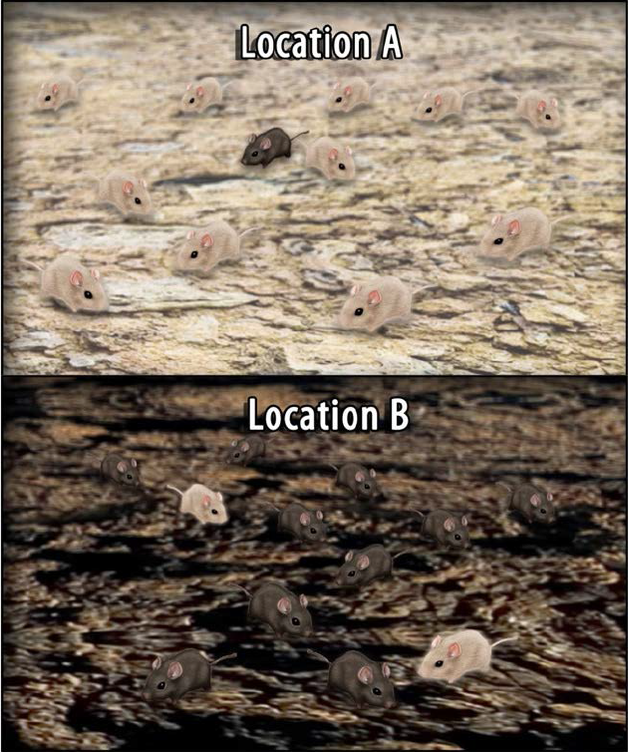
1

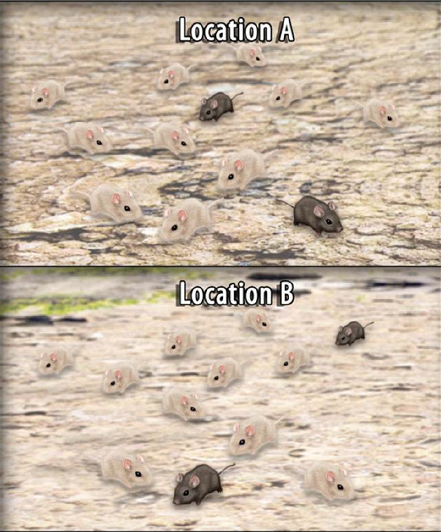
3
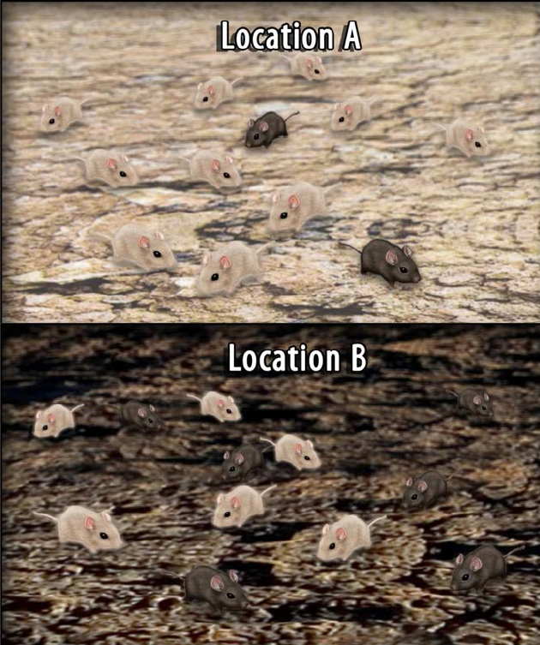
3

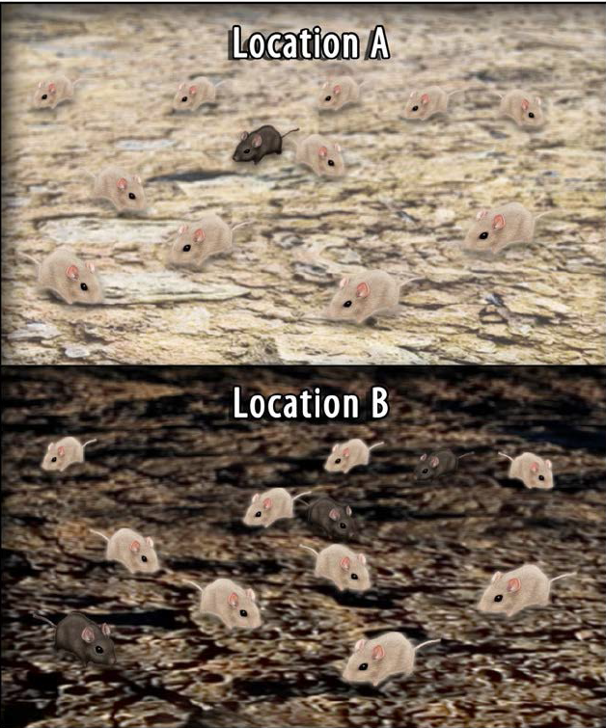
4

