**CREDIT SEARCH**

Save as Visa LastName

1. Search the Internet for the lowest Interest Rate on a Credit Card.

*Print Screen* the website and include the URL (website address)

Example:

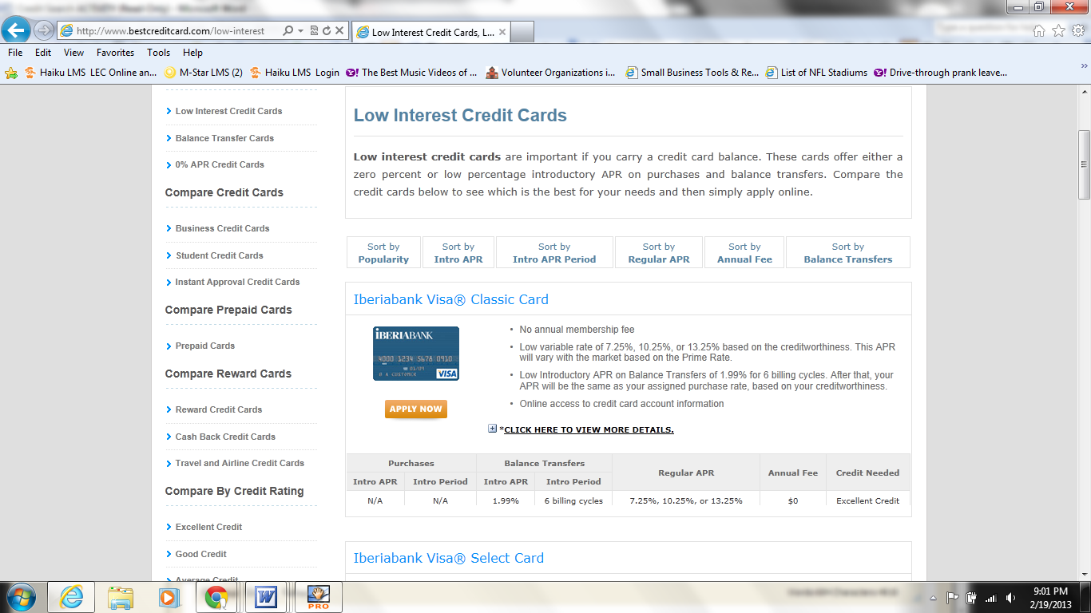

[www. bestcreditcardoffersintheworld](http://www.bestcreditcard.com)

Sort by Regular APR

(Annual Percentage Rate)

Find the Lowest Interest Rate

* Paste your Print Screen below

2. What is the highest Credit Score a person can earn? (include the website you used)

3. List the top 3 things that can lower a Credit Score? (include the website you used)

4. What is an SR-22 in insurance terms? (include the website you used)

5. What types of auto insurance is required in California? (include the website you used)

6. What is GAP insurance? (include the website you used)

7. What does an Acceleration Clause mean? (include the website you used)

<< LIFE INSURANCE >>

8. What is the difference between Term and Whole life insurance? (include the website you used)

9. What is a Death Benefit in life insurance?

10. What is Rider in life insurance?