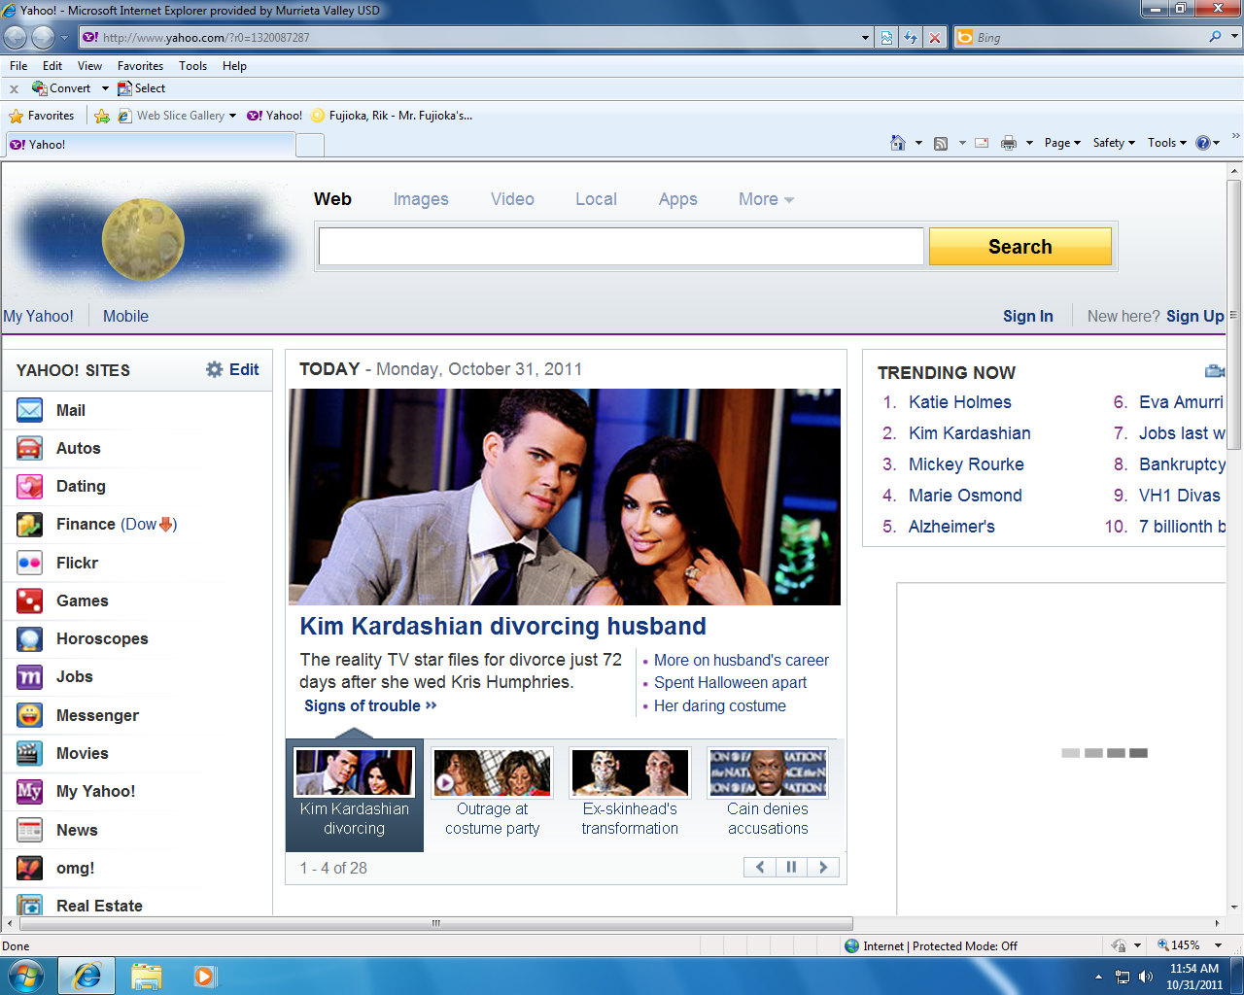Save as Kar LastName





HOW MANY DAYS WERE THEY MARRIED?

WHAT WAS ONE OF THE REASONS FOR THE DIVORCE?

WHAT WAS THE COST OF THE WEDDING?

\*Search the Internet for the following questions below:

WHAT IS A “PRENUP” (PRENUPTIAL AGREEMENT)?

WHAT IS THE DIFFERENCE BETWEEN AN “ANNULMENT” AND A “DIVORCE”?

WHEN DOES A DIVORCE BECOME FINAL?

HOW DOES THE MARRIAGE & DIVORCE BENEFIT KARDASHIAN?