Industrialization Notes
Main Idea: The Industrial Revolution started in England & soon spread elsewhere
Why It Matters Now: The changes that began in Britain paved the way for modern industrial societies

During the 1700’s England’s landscape was primarily small farms. Wealthy landowners bought up the land that the farmers owned & improved farming methods. This was known as the Agricultural Revolution.

The wealthy landowners enclosed their land with fences & hedges called Enclosures. This enabled them to cultivate larger fields.
It had two results:
1: Landowners experimented with new agricultural methods
2: It forced small farmers to become tenant farmers or give up farming & move to the cities.

Jethro Tull
- Felt that the usual way of sowing seeds by scattering them along the ground was wasteful.
- He invented the seed drill in 1701, which allowed farmers to sow seeds in well-spaced rows at specific depths.
- This caused a larger share of the seeds to germinate, which boosted crops.
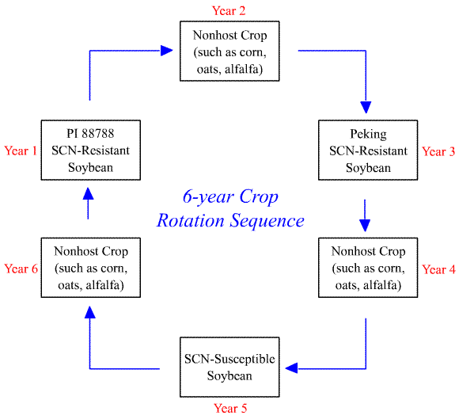

Crop rotation proved to be one of the best developments of the scientific farmers.
For example: One year a farmer might plant soybeans, the next, corn, the next, back to soybeans.
This was done to aid the soil by replacing nutrients that may be lost during the first planting.
This system improved on the older methods of crop rotation.

Livestock Breeders also improved their methods. In the 1700’s farmers began allowing only their best livestock to breed, which resulted in stronger, bigger, & healthier livestock.

The Agricultural Revolution caused three things to happen:
- Food supplies increased
- Living conditions improved
- England’s population increased
The population increase caused the demand for food & goods to increase.
Farmers who lost their lands to large enclosed farms began working in factories, which led to THE INDUSTRIAL REVOLUTION

INDUSTRIALIZATION
The process of developing machine production of goods or The growth of industry.
This requires various resources:
- Water power & coal to fuel the machines
- Iron ore to construct machines, tools, & buildings
- Rivers for inland transportation
- Harbors from which its merchant ships set sail.

Several factors helped support industrialization in England:
- Britain’s expanding economy – business people invested in the manufacture of new inventions
- Britain’s highly developed banking system – people were encouraged by the availability of bank loans to invest in new inventions & machinery
- Britain’s political stability – which gave the country a tremendous advantage over its neighbors & Britain’s Parliament passed laws that protected business & helped expansion.

Inventions Spur Technological Advances
- Britain’s textile industry was the 1st to be transformed by new inventions.
- Britain clothed the world
- Cloth merchants boosted their profits by speeding up the process by which spinners & weavers made cloth.

Two new major inventions in the textile industry were:
The Flying Shuttle-invented in 1733 by John Kay.

The Spinning Jenny-invented by James Hargreaves around 1764 named after his daughter.
Originally Hargreaves produced the machine for family use but when he began to sell the machines, spinners from Lancashire, fearing the possibility of cheaper competition, marched on his house and destroyed his equipment.
It is estimated that by the time James Hargreaves died in 1778, over 20,000 Spinning-Jenny machines were being used in Britain.

Richard Arkwright
Invented the Water Frame in 1769 so that people did not have to use the spinning jenny & the flying shuttle by hand.
This machine used the water power from rapid streams to drive spinning wheels.

In 1779, Samuel Crompton combined features of the spinning jenny & the water frame to produce the spinning mule.
The spinning mule made thread that was stronger, finer & more consistent than earlier spinning machines.

Factory
Wealthy textile merchants set up the machines in large buildings called factories. At first they were built near streams so they could take advantage of the water power.

England’s cotton came from plantations in the American South in the 1790’s
In 1793 an American Inventor – Eli Whitney invented the cotton gin to speed up the chore of removing seeds from the raw cotton.

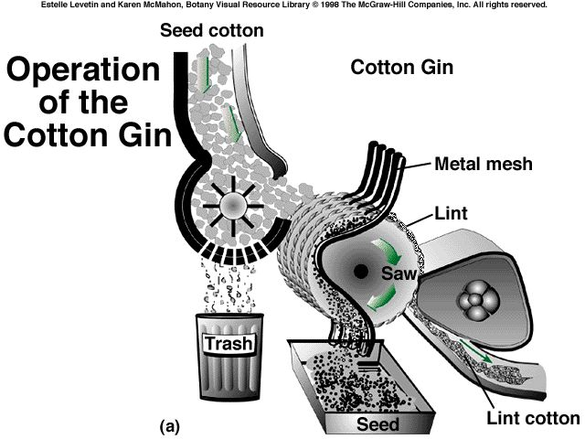

Improvements in Transportation
Progress in the textile industry spurred other industrial improvements:
- The Steam Engine- was a result of searching for a cheap, convenient source of power. It was a heat engine that makes use of the thermal energy that exists in steam, converting it to mechanical work. A steam engine needs a boiler to boil water to produce steam under pressure.
- Any heat source can be used, but the most common is a fire fueled by wood, coal, or oil. (However, anything that can be burned can be used as fuel for the fire: paper, trash, used crankcase oil, ground-up corncobs, manure, natural gas, gasoline, high proof alcohol, dry grass, hay, dry weeds, etc).
- The steam expands and pushes against a piston or turbine, whose motion does the work of turning wheels or driving other machinery.
The first steam engine was used in mining, but it was expensive to run because it used large amounts of fuel.
James Watt
A mathematical instrument maker at the University of Glasgow in Scotland figured out a way to make the steam engine work faster & more efficiently while burning less fuel.
Watt along with a businessman (entrepreneur) named Matthew Boulton began building better steam engines. Boulton was the financial backer & Watt was the builder.
The steam engine was also used to propel boats.
An American inventor named Robert Fulton ordered a steam engine from Watt & Boulton & he used it to propel boats.
After its first successful trip in 1807, Fulton’s steamboat- The Clermont transported passengers up & down New York’s Hudson River
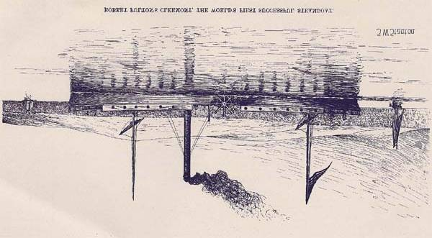
Robert Fulton’s Clermont, The world’s first successful steamboat.
Note: As a result of the steamboat, in England water transportation improved with the creation of a network of canals or human-made waterways, which helped cut the cost of transporting raw materials.

In England roads improved also, thanks to John McAdam, a Scottish engineer working in the early 1800’s. He equipped roadbeds with a layer of large stones for drainage. On top, he placed a carefully smoothed layer of crushed rock, making travel possible over these roads without heavy wagons sinking in mud.

Private investors (entrepreneurs) formed companies that built roads & then operated them for profit called turnpikes because travelers had to stop at tollgates (turnstiles or turnpikes) to pay a toll before traveling farther.

The Railway Age Begins
Locomotives were first pulled by horses, but the steam engine soon changed that.
After 1820, the railroad locomotive drove English industry.
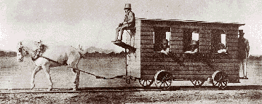

In 1804, an English engineer named Richard Trevithick won a bet of several thousand dollars by hauling ten tons of iron over almost ten miles of track in a steam-driven locomotive.
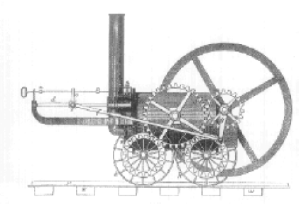
George Stephenson
- Improved the Trevithick locomotive
- Built some 20 engines for mine operators in Northern England
- In 1821, he began work on the worlds first railroad line
- It ran 27 miles from The Yorkshire coal fields to the port of Stockton on the North Sea.
- Railroad opened in 1825
- It used 4 locomotives that Stephenson designed & built
News soon spread throughout Britain about the success of the railroad line. Various investors wanted a railroad line to connect the port of Liverpool with the inland city of Manchester. The track was laid and in 1829 trials were held to choose the best locomotive for use on the new line. Five engines entered the competition, but the best of the five was The Rocket designed & built by Stephenson & his son.

Railroads Revolutionize Life in Britain
- They gave manufacturers a cheap way to transport materials & finished products
- Created hundreds of thousands of jobs for both railroad workers & miners (miners provided coal for the steam engines & iron for the tracks)
- It boosted the agricultural & fishing industries, because it transported their products to distant cities
- The railroads encouraged people to travel from the country to the cities for jobs & the people from the cities to the country for rest & relaxation in the countryside resorts.

By the 1800’s more people could afford to heat their homes with coal from Wales. They wore better clothing woven on power looms in England’s industrial cities. These cities soon swelled with workers.
For centuries, most Europeans lived in rural areas. But after industrialization began in the 1800’s people began primarily living in the cities.
The growth of factories or the factory system, brought waves of jobseekers to cities & towns.
Most of Europe’s urban areas doubled in population. This period was one of URBANIZATION (city building, and the movement of people to cities). Some cities such as Glasgow & Berlin tripled or quadrupled in size.
Factories developed in clusters because they were built by sources of energy, such as rivers & coal-rich areas.
The biggest of these centers developed in England

Britain’s capital, London, was the country’s most important city.
- Contained twice as many people as Paris
- Became Europe’s largest city.
- It had a population of 1 million by 1800
- During the 1800’s London’s population exploded further, which provided a vast labor pool & market for new industry.
- Other cities in England such as Manchester, Birmingham & Sheffield also experienced rapid population growth.

Birmingham & Sheffield became dominated by iron-smelting centers
Manchester became dominated by textile & cotton industries

Living Conditions
No plans, no sanitary codes & no building codes controlled the growth of England’s Cities. They lacked:
- Adequate housing
- Education
- Police protection for the people who in from the country side
- Most of the unpaved streets had no drains & collected heaps of garbage
- Workers lived in dark, dirty shelters
- Whole families crowded into one bedroom.
- Sickness was widespread-average life span showed by the British government was 17 years for working-class people & 38 years in a nearby rural area.
The sickness was generally caused by CHOLERA – a deadly disease caused by bacteria that usually occur in contaminated drinking water.
In July 1832, there was a cholera epidemic in Sheffield. The standards of sanitation were so low - virtually streams of raw sewage in the streets - that many people, forced to live in these appallingly unhygienic conditions, were bound to catch the deadly disease.
Records show that 1,347 people caught the disease and 402 died.
Most of these victims were buried in mass graves in the Cholera Gardens on Norfolk Road.
This epidemic lasted for six months from July until December 1832, but cases of cholera were common during the rest of the century.
The symptoms of cholera are like those of food poisoning: dreadful stomach pains, terrible vomiting, severe diarrhea. Without proper medical care it is frequently fatal. The victim can die of dehydration within just two days of the first symptoms appearing.

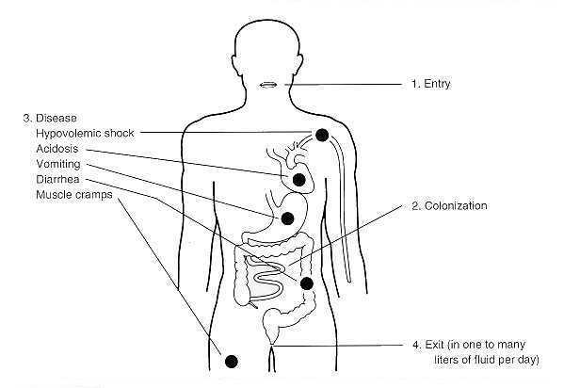
Working Conditions
- Workers worked 14 hours a day, six days a week.
- Factories were poorly lit
- Machines would injure workers & there was no government program to provide aid in case of injury.
- Coal miners faced the worst conditions. They had frequent accidents, damp conditions & the constant breathing of coal dust.
- The average miner’s life span was ten years shorter than that of other workers.
The Industrial Revolution created enormous amounts of money in the country. Most of the wealth lined the pockets of factory owners, shippers, wealthy farmers & merchants. These wealthy people made up a growing Middle Class.

The new middle class transformed the social structure of Britain:
- No longer were aristocrats & landowners occupying the top position in British society.
- Some factory owners, merchants & investment bankers grew wealthier than the landowners & aristocrats
- Two distinctions between the two wealthy classes
- Landowners looked down on those who had made their fortunes in the “vulgar” business world
- Not until the late 1800’s were the rich entrepreneurs considered the social equals of the aristocrats

Eventually, a larger middle-class emerged, who were neither rich nor poor. This group included:
Upper middle-class = Government employees, Doctors, Lawyers & Managers of factories, mines & shops.
Lower Middle-Class = Factory overseers, Toolmakers, Mechanical Drafters, & Printers.
All of which enjoyed a comfortable standard of living.

The Luddites
During the years 1800 to 1850, frustrated workers watched their livelihoods disappear as machines replaced them.
In 1811 a group of workers formed a secret organization led by a mysterious 'King' Ned Ludd of Sherwood Forest. Whether a man named Ludd existed or not is unknown. Their targets were the wide-frame stocking machines which were causing falling wages and unemployment in the Midlands. Letters were sent to machine owners, demanding the removal of the machines.
In the first year of the riots, 1811, over a thousand machines were smashed. The movement spread from Nottinghamshire to Lancashire and Cheshire and later Yorkshire. Force was used to protect machines - soldiers fought with Luddites at William Cartwright's mill near Huddersfield, killing two rioters.
The Leeds Mercury reported that only the machines of owners who had lowered wages were broken. Discipline was strict - the groups had to be secret and free from informers. However the government liked to portray the Luddites as mindless vandals.

Positive Effects of the Industrial Revolution
- It created jobs for workers
- It contributed to the wealth of the nation
- It fostered technological progress & invention
- It greatly increased the production of goods & raised the standard of living
- It provided the hope of improvement in people’s lives
Other Benefits
- Healthier diets
- Better housing
- Cheaper, mass-produced clothing
- Created a demand for engineers, clerical & professional workers
- Expanded educational opportunities
- Middle & Upper classes prospered immediately

Child labor
Children were expected to carry heavy loads as part of their job in the factory
They had to work around dangerous machinery in which a small hand could easily be caught & injured
Adult overseers sometimes whipped exhausted children in order to keep them awake during their long, 14 hour days.
The day of a child laborer:
5 a.m.-The workday begins. Children wake as early as 4:00 or 4:30 to get to the factory to start working by 5:00. They usually grabbed breakfast on the run.

12 noon – The children were given a 40-minute lunch break. This was the only break they received during the whole course of the day.

3 p.m.- The children often became drowsy during the afternoon or evening hours. In order to keep them awake, adult overseers sometimes whipped the children.

6 p.m. – There was no break allowed for an evening meal. Children ate on the run. From 12:40 until 9:00 at night, the children worked without a break

9 p.m. – The day ended after an exhausting 16 hour shift at work.

Child Labor Currently
In India nearly 300,000 youngsters under 13 work in bondage, or under other circumstances that approximate slavery, as they weave luxurious carpets for living rooms in the U. S. & Europe. As a chief justice of the Supreme Court of India has testified, the carpet children are often disciplined by being beaten up, branded with red hot iron rods, and even hung from trees upside down. It is the fear of such punishment that keeps children as young as six working long hours every day six or seven days a week.
“The images of children working in a gravel quarry were so shocking and so prehistoric and so unthinkable in the year 2005. It just took our breath away. The big question was how can this happen? Why does this happen? How many children are affected in this way by this kind of work and hard labor?” - Len Morris, director and producer of Stolen Childhoods
(A documentary about current child labor on all 7 continents!)

