Español I Uni 1 Etp 1 El Vocabulario
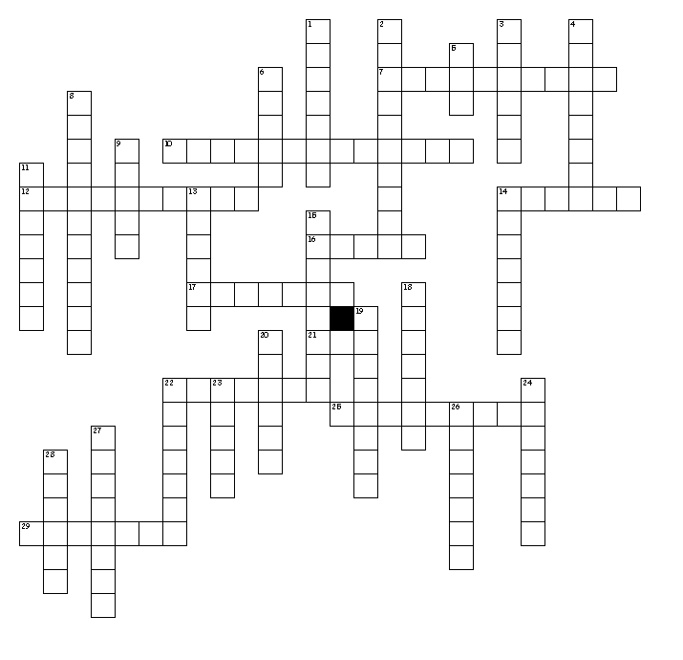

Horizontal
7. Contest
10. Apartment
12. Boy
14. Country
16. I am
17. Friend
21. To be
22. Girl
25. Doctor (fem)
29. To skate

Vertical
1. S/he, you likes (form)
2. Welcome
3. House
4. We like
5. I am
6. To be
8. Community
9. Much/Many
11. I like
13. To run
Vertical
14. World
15. They like
18. Mr.
19. To work
20. To dance
22. Woman
23. To eat
24. Also
26. You like (fam)
27. To write
28. You're welcome

