Español I Unidad 2 Etapa 1 El Vocabulario
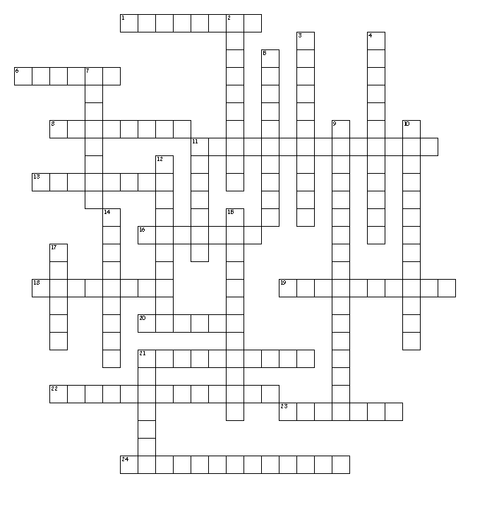

Horizontal
1. What you do before un examen.
6. Draw, paint, color.
8. What comes at the end of a chapter?
11. Add, subtract, divide, times
13. Play an instrument.
16. To wait for, to expect.
18. What you do with your ears.
19. To remove what was written.
20. What you do with your mouth.
21. How you view photos, words; electronically.
22. If you don't know what a word means.
23. What you're using to do this.
24. Once in a while.

Vertical
2. Right now!
3. What your computer uses with paper.
4. Opposite of never and always.
5. What I write on.
7. To have to.
9. Run, play, workout.
10. To add quickly with a machine.
11. What you're to do each night.
12. Who did what, when and where.
14. Teachers give you one of these each day.
15. Melville, Poe, Steinbeck
17. To look for, to search.
21. Where are you at right now.

