Insert your data table and highlight the data as shown:
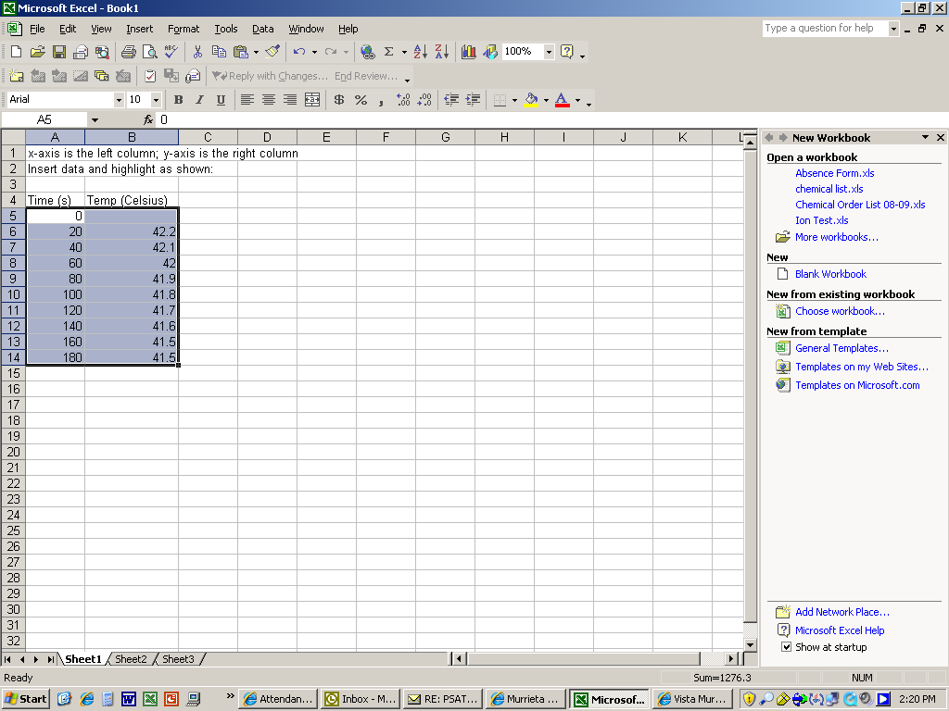

Next, create your graph as shown in the next series of steps:
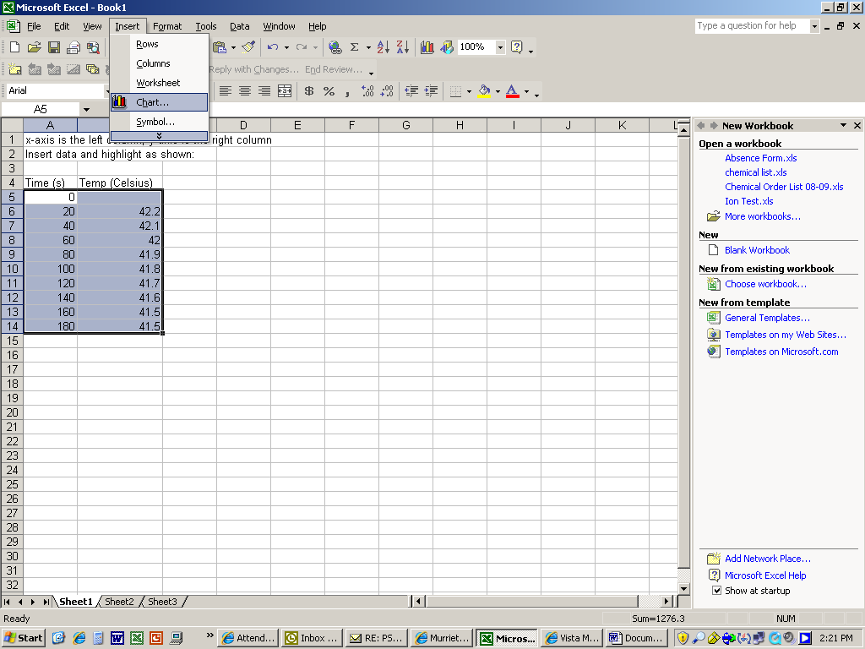

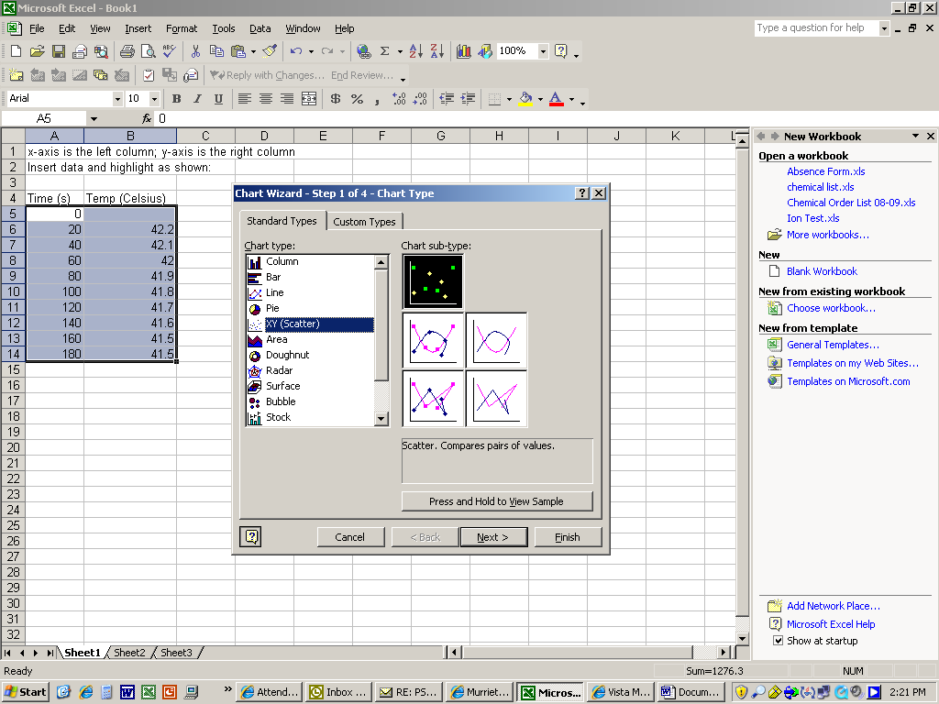
Click “XY (Scatter)” and then “Next”

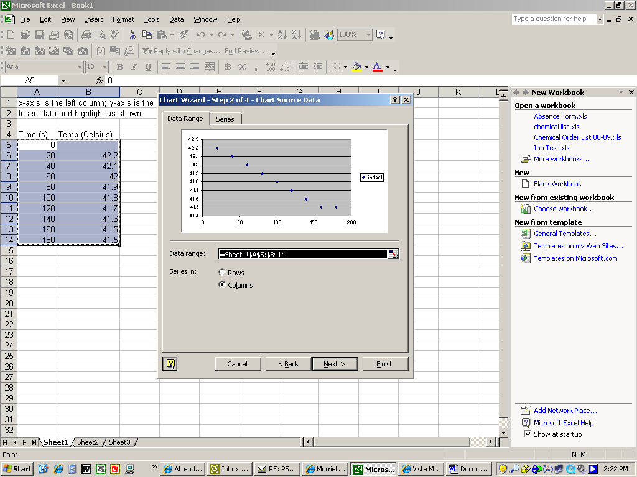

Click Next again
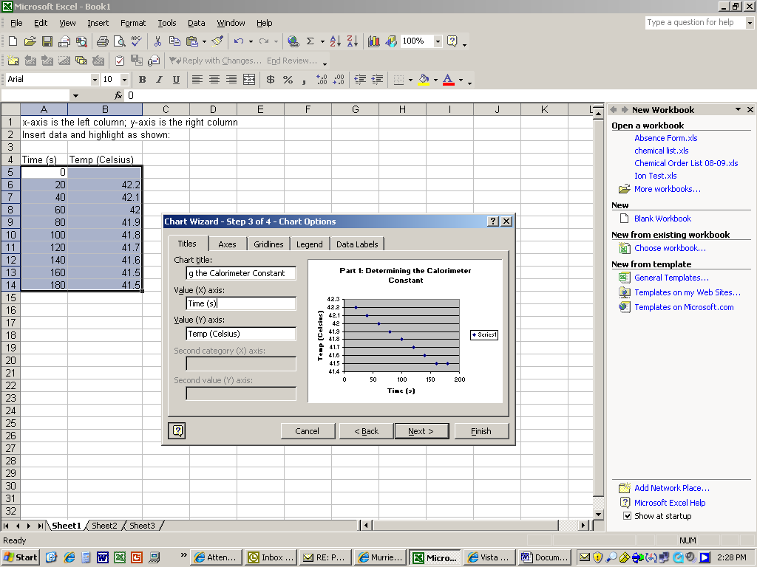
Fill in Chart Title and Axis labels as shown above and then click Next

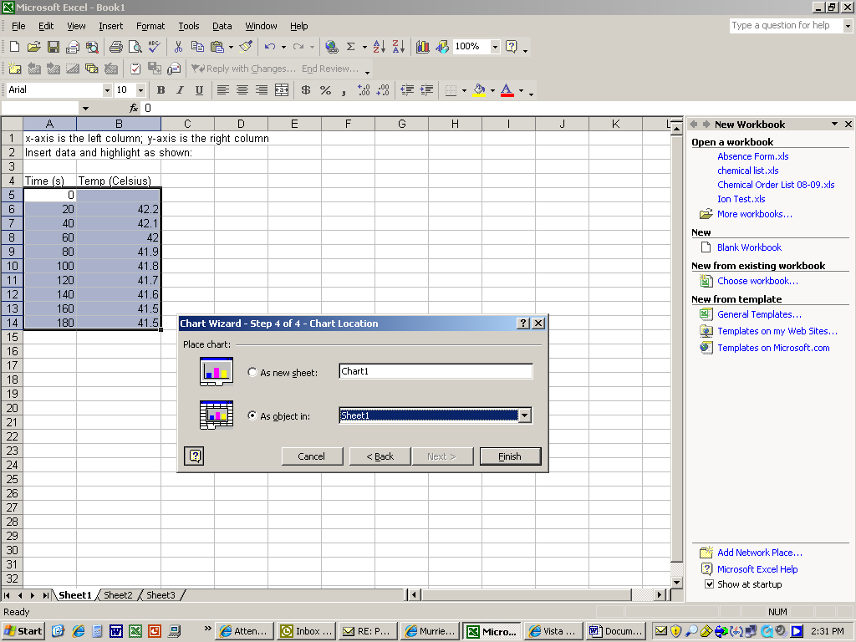

Click Finish and your graph will pop up right next to your table
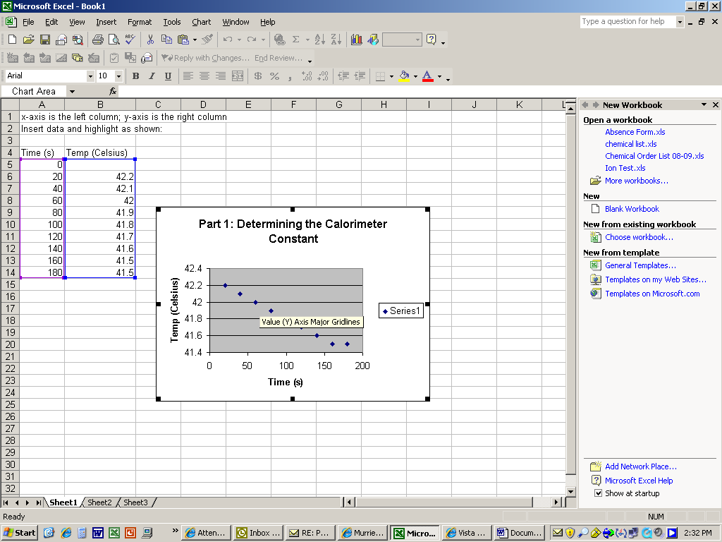

Now click on one of the blue data points.
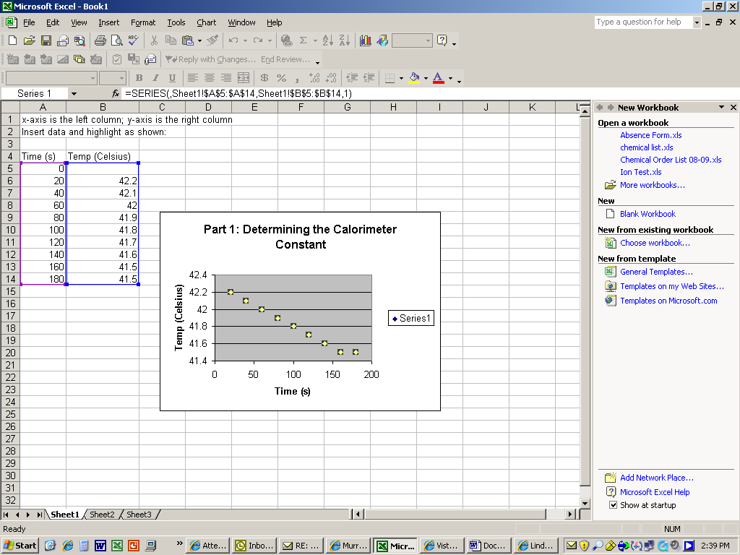

Now click the “Chart” tab at the top to add a linear trendline:
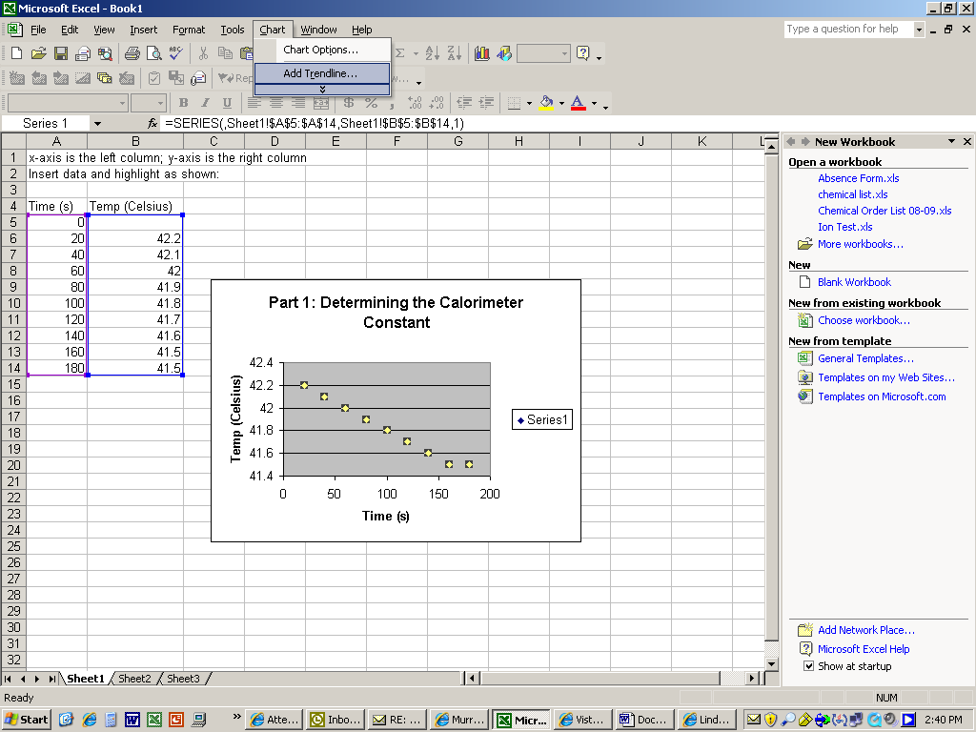

Another box will pop up:
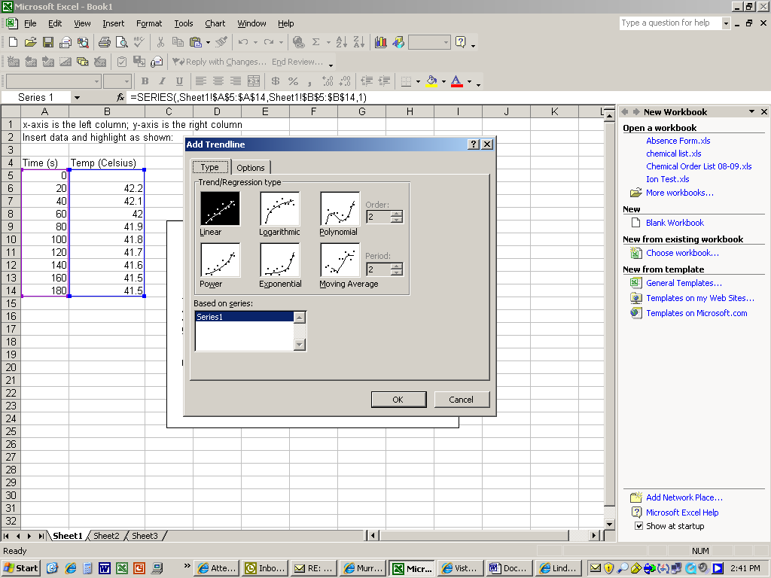

Linear is what we want and linear is already selected. Now click the “Options” tab.
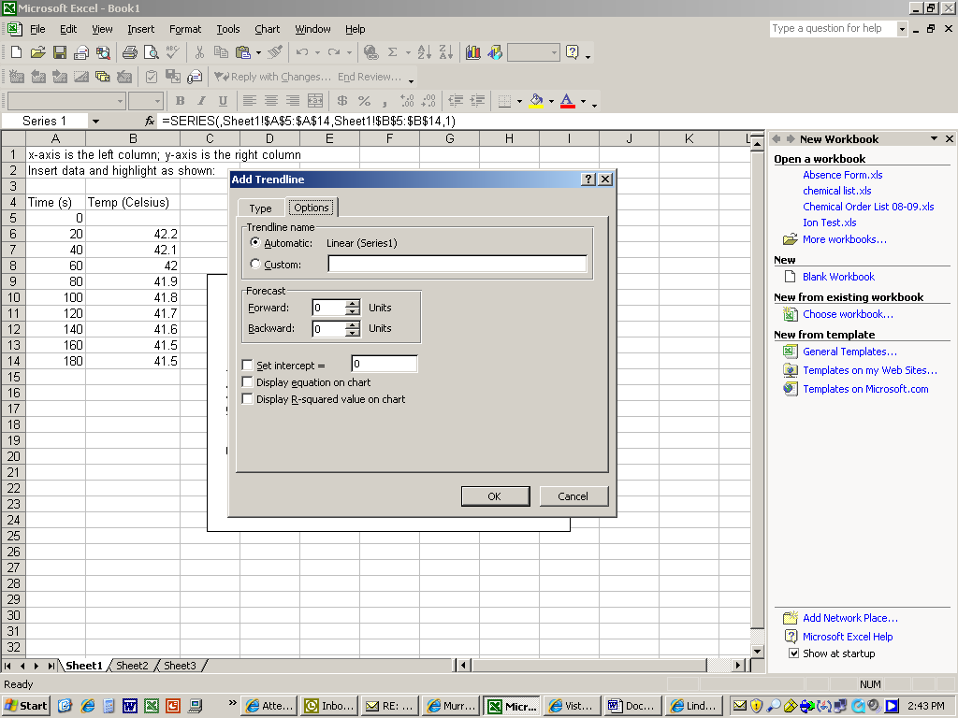

Click the box that says “Display equation on chart”
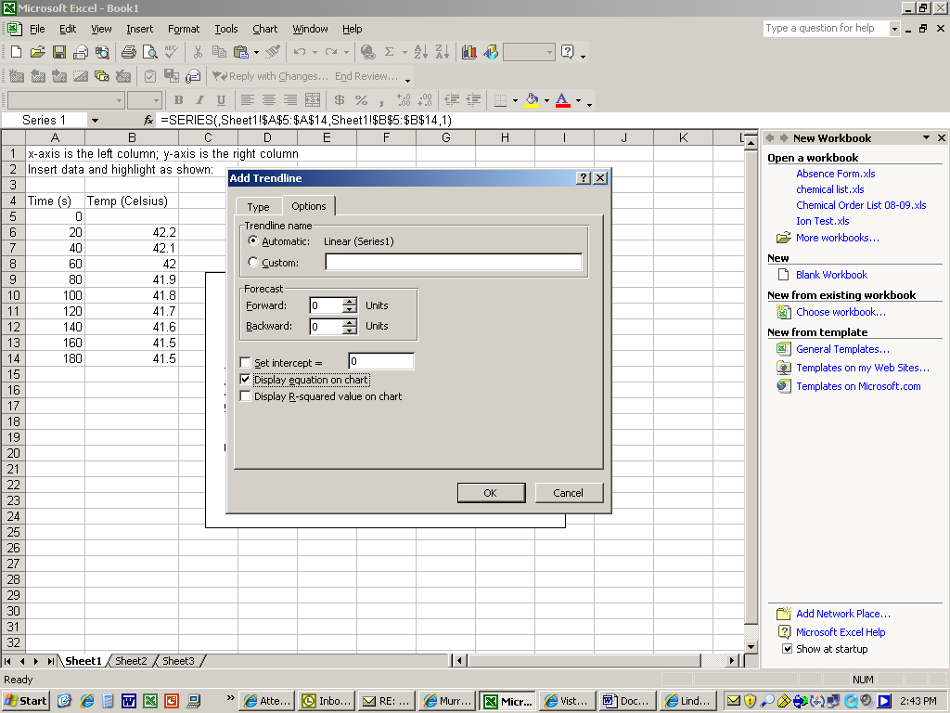

Click OK.
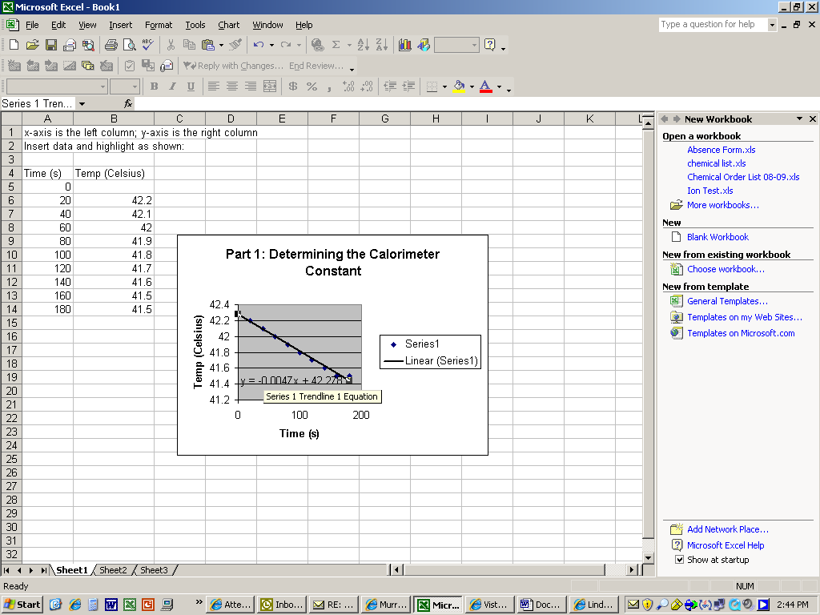
Click on equation to move it so it’s easier to read.
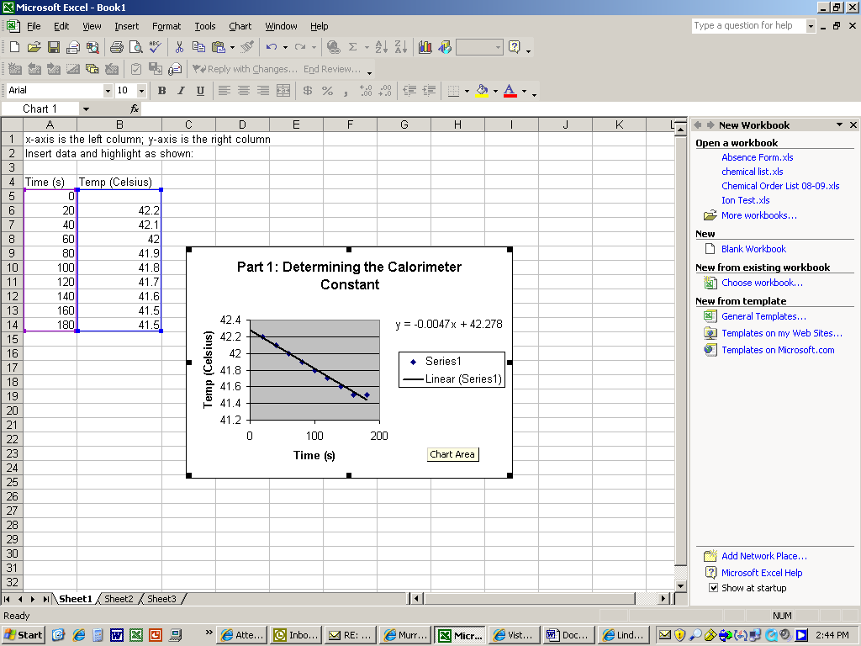

Use your equation to find T_{f} by plugging 0 in for x. (According to this equation: T_{f} is 42.278°C.)

