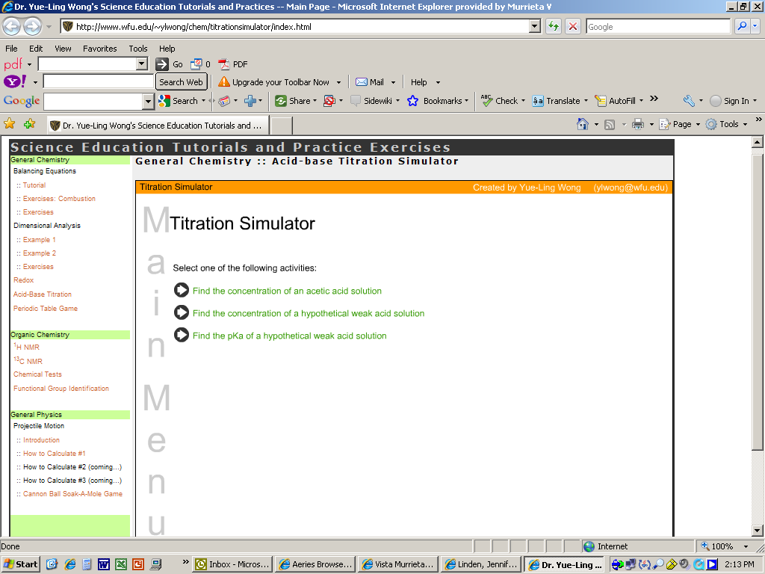
Click on the first arrow. The following window will appear:
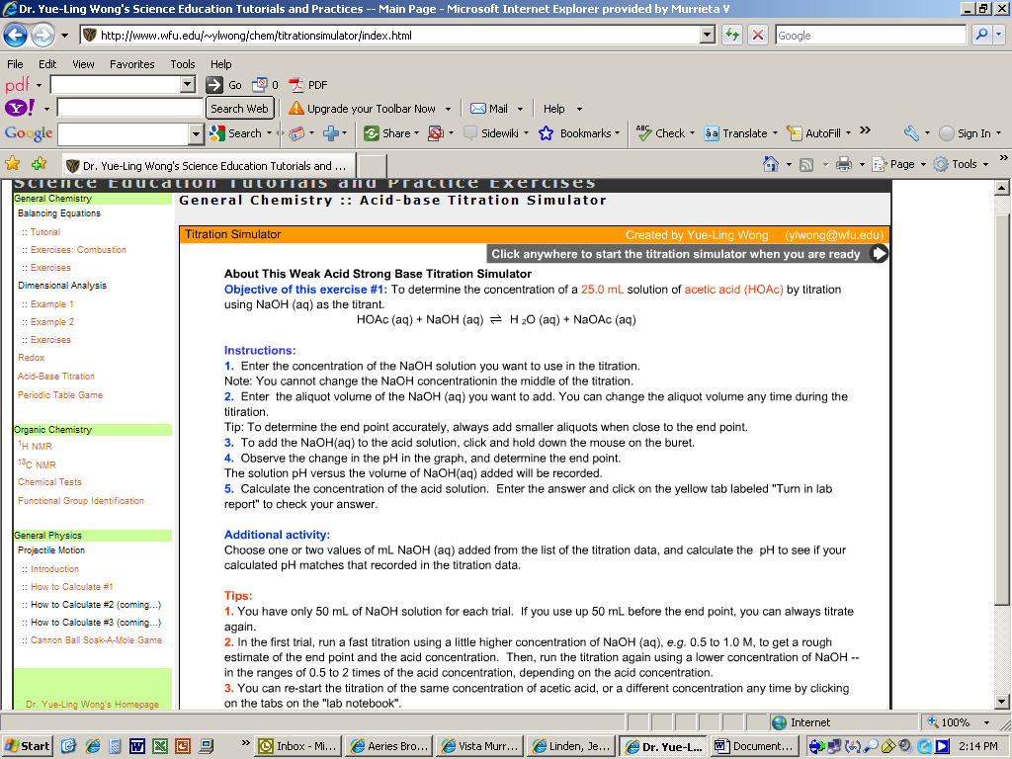
Read the objective and the instructions NOW. (Note: An aliquot is the volume that will be added each time. For example: if you choose a 1 mL aliquot volume, 1 mL of NaOH will be added at a time. You may change the aliquot volume during the titration (which I suggest you do when approaching the end point—make it small so you don’t miss the end point.)
**Pay attention to the “Tips” given to you.
⇒Do several trials varying the concentration of NaOH and the aliquot volume so you have an idea of where the equivalence point will be. Then, use a smaller concentration and smaller aliquots once you approach the end point so you get a more accurate measurement of the equivalence point. (Be sure to “re-run with the same unknown concentration.”)
Example: Using 1 M NaOH with a 1 mL aliquot volume gave me a titration curve like so:
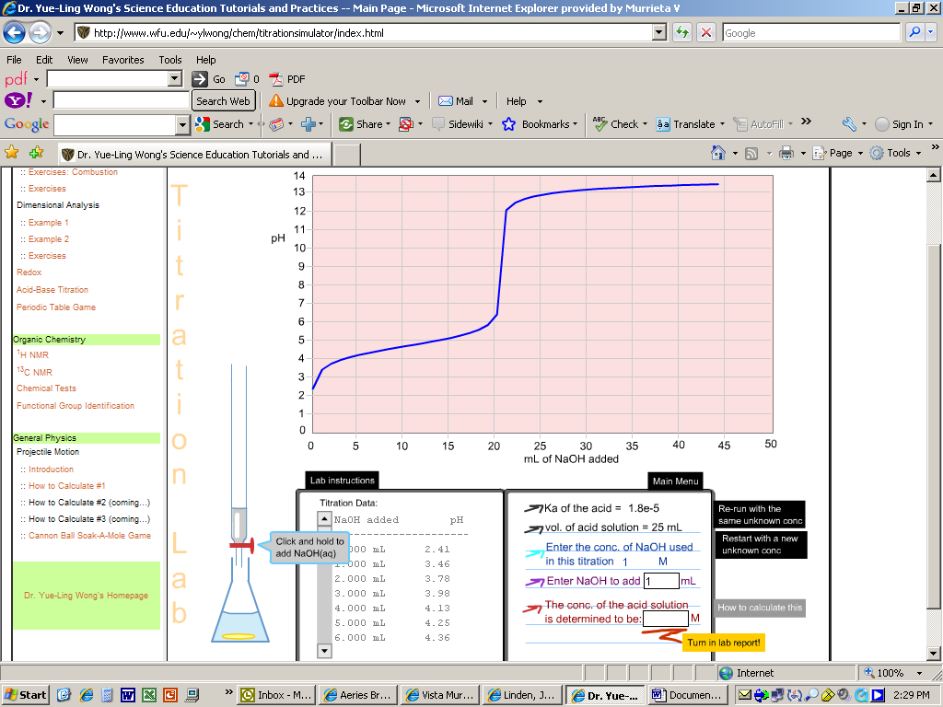

***Once you have done your calculation as instructed in Step 5, hit the “print screen” button (make sure that your inputted calculation and the computer’s evaluation of your calculation are showing before you do this. This is where most of your grade is coming from so make sure it is visible!!!)
Based on this titration curve, the equivalence point occurs when about 21 mL of NaOH is added. Therefore, the [acid] can now be calculated, because moles of OH⁻ equal moles of acid at the equivalence point. Be sure to divide the moles of acid by the volume of acid (25 mL) and not the total volume!! You would perform that calculation and then enter it in as instructed. The computer will let you know if you were correct.

If you do too high of a concentration and too large of an aliquot like the example below (2 M NaOH and 5 mL aliquots), you will not correctly predict the end point and your calculation of [acid] will be incorrect. For example, it appears as though the end point occurs when about 8 mL of NaOH is added. Based on that end point, I calculated [acid] to be 0.64 M. That was incorrect, because I incorrectly determined the end point.
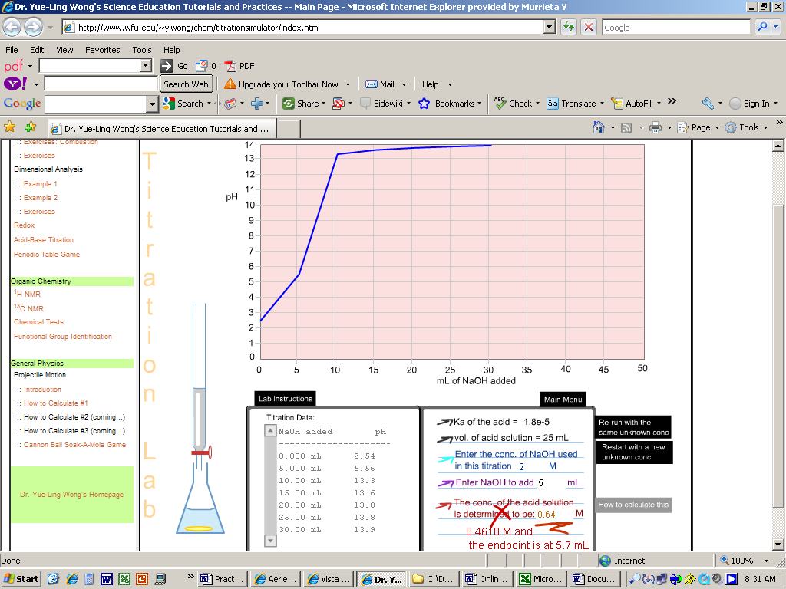

You must do the optional activity for one volume calculation. Based on the concentration of the acid you just calculated, you may now calculate pH for any volume of NaOH added. Let the major species in solution point you in the right direction for this calculation!! (You may choose to do this calculation later, because you don’t want to run out of time for the other two titration activities.)

Now, do the second titration. Follow the same instructions concerning “print screen”.

You must do the second optional activity for just one more Ka. There is no need to perform a calculation for the new Ka titration but be sure to “print screen” so the graphs can be compared. Briefly describe the difference between the graphs and explain why the difference makes sense.

Now, do the third titration. Follow the same instructions concerning “print screen”.
(Hint: in order to determine the pKa of an acid using a titration curve, you must use “half-titration” data.)

You do not have to do an optional activity for this third titration.

Informal Lab Report Checklist:
- Determining [acetic acid]
  - “Print screen with computer evaluation visible” (attach your work for your calculation)
  - Optional Activity: Calculation of pH for one selected NaOH volume.
  - Percent error calculation for your pH calculation to the measured pH for that volume. (Yours is the calculated valued and the pH in the data table is the experimental value.)
- Determining [hypothetical acid]
  - “Print screen with computer evaluation visible” (attach your work for your calculation)
  - Optional Activity: “Print Screen” (no need to perform a calculation for the computer to evaluate)
  - Description of the differences in the graphs
- Determining pKa of an acid
  - “Print screen with computer evaluation visible”

