AP Chemistry Name ___________________________________
Period ___ Date ___/___/___
15 • Acid-Base Equilibrium
TITRATION CALCULATIONS

Information from the Curve:
There are several things you can read from the titration curve itself. Consider this titration curve.

1. This is a ___________ (strong/weak) acid titrated with a strong base. The acid is ________________ (monoprotic/diprotic).
How would the other strength of acid look?

2. Place a dot (•) on the curve at the equivalence point. The pH at the equivalence point is ____. Choose a good indicator for this titration from Figure 17.11 on page 810 of your textbook.

3. What volume of base was used to titrate the acid solution? _______ mL

4. Place a box () on the curve where the pH of the solution = the pK_{a} of the acid.
What is the pH at this point? _______
What is the pK_{a} of the acid? _______
What is the K_{a} of the acid? _____________

Calculations knowing the Acid:
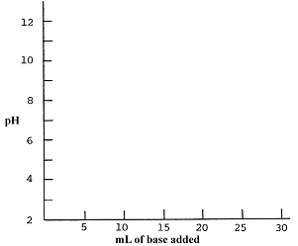
5. Hydrofluoric acid, HF, has a K_{a} = 7.2 x 10⁻⁴. Calculate the pH of 10.0 mL of a 0.050 M solution of HF. Plot this point on the axes.

6. A 0.020 M solution of NaOH is used for the titration. What volume will be needed to reach the equivalence point?

7. Write the net reaction for the neutralization of a solution of HF with a solution of NaOH.
___________________________________

8. Calculate the moles of F⁻ at the equivalence point. What is the total volume? _______ L
The [F⁻] at the equivalence point is _________

9. Calculate the pH of the solution at the equivalence point. Use this information and the answer to question 6 to plt the equivalence point on your graph. Choose a good indicator for this titration from Figure 17.11 on page 810 of your textbook.

10. What is the pH halfway to the equivalence point? Plot this point on your graph.

11. How many moles of HF are in the original 10.0 mL sample of HF? _______

12. When only 5.0 mL of 0.020 M NaOH has been added, calculate the moles of HF left and F⁻ produced.
 | HF | OH⁻ | H₂O | F⁻
i |  |  | -------
c |  |  | -------
e |  |  | -------

13. Use the Henderson-Hesselbach equation or an icebox to calculate the pH when 5.0 mL of base has been added. Plot this point on your graph.

14. When 20.0 mL of 0.020 M NaOH has been added, calculate the moles of HF left and F⁻ produced.
 | HF | OH⁻ | H₂O | F⁻
i |  |  | -------
c |  |  | -------
e |  |  | -------

15. Use the Henderson-Hesselbach equation or an icebox to calculate the pH when 20.0 mL of base has been added. Plot this point on your graph.

16. When 30.0 mL of base is added, how many moles of OH⁻ is in excess? _______
The total volume is _______ L.
[OH⁻] = _________
pOH = _________ pH = __________
Plot this point on your graph.

17. Sketch the titration curve on your graph.
Weak Base-Strong Acid Curve:
A 20.0 mL sample of 0.10 M CH₃NH₂ (methyl amine) is titrated with 0.15 M HCl. The K_{b} for CH₃NH₂ = 4.2 x 10⁻⁴.

Do the appropriate calculations to sketch a titration curve for this titration.

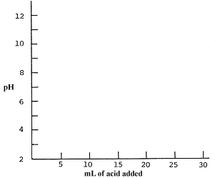

Formulas from the AP Exam:
