AP Chemistry Name _________________________________
Period ___ Date ___/___/___
15 • Acid-Base Equilibrium
TITRATION CURVE CALCULATIONS
Strong Acid – Strong Base Titrations  When a strong acid (such as HCl) and a strong base (such as NaOH) are used for a titration, the pH change looks like the graph on the right. You can calculate the volume of base needed to reach the equivalence point using the formula: V·M = V·M or a line equation.  There are three situations in which you determine pH.  - initial strong acid concentration (this is simply the –log[H⁺] which is based on the [Acid].)  - equivalence point (or endpoint) when moles of OH⁻ = moles of H⁺. The pH is 7 (due to the auto-ionization of water.) | 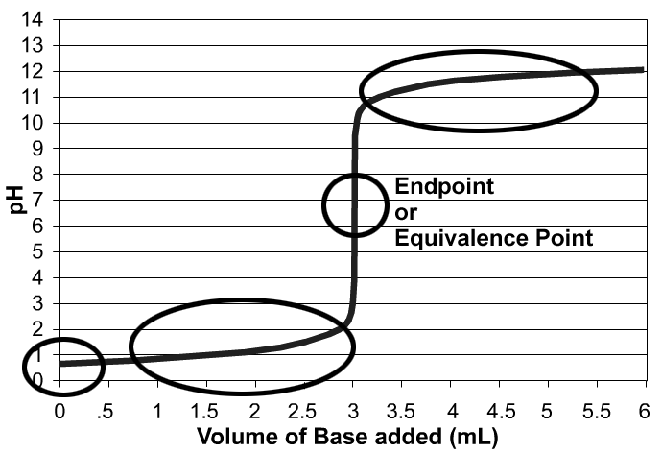
- before and after the endpoint (calculate excess moles of H⁺ or OH⁻, divide by the total volume, and calculate the pH based on this value.)

Weak Acid – Strong Base Titrations
When a weak acid (such as HC₂H₃O₂) is neutralized by a strong base (such as NaOH), the graph varies in two ways:
- the equivalence point is not at pH = 7 and
- a buffer region exists as you approach the endpoint.
You can still calculate the volume of base needed to reach the equivalence point using the formula: V·M = V·M. Weak acids require the same amount of base for neutralization as strong acids because they dissociate as they are neutralized.
There are five situations in which you need to be able to calculate the pH.  - initial weak acid concentration (this is an ICE box calculation.) The shortcut can be used here.  - equivalence point (endpoint) is when all of the weak acid has been neutralized and turned into the conjugate base (C₂H₃O₂⁻ in this case.) This is a hydrolysis problem. Calculate the [C₂H₃O₂⁻] and then do an ICE box problem knowing that K_{b} = $\frac{K_{w}}{K_{a}}$. Calculate the [OH⁻], the pOH, and then the pH.  - Halfway to the equivalence point (as in a half-titration) the pH = pK_{a}. This is because at this point, there is a perfect buffer as the [HA] = [A⁻]. At this point, you can determine the K_{a} of an unknown weak acid… very useful.  - before and after the half-way point, the pH can be calculated using the Henderson-Hasselbach equation (or an ICE box, if you want.) Use stoichiometry to determine the [HA] and [A⁻]. pH = pK_{a} + log$\frac{\left[A^{−}\right]}{\left[\text{HA}\right]}$ | 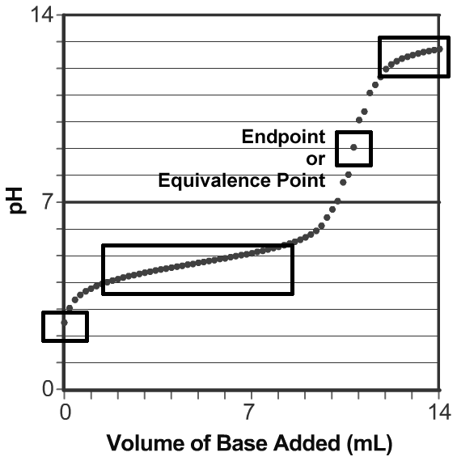  - finally, after the equivalence point, the pH depends on the excess strong base that has been added. As in the strong acid-strong base titration, calculate excess moles of OH⁻, divide by the total volume, and calculate the pOH and then pH based on this value. The effect on the pH by the A⁻ is negligible compared to the excess OH⁻.

Weak Base – Strong Acid Titrations  When a sample of a weak base is titrated with a strong acid, the curve resembles an inverted Weak Acid – Strong Base titration curve.  Note that the pH at the equivalence point is less than 7. An indicator such as phenolphthalein that changes at pH of 9 would change when only 6 mL of acid had been added even though the equivalence point is reached at around 11 mL.  The acid-base indicator must be chosen with a K_{a} near to the [H⁺] of the equivalence point; that is the pK_{a} of the indicator must match the pH of the equivalence point. | 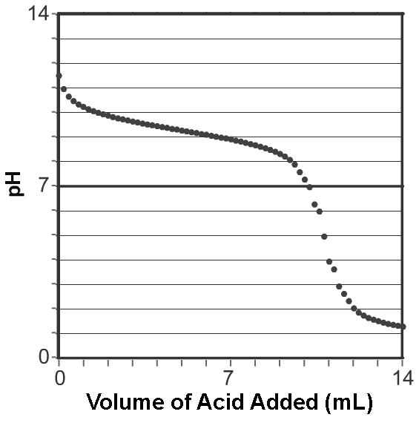
Weak Diprotic Acid – Strong Base Titrations  When a weak diprotic acid (examples: H₂C₂O₄ or H₂CO₃) is titrated, there are two equivalence points. The curve is not as distinct because of the various proton donors and proton acceptors in solution.  I believe that simply knowing the general shape of the titration curve and being able to identify the two equivalence points is sufficient for the AP exam. | 