AP Chemistry Name __________________________________
Period ___ Date ___/___/___
17 • Electron Transfer Reactions
STUDY LIST

General Terms
I can…
- Determine the oxidation number of any element.
- State that oxidation number is the charge an atom would have if all of the shared electrons were assigned to the more electronegative atom.
- Identify for any element in a reaction whether it is gaining or losing electrons (LeO GeR).
- Explain that when oxidation occurs, reduction must also occur (RedOx).
- Correctly apply the terms oxidizing agent and reducing agent to a redox reaction.
- State that there are two big topics in electrochemistry, (1) Electrolysis—in which electricity (moving electrons) causes chemical change, and (2) Electrochemical Cells—in which chemical changes cause a flow of electrons (electricity).

Electrolysis
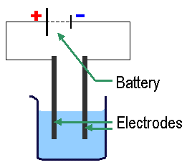
I can…
- State that during electrolysis, electricity applied to a solution causes ions to migrate to the electrodes.
- State that an electrode is the part of the conductor that touches the solution.
- State that reduction always occurs at the cathode (red cat).
- State that oxidation always occurs at the anode (an ox).
- Write equations for the reactions that occur at the electrodes when water undergoes electrolysis (memorize how to derive these).
(−) cathode: 2 H₂O(l) + 2 e⁻ → H₂(g) + 2 OH⁻
(+) anode: 2 H₂O(l) → O₂(g) + 4 H⁺ + 4 e⁻
- Explain that during the electrolysis of an ionic solution, either the + ion can be reduced or water can be reduced. In the same way, either the – ion can be oxidized or water can be oxidized.
- Use a reduction potential chart to determine which of two substances is more likely to be reduced or oxidized.
- State that electrical current is measured in Coulombs and 1 Coulomb = 1 amp·1 sec.
- State that 1 Faraday (F) = 1 mole of electrons = 96,500 Coulombs.
- Use the Faraday, amps and seconds to quantify electrolysis problems.

Electrochemical Cells
(Voltaic Cells & Galvanic Cells)
I can…
- State that oxidization always occurs at the anode and reduction always occurs at the cathode.
- Draw a simple electrochemical cell:
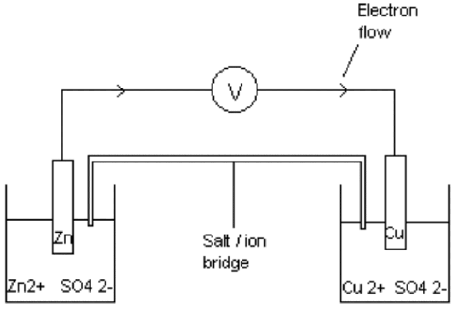
- Use the reduction potential chart to determine which chemical is the anode (smaller E°) and which chemical is the cathode (larger E°).
- State that standard conditions are 25°C, solutions are 1 M, and gases are 1 atm.
- Calculate the voltage of a standard cell as the difference in the two E° values. (not like Hess)
- State that the anode is the (−) electrode because the chemicals are being oxidized (losing e⁻’s).
- State that for non-standard cells, changes that drive the reaction forward increase the voltage.
(The Nernst equation allows you to calculate this voltage for a non-standard cell.)

