AP Chemistry Name_____________________________________
Period _____ Date ___/___/___
8&9 • Bonding & Molecular Structure
P R A C T I C E T E S T

1. The correct Lewis symbol for is
a) 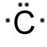 b) 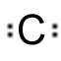 c) 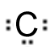 d) 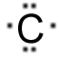 e) 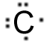
none of the above. Sorry.
2. The correct Lewis symbol for ground state aluminum is
a)  b) 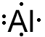 c)  d)  e) 

3. Using the picture below, what process corresponds to the lattice energy?
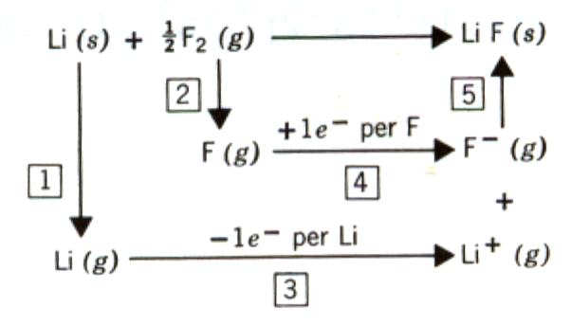
a) 1 b) 2 c) 3 d) 4 e) 5

4. Which of the following favors formation of an ionic compound?
a) low ionization energy for metal
b) high electron affinity for non metal
c) high lattice energy
d) all of a-c above
e) none of a-c above

5. Which of the atoms below is least likely to violate the octet rule?
a) Be b) P c) S d) B e) F

6. How many electrons are shown in the Lewis structure of perchlorate ion, ClO4–?
a) 30 b) 31 c) 32 d) 50 e) 51
Questions7 - 9 refer to the following energy diagram:
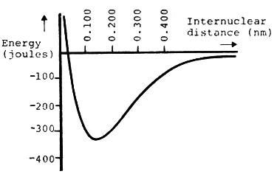
7. What is the energy of the two isolated atoms?
a) –400 J d) 0.100 nm
b) –335 J e) –155 J
c) 0 J
don’t worry about this question.
8. What is the bond length of the bond between the two atoms?
a) 0.020 nm d) 0.330 nm
b) 0.140 nm e) 2.00 nm
c) 0.400 nm

9. What is the bond energy (bond strength) of the bond?
a) 0 J d) –330 J
b) –110 J e) –422 J
c) –10 J

10. What is the bond order of the C–O bond in
a) 4 b) 1.5 c) 0.5 d) 1 e) 2
11. Which of the following is the correct Lewis structure for SOCl2? (Consider formal charge)
a) 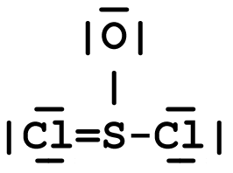 d) 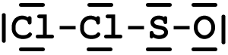
b) 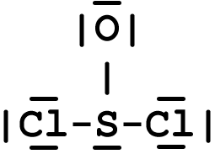 e) 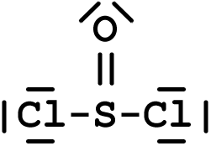

c) 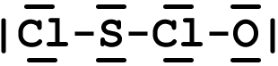
S is least electronegative and therefore should have the most positive charge. Letter c violates this rule.
12. As the bond order of a carbon-carbon bond increases, which one of the following decreases?
a) # of electrons between the carbon atoms
b) vibrational frequency of bond vibrations
c) bond energy (bond strength)
d) bond length

13. In which of the following is the actual compound a resonance hybrid of Lewis structures?
a) NO₂ d) CCl₄
b) H₂O e) none of these
c) O₃
oops. There were 2 answers.
14. Which of the following bonds is most polar?
a) N – Cl d) Br – Br
b) C – N e) S – O
c) S – S

15. Which one of the following molecules is a polar molecule?
a) 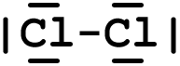 c) 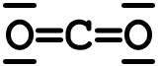
b) 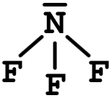 d) 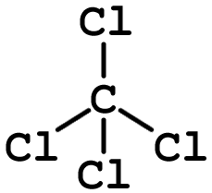

16. Which of the following molecular shapes has six atoms joined to a central atom?
a) linear d) trigonal bipyramid
b) tetrahedral e) planar triangular
c) octahedral

17. Which molecular shape has bond angles which are not all the same?
a) linear d) planar triangular
b) tetrahedral e) trigonal bipyramid
c) octahedral

18. What molecular shape is pictured below?
a) linear d) planar triangular
b) tetrahedral e) trigonal bipyramid
c) octahedral

19. The molecule BrF3 has how many lone pairs of electrons on the central atom?
a) 0 b) 1 c) 2 d) 3

20. What is the geometrical arrangement of electron pairs in H2O?
a) linear d) trigonal bipyramidal
b) bent e) tetrahedral
c) octahedral

21. What is the shape of BrI3?
a) square planar d) pyramidal
b) T-shaped e) bent
c) distorted tetrahedral

22. What is the shape of the IF4– ion?
a) square planar d) octahedral
b) tetrahedral e) T-shaped
c) square pyramidal

23. Which of the following is a polar species?
a) CO2
b) PCl5
c) ICl2–
d) TeCl4
e) CCl4

24. Among those listed below, which element will have the strongest tendency to form double bonds?
a) S b) B c) Al d) O

H  2.1 | Electronegativity Values |  |  |  |  |  | He  ---
Li  1.0 | Be  1.5 | B  2.0 | C  2.5 | N  3.0 | O  3.5 | F  4.0 | Ne  ---
Na  0.9 | Mg  1.2 | Al  1.5 | Si  1.8 | P  2.1 | S  2.5 | Cl  3.0 | Ar  ---
K  0.8 | Ca  1.0 | Ga  1.6 | Ge  1.8 | As  2.0 | Se  2.4 | Br  2.8 | Kr  ---
Rb  0.8 | Sr  1.0 | In  1.7 | Sn  1.8 | Sb  1.9 | Te  2.1 | I  2.5 | Xe  ---
Cs  0.7 | Ba  0.9 | Tl  1.8 | Pb  1.8 | Bi  1.9 | Po  2.0 | At  2.2 | Rn  ---
Fr
0.7

