Answers to selected questions: Study Guide for Statics

Name: __________________________________ Period:________________ Team: _________

***Don’t forget to write your name, period, and team no.

I. Newton’s 1st Law of Motion. From nos. 1-7, circle the letter that corresponds to the correct answer.
b 1. An astronaut in outer space away from the gravitational or frictional forces throws a rock. The rock will
a. gradually slow to a stop b. continue moving in a straight line at constant speed
2. Referring to no. 1, the rock’s tendency to do this is called
a. inertia b. weight c. acceleration
c 3. The sketch shows a top view of a rock being whirled at the end of a string (clockwise. If the string breaks, the path of the rock is
a. A b. B c. C d. D
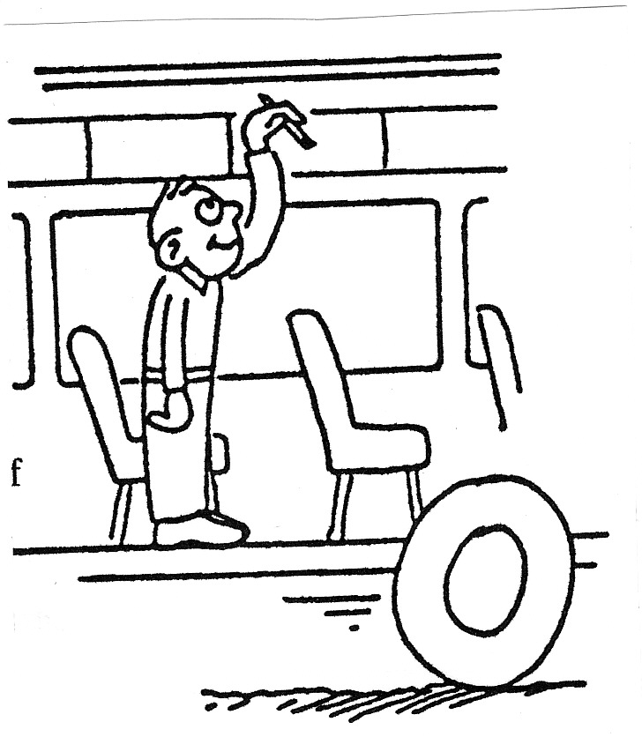
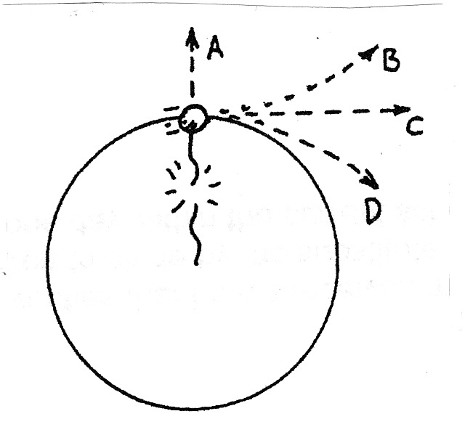

For nos. 4 to 8, refer to the following situation:
You are standing in the aisle of a bus that travels along
a straight road at 100 km/h, and you hold a pencil still
above your head.

4. Relative to the bus, the velocity of the pencil is 0 km/h, and relative to the road, the pencil has a horizontal velocity of
a. less than 100 km/h b. 100 km/h c. more than 100 km/h
b 5. Suppose you release the pencil. While it is dropping, and relative to the road, the pencil still has a horizontal velocity of
a. less than 100 km/h
b. 100 km/h
c. more than 100 km/h
6. This means that the pencil will strike the floor at a place directly
a. behind you b. at your feet below your hand c. in front of you
a 7. Relative to you, the way the pencil drops
a. is the same as if the bus were at rest b. depends on the velocity of the bus
8. How does this example illustrate the law of inertia?
_______________________________________________________________________________________________________________________________________________________________________________________________________________________________________________

II. Newton’s 3rd law of Motion. Circle the letter that corresponds to the correct answer.

Nellie Newton holds an apple weighing 1 N at rest on the palm of her hand. The force vectors shown are the forces acting on the apple.

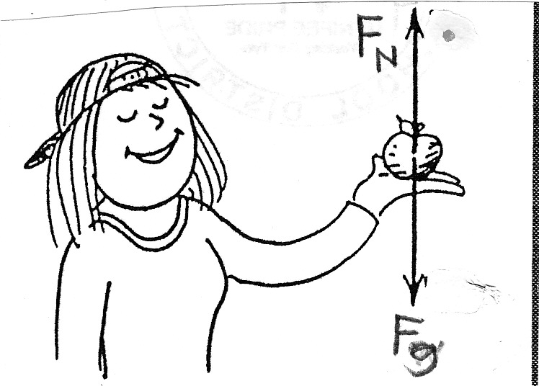

1. To say the weight of the apple is 1 N is to say that a downward gravitational force of 1 N is exerted by the
a. earth b. hand
b 2. Nellie’s hand supports the apple with normal force F_{n} which acts in a direction opposite to F_{g}. We can say F_{n}
a. equals F_{g} b. has the same magnitude as F_{g}
3. Since the apple is at rest, the net force on the apple is
a. zero b. nonzero
a 4. Since F_{n} equal and opposite to F_{g}, we
a. can say b. cannot say
that F_{n} and F_{g} comprise an action-reaction pair.
5. The reason for no. 4 is because action and reaction always
a. act on the same object b. act on different objects
b 6. In this situation, we see F_{n} and F_{g} are
a. both acting on the apple b. acting on different objects
7. In accord with the rule, “If action is A acting on B, then reaction is B acting on A,” if we say action is the earth pulling down on the apple, reaction is
a. the apple pulling on the earth b. Nellie’s hand pushing up on the apple
8. To repeat for emphasis, we see that F_{n} and F_{g} are equal and opposite to each other and
a. comprise an action-reaction pair
b. but do not comprise an action-reaction pair
9. Another pair of forces is F_{n} shown and the downward force of the apple against Nellie’s hand (not shown). Is this force pair an example of action- reaction pair?
a. Yes b. No
b10. Suppose Nellie now pushes upward on the apple with a force of 2N. The apple
a. is still in equilibrium b. accelerates upward
11. Referring to no. 10: Compared to F_{g}, the magnitude of F_{n} is
a. the same b. twice c. not the same, and not twice
a 12. Once the apple leaves Nellie’s hand, F_{n} is
a. zero b. still twice the magnitude of F_{g}
13. Referring to no. 12: The net force on the apple is
a. zero b. only F_{g} c. still F_{g} – F_{n}, which is a negative force
III. Statics. Fill in the blank with the correct reading in the scale. A spring scale is a device used to measure the force in N. An object is attached to the hook at one end of the scale. The spring stretches up to the scale reading.
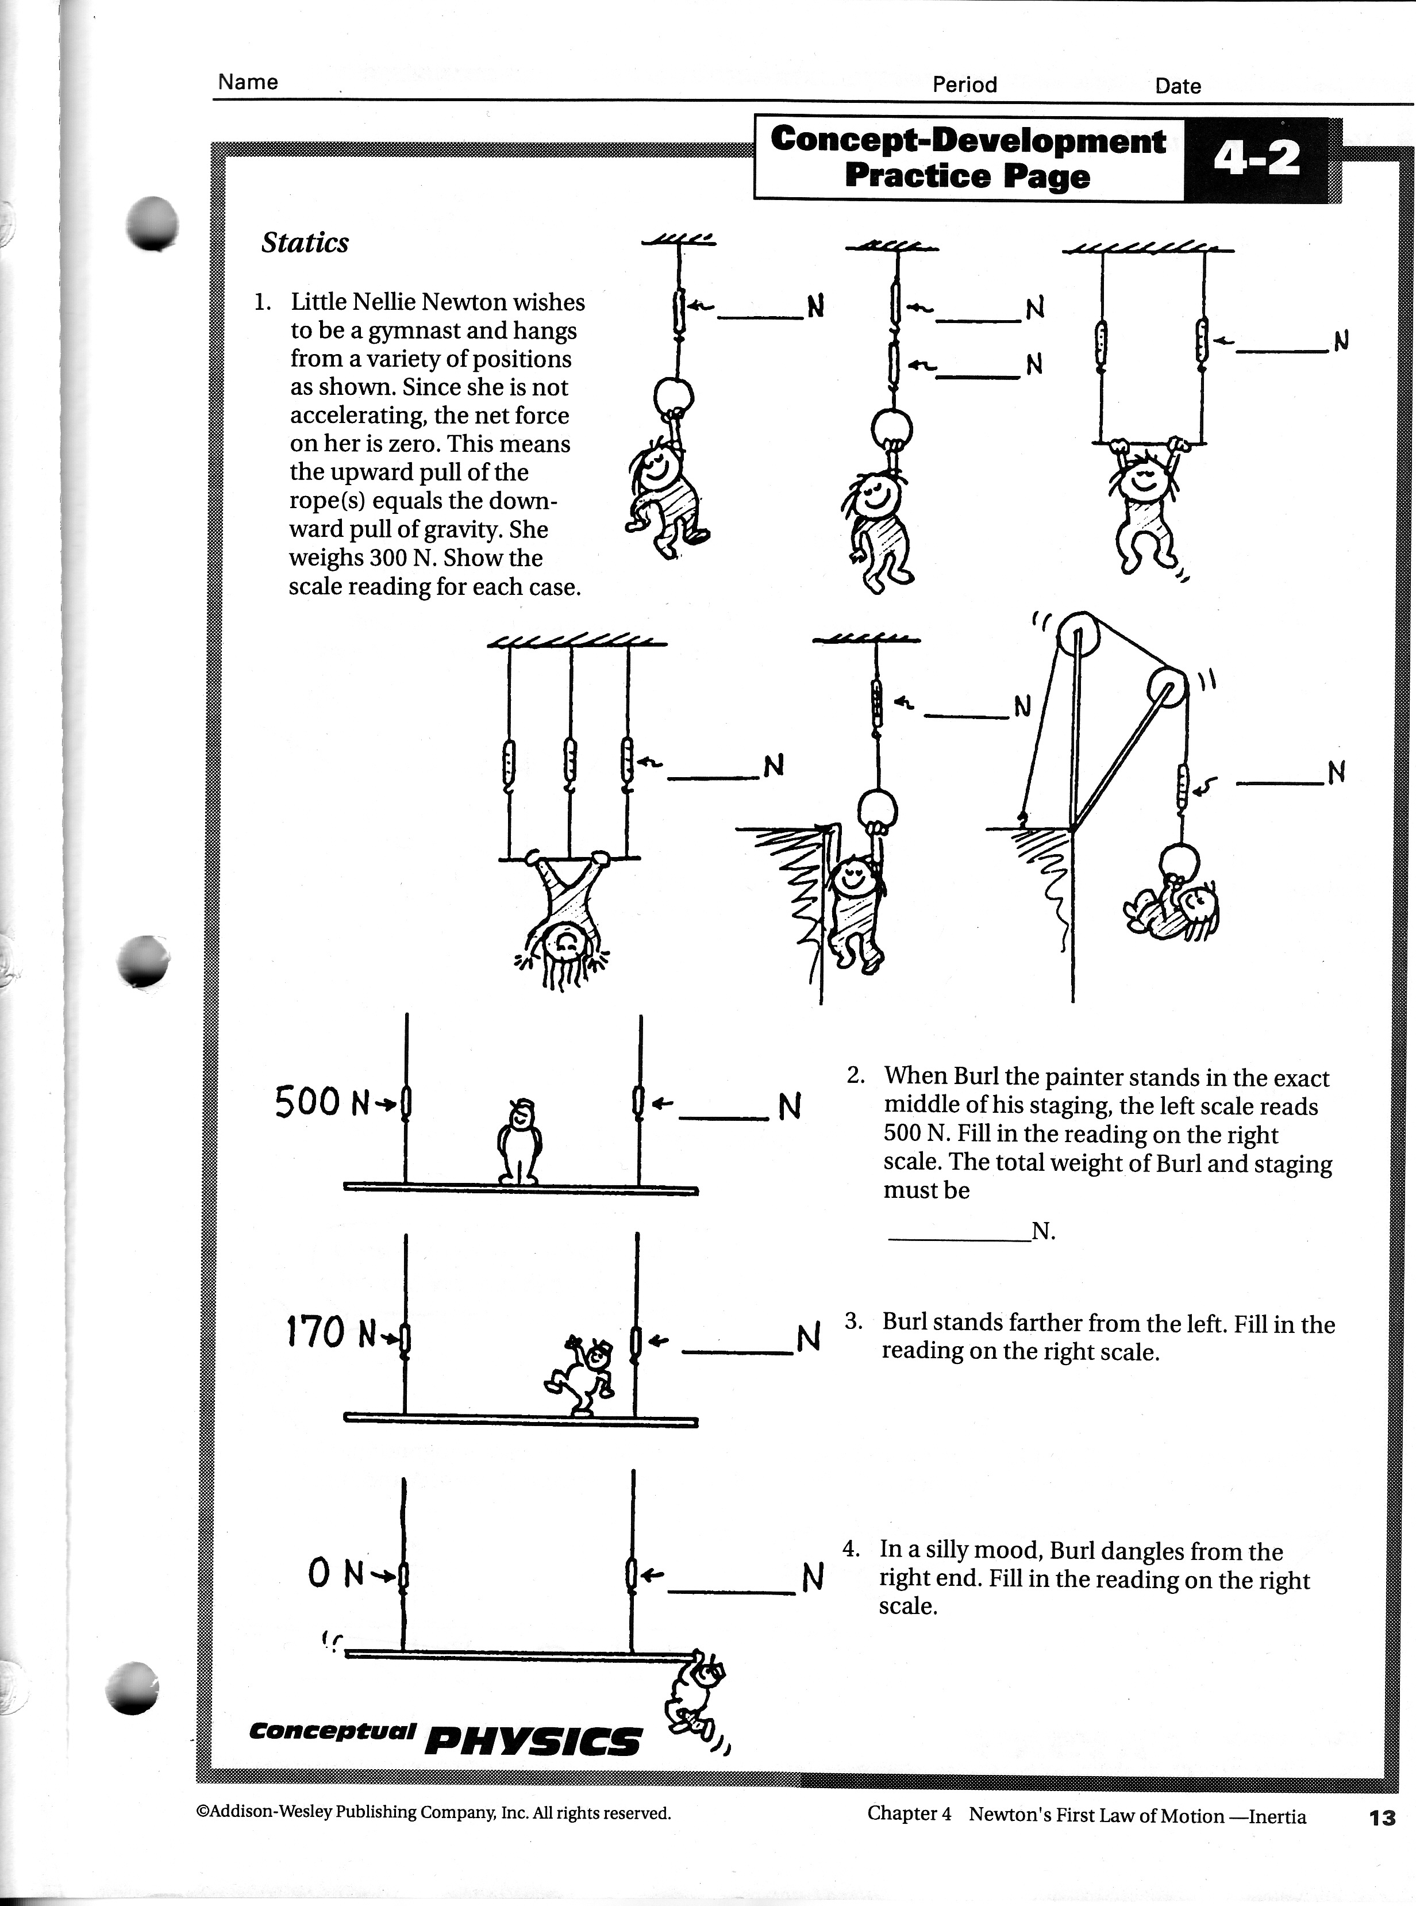

Answers to selected items in III.

1. b.) 300 N
d.) 100 N

2. a.) 500 N

IV. Additional Problems in Statics

- What is the tension on the cable that holds the 300-N traffic lights?
a. 2 vertical ropes hold the traffic lights Ans. Ft in each cable is 150 N

b. two cables hold the traffic lights- one horizontal cable and the other makes an angle of 30º above the horizontal Ans. F_{T1}= 600 N, F_{T2}= 520 N

- A gardener pushes a 30-kg lawnmower with a horizontal force of 500 N causing it to move at a constant velocity along the rough grass.
  - Draw the FBD of the lawnmower.
  - What is the weight of the lawnmower? 294 N
  - What is the normal force exerted by the ground on the lawnmower? 294 N
  - What is the frictional force exerted on the lawnmower? 500 N

- Refer to prob. 2: If the gardener applies the force at an angle of 45º above the horizontal (the lawnmower is still moving at constant v)
  - Draw the FBD of the lawnmower.
  - What is the weight of the lawnmower?
  - What is the normal force exerted by the ground on the lawnmower? 648 N
  - What is the frictional force exerted on the lawnmower? 354 N

