Ch. 20 Food Safety and Storage Pg.279
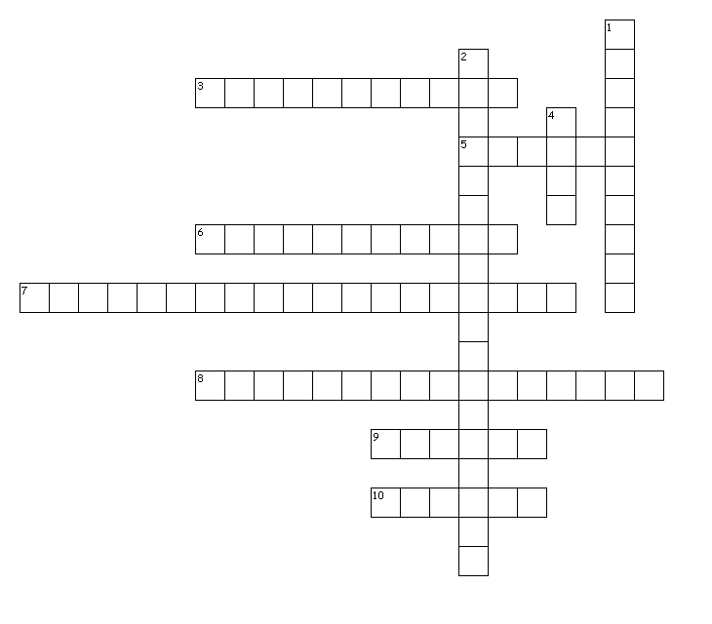
Across
3. moisture loss caused when food is improperly packaged or stored in the freezer to long
5. protected cells that develop into bacteria under the right conditions
6. the process of exposing food to high-intensity energy waves to increase its shelf life and kill harmful microorganisms
7. registered at the center of the thickest part of the food
8. sickness caused by eating food that contains a harmful substance
9. the immediate removal of a product from store shelves
10. poisons that can cause illness
Down
1. means keeping food safe to eat by following proper food handling and cooking practices
2. occurs when harmful bacteria spread from one food to another
4. generally recognized as safe

