Save as Chips LastName

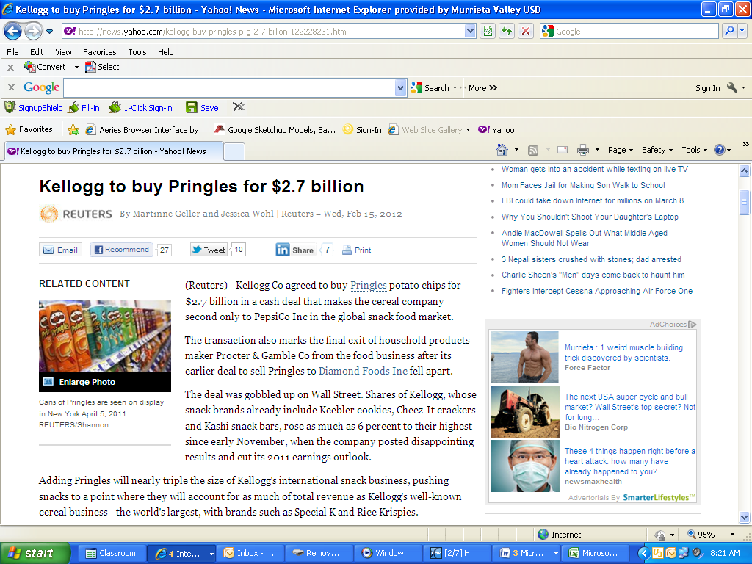

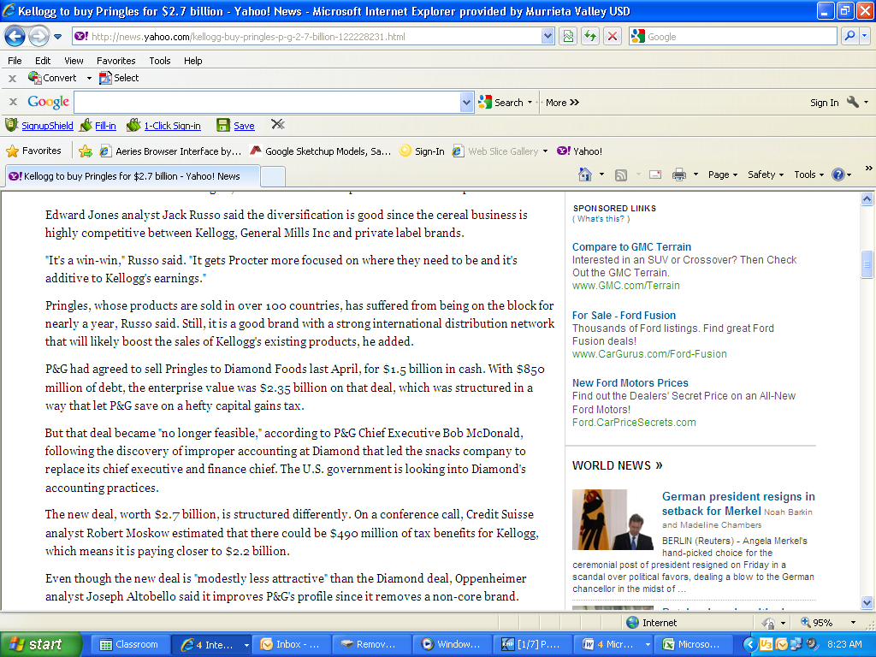

What other snacks are owned by Kelloggs?

What company is a major competitor to Kelloggs?

How many countries sell Pringles products?

What does P & G stand for?

Which stock do you think will go up (Kellogg’s, P & G, both or neither)? Explain