

DUE DATE:____________________

PURPOSE: In order to better learn all 206 bones of the human skeleton, you will be producing a Skeletal System Portfolio with labeled pictures.

MATERIALS: textbook, lab manual, internet, ruler, regular pencil, good eraser, manilla “clasp” envelope.

PROCEDURE:
- All drawings must be done in pencil (no colors), using shading when appropriate
- The labels must be done using a ruler. I will list the exact parts to be labeled each day in class.
- The more professionally done the higher the grade.
- Use a gradation of graphite values from pure black to white and shades in between.
- Include a simple title on the top and label each view. (e.g.—posterior, anterior, lateral, etc)
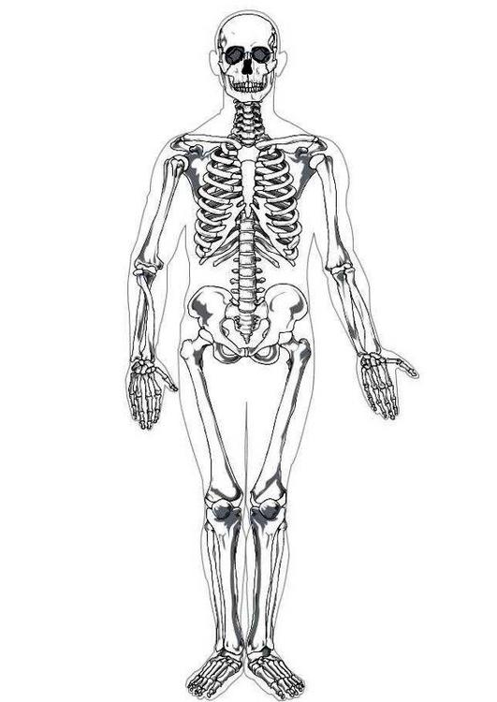
LIST OF BONES
1. Scapula
*both anterior and posterior views- label all parts- 2 pictures/1 page

2. Humerus
*both anterior and posterior views- label all parts- 2 pictures/1 page

3. Ulna and Radius
*all structures labeled- both on 1 page

4. Clavicle—anterior view on 1 page in horizontal position.

5. Pelvic Girdle
*one view with all structures labeled (2 coxa, sacrum & coccyx)—1 page
* anterior and posterior views of Coxa (hip bone)—2 pictures/1 page.

6. Femur
*both anterior and posterior views- label all parts- 2 pictures/1 pg

7. Tibia and Fibula
*all structures labeled- both on 1 page

8. Vertebral Column
*show all vertebrae and curvatures (lateral and posterior) – 2 pictures/1 page
*show the 3 types of vertebrae: cervical, thoracic & lumbar—3 pictures/ 1 page

9. Thoracic Cage
*all structures labeled on 1 page. Include sternum, true & false ribs.

10. Hand
*one view with all structures labeled

11. Foot
*both lateral and superior views – 2 pictures/1 pg

12. Skull
*lateral view – label all structures from your skull bone list.—1 page for each view.
*anterior view- label parts

