Name ____________________________________________ Period _____ Date _________________
Microscope Diagram
Directions: 1) Read items #1-7 on page R8 in your text. 2) Label all boxes on the diagram. 3) Write functions of all 14 parts on the backside of your paper using page R8 in your text.

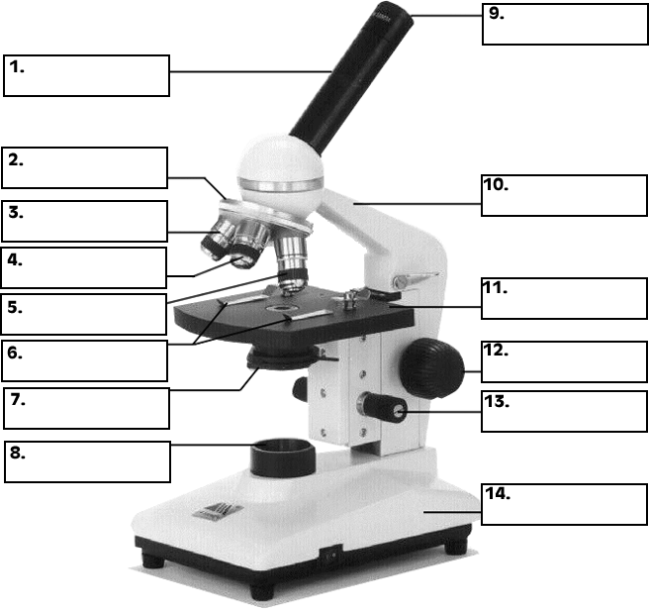

Guidelines for using microscopes:
- Always carry the microscope with ________ hands. Hold it by the __________ and the __________.
- Always start on ______________ power.
- Use only ____________ focus on ____________ or ____________ power.
- Always pull out the ____________ by the ____________, not the ____________.
Ans Choices: plug, both, arm, cord, base, low, fine, wire, course, medium, two

