The End of World War One

The Treaty of Versailles

World War One ended at 11am on 11th November 1918. In 1919, Lloyd George of England, Orlando of Italy, Clemenceau of France and Woodrow Wilson from the US met to discuss how Germany was to be made to pay for the damage world war one had caused.

Wilson had devised a 14 point plan that he believed would bring stability to Europe.
- There were to be no secret treaties between powers like the treaties that had helped to cause the First World War. (Open Diplomacy)
- Seas should be free in peace and in war to ships of all nations (Freedom of Navigation)
- The barriers to trade between countries such as custom duties should be removed (free trade)
- All countries should reduce their armed forces to the lowest possible levels (Multilateral disarmament.)
- The national groups in Europe should, wherever possible, be given their independence. Wilson supported the idea of National Self-Determination, whereby a nation had the right to self-government.
- Russia should be allowed to operate whatever government it wanted.
- Territorial changes:
- Germany should give up Alsace-Lorraine and any lands taken away during the war.
The Italian frontier should be readjusted.
Belgium should be evacuated.
Poland should be given an outlet to the sea.
- The defeated nations should not be made to pay for the war as a whole.
- A ‘League of Nations’ should be formed to protect world peace in the future.

Germany expected a treaty based on these 14 points. However, the French were not happy and wanted more from Germany. The Germans were not invited to the Paris Conference and had no say in the making of the peace treaty. Although Germany complained about the severity of the Treaty, in the end Germany had no choice but to sign the document.

Activity
1. Using the information on p.25 of The Twentieth Century by John D Clare and source 1, complete the Versailles Treaty table.
2. Look at source 2? Explain what the the various elements in the picture represent.
3. What were the differences between Wilson’s 14 points and the Treaty of Versailles.

Source 1
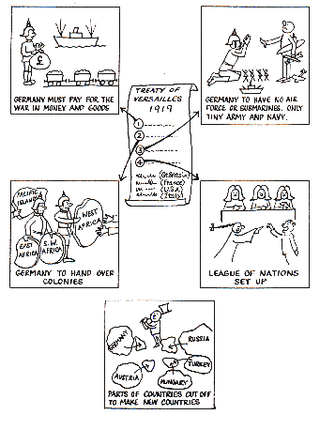
Source 2
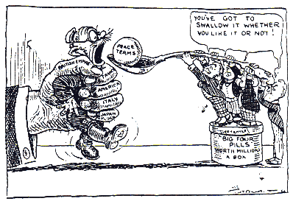

What did the Treaty of Versailles mean for Germany and for Europe?
 | Germany | Europe
War Guilt Clause

Reparations

Military

Land

Peace Keeping

