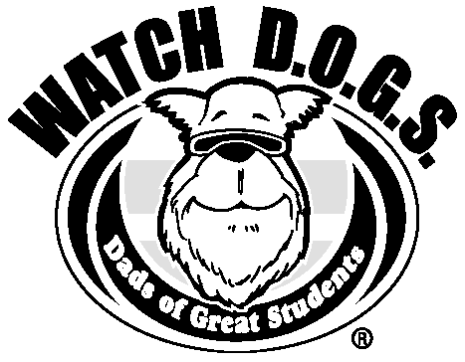
Thank you for supporting Murrieta Elementary and the students at our Pizza Night event.
We are very appreciative of your efforts as we look to launch a very successful
WATCH D.O.G.S.® program. If you were not able to signup tonight, please make
time to contact ( the office) this week to put your date on the calendar.

If you have any questions about the WATCH D.O.G.S.® Program at our school, please contact
one of the individuals below or go to www.fathers.com/watchdogs for more information:

Top Dog: Rob Lurkins Phone: 951-696-1401 Email:Rlurkins@murrieta.k12.ca.us

(Complete and return bottom portion to school with cash or check made out to the school)
- - - - - - - - - - - - - - - - - - - - - - - - - - - - - - - - - - - - - - - - - - - - - - - - - - - - - - - - - - - - - - - - - - - - - - - - - - - - - - - - - - - - - - - - - - - - - - - - - - - - - - - - - - - -

WatchDOG’S Name: ________________________Relationship to Student: _______________Signup Date:_________
Student’s Name: ______________________________ Student’s Teacher: ____________________ Grade_________
Home Phone: __________________ Cell Phone: ___________________ Office Phone: _________________
Email: ___________________________________________________________________________________

Men’s Uniform S/S or L/S (circle one) Qty. _____S _____M_____L_____XL_____2XL_____3XL_____4XL_____5XL
Polo Sport (men’s) Qty. _____M_____L_____XL_____2XL_____3XL_____4XL_____5XL
Ball Cap Qty. _____ea.
My Hero for students S/S or L/S (circle one) Qty. ____YS____YM____YL____YXL____S____M____L____XL ____2XL
Military Qty. _____S _____M_____L_____XL_____2XL_____3XL
WatchDOGS Rock Black w white letters Qty. ____YS____YM____YL____YXL____S____M____L____XL
WatchDOGS Rock Brown w blue letters Qty. ____YS____YM____YL____YXL____S____M____L____XL
I ♥ WatchDOGS Qty. ____YS____YM____YL____YXL____S____M____L____XL
Got Dads? Qty. _____S _____M_____L_____XL_____2XL_____3XL
Men’s Uniform T-Shirt Polo Sport Shirt WatchDOGS Cap My Hero S/S or L/S for students
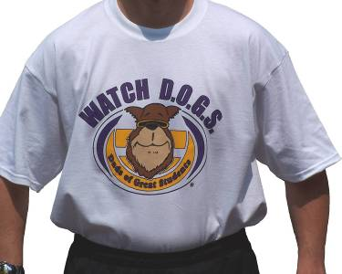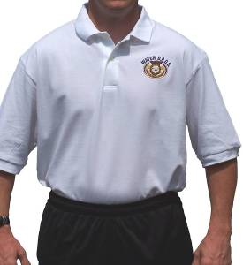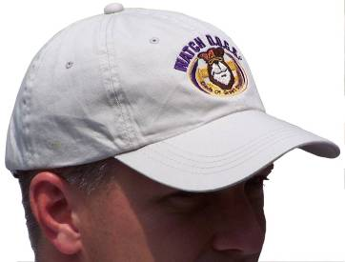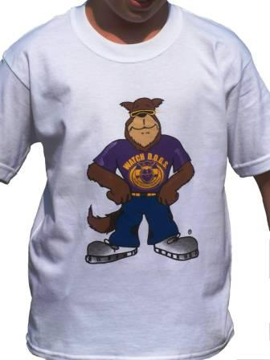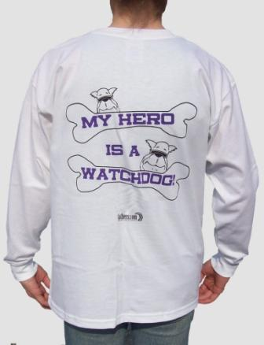

$15 ea. Short Sleeve $ 35 ea. $ 20 ea. $ 15 ea. Short Sleeve
$ 22 ea. Long Sleeve $ 22 ea. Long Sleeve
Military Promo shirt WatchDOGS ROCK! I heart WatchDOGS ‘Got Dads?’ Promo
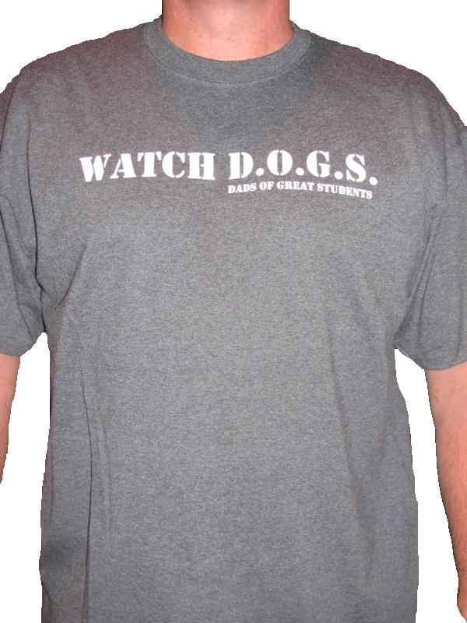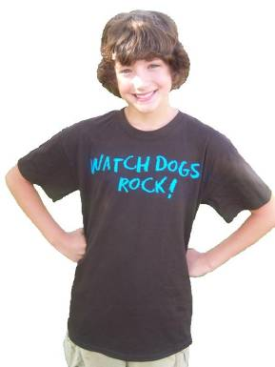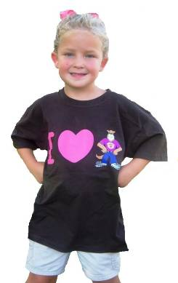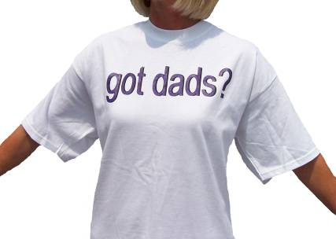
$ 15 ea. Black w white letters
$ 20ea. S/S only $ 15 ea. Brown w blue letters $ 15 ea. S/S only $ 12 ea.

